Lab S00
  - Splunk and Splunk App for Stream

Prerequisites

This lab was run using a Ubuntu 22.04 Virtual Machine in VMM and a Windows 10 Virtual Machine. Check links for .iso images.

This should work for nearly any local network environment of the same operating systems, virtual or bare metal, but was tested only on a Synology Network Attached Stored using Synology’s Virtual Machine Manager.

Introduction

What is Splunk? – Check out this introductory video from Splunk!

(From Google AI)
Splunk is a big data platform that helps organizations collect, manage, and analyze machine-generated data. It uses indexes to store data, so it doesn't require a separate database. Splunk's features include:

Data analysis
Splunk can analyze data from other databases, networks, web servers, and sensors. It can create dashboards, graphs, reports, alerts, and other visualizations.

Security
Splunk can help with security monitoring, incident response, compliance, and threat hunting. It can also help detect security risks across cloud, on-premises, and hybrid environments.

Observability
Splunk can provide full stack and OpenTelemetry-native observability.

User behavior analytics
Splunk can provide user behavior analytics (UBA) and observability solutions.

Splunk's products include:
- Splunk Enterprise: Allows users to search, analyze, and visualize data
- Splunk Cloud Platform: Offers data search, analysis, and visualization in the cloud
- SOAR: Provides user behavior analytics (UBA) and observability solutions

What is indexing in Splunk? (From Google AI)

Splunk indexing is the process of transforming raw data into searchable events and storing them in indexes:

Data input
The indexer processes and stores data in an index. In larger deployments, forwarders may handle data input and send it to the indexer.

Data storage
The indexer stores the data in flat files on the indexer. These files are located in a structured directory under $SPLUNK_HOME/var/lib/splunk.

Data search
The indexer searches the indexed data in response to search requests. When a search is performed, Splunk looks in the buckets that are included in the specified time window.

Index types
There are two types of indexes:
- Events indexes: The default type of index that can hold any type of data
- Metrics indexes: Hold only metric data

Splunk also maintains multiple copies of data across the configured retention period in clustered indexer topologies.

Splunk Enterprise on Ubuntu 22.04

Navigate to Splunk’s homepage then to the Products drop down menus and select “Free Trials and Downloads.”
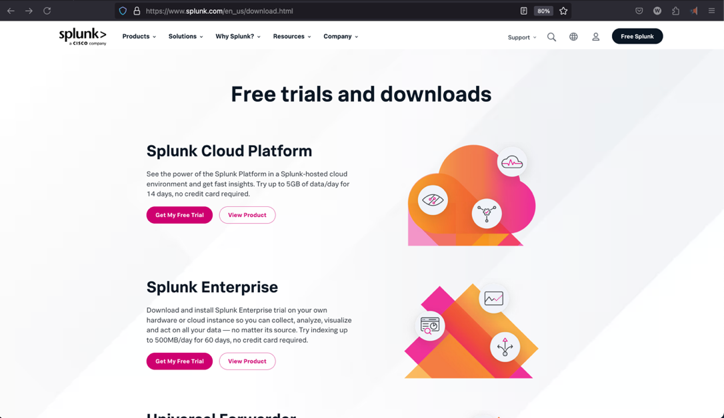

Under Splunk Enterprise select “Get Free Trial.” This will send you to a registration page where you can register for a 60 free trial of an on-premises installation of Splunk Enterprise.

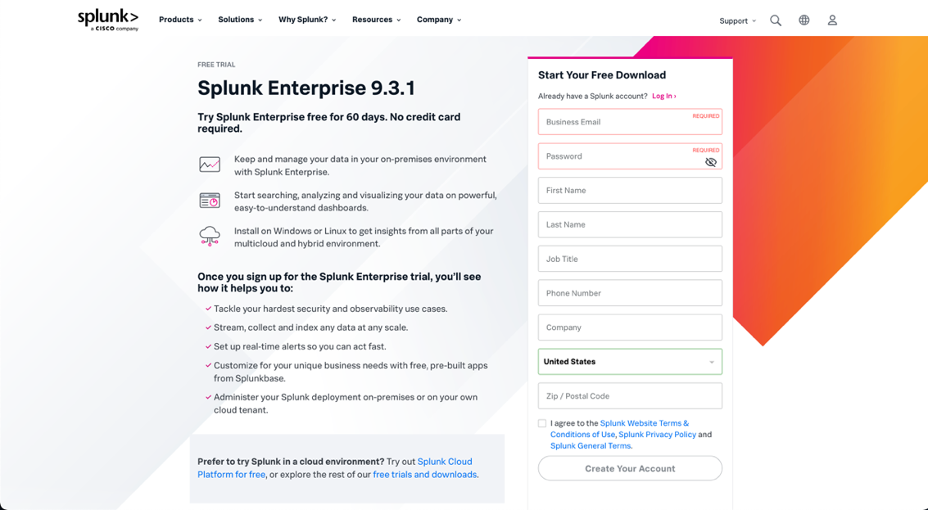

Sign up

After filling out and submitting the form wait for the email confirmation (this make take a few minutes).

Login with the email and password you’ve just created.



Navigate back to Splunk -> Free Trials and Downloads -> Splunk Enterprise -> Get My Free Trial

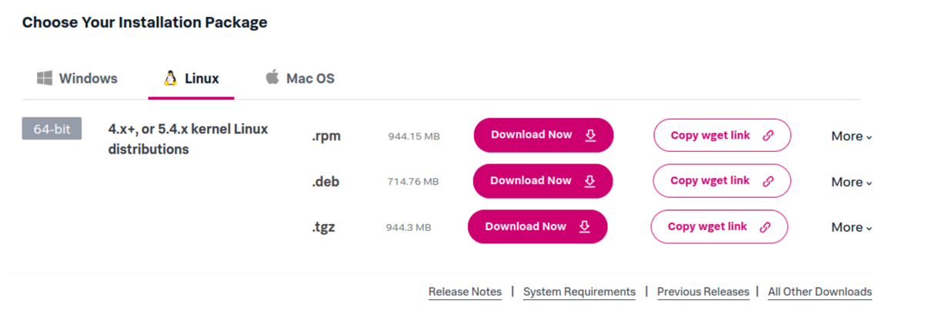

Splunk Enterprise will be running as a Search Head and a Deployment Server on our Ubuntu 22.04 VM

On Search Heads
From Search in docs - “Summary | Powered by Splunk AI”
“A search head, also known as an indexer, is a core component of a Splunk deployment that helps in collecting, indexing, searching, and analyzing data. It is responsible for accepting and processing search requests and providing results to users. In a distributed deployment, multiple search heads are used to distribute the search workload and provide redundancy and high availability.

Splunk Enterprise can utilize search heads to increase the available search capacity, distribute the scheduled search workload across the cluster, ensure optimal user failover if a search head fails, and limit the need for cross-site latency in index replication. In a multisite indexer cluster deployment, you will need at least three search heads per site.”

On Deployment Servers
From Search in docs - “Summary | Powered by Splunk AI”

“The Splunk Enterprise Deployment Server is a system designed to distribute files, apps, and configurations to Splunk instances, including universal forwarders. It aids in efficiently getting the environment up and running, and it is included with Splunk Enterprise at no additional cost. By activating the Deployment Server, you can quickly and easily deploy apps and configurations to a wide range of Splunk instances. However, while it is the default and fastest distribution method, using it is optional, and external deployment tools can be used in place.”

Under Linux and the .deb option for Debian (Ubuntu’s base linux) I’ve selected “Copy wget link”

You will need to install curl.

sudo apt install curl

Then paste the copied command into the command line.

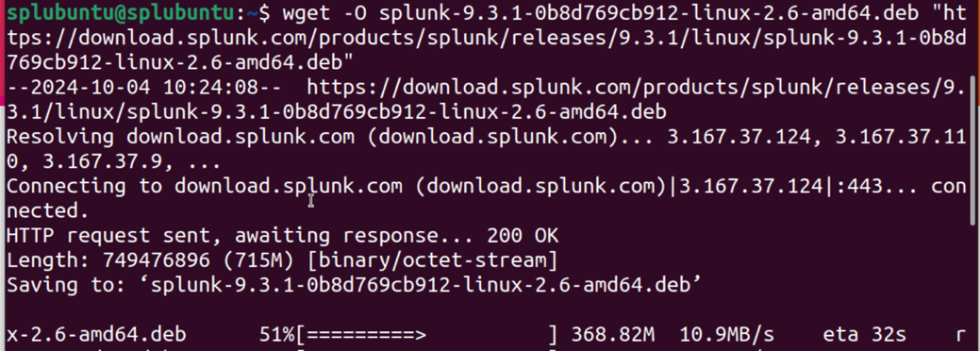

I will provide the required step here but for the installation manual: https://docs.splunk.com/Documentation/Splunk/9.3.1/Installation/InstallonLinux

I’ve moved the file to a directory located on the desktop I’ve created.

mkdir ~/Desktop/artifacts
mv splunk-9.3.1-0b8d769cb912-linux-2.6-amd64.deb ~/Desktop/artifacts

Packages must be installed as root in Linux

sudo dpkg -i ./Desktop/artifacts/ splunk-9.3.1-0b8d769cb912-linux-2.6-amd64.deb

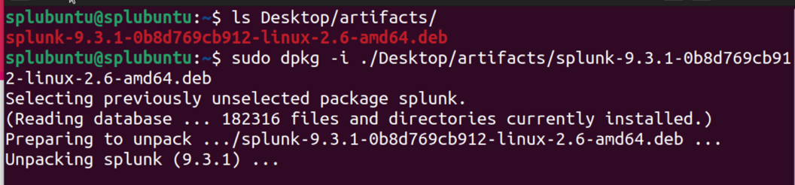

After the dpkg installation is complete check the /opt directory for splunk

ls /opt
Next we want to proceed with the installation through the Splunk executable located in /opt/splunk/bin. (NOTE: $SPLUNK_HOME will refer to /opt/splunk)

sudo /opt/splunk/bin/splunk enable boot-start

Press space to scroll to 100% and agree with license to continue.

Create credentials for the administrator account.

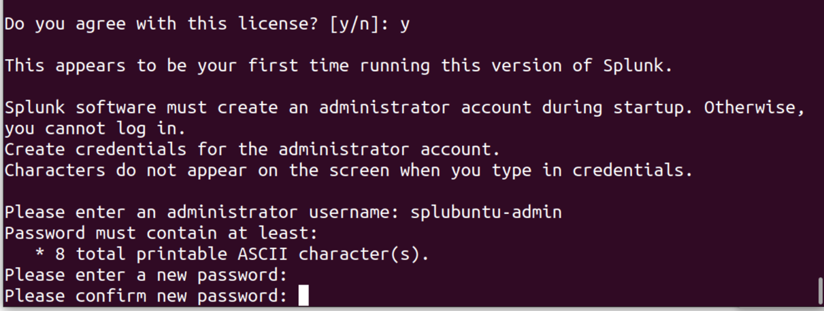

Then start Splunk as a system service.

sudo service splunk start

Navigate to Splunk web interface.

If you do not know your IP address in Ubuntu 22.04 you can type <ip address> in the command line.

In the browser of your choice enter in the address bar <YOURIP>:8000 port 8000 is the default the Splunk Enterprise Web UI is running on for access. Local area network access is enabled by default, so this log in interface is accessible by any machine on your network.

Enter the credentials you created during the CLI installation above.

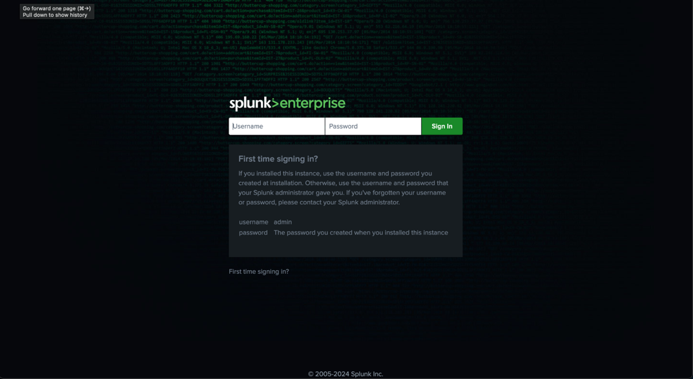

You now have access to the Splunk Enterprise Dashboard! This is where you can manage “Apps,” search indexes, and customize visualizations.

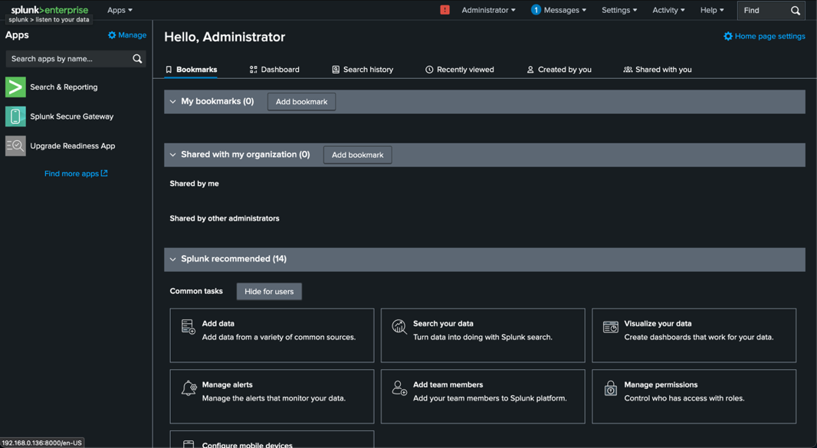

Set up a receiving port on your Search Head

To receive any input from your forwarders you will need to set up a receiving port.

From the Splunk Web UI select Settings and Forwarding and Receiving.

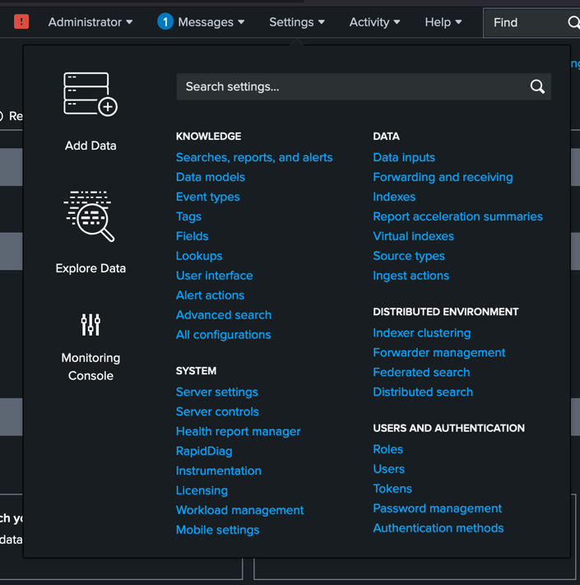

Under “Receive data” select “Configure receiving.”

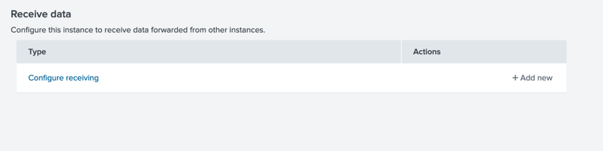

Select “New Receiving Port” and enter 9997, this is the default port for receiving data in Splunk. Save the input and confirm on the “Receive data” page that your configuration is in place.

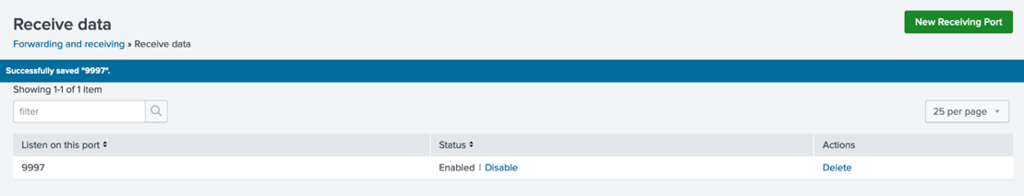
Install a Universal Forwarder

Now you are ready to install a Universal Forwarder (UF) on your target clients, in our case it is the Windows 10 VM we have up and ready.
I will be using the graphical install on Windows, but the command line works just as well. For the command line option see here and “Install a Windows universal forwarder from the command line.”

On your forwarding client (Windows 10) download the .msi for Splunk Universal Forwader from the “Free trials and downloads” page from above. Select the option for the 64-bit version, shown in the far-left column.

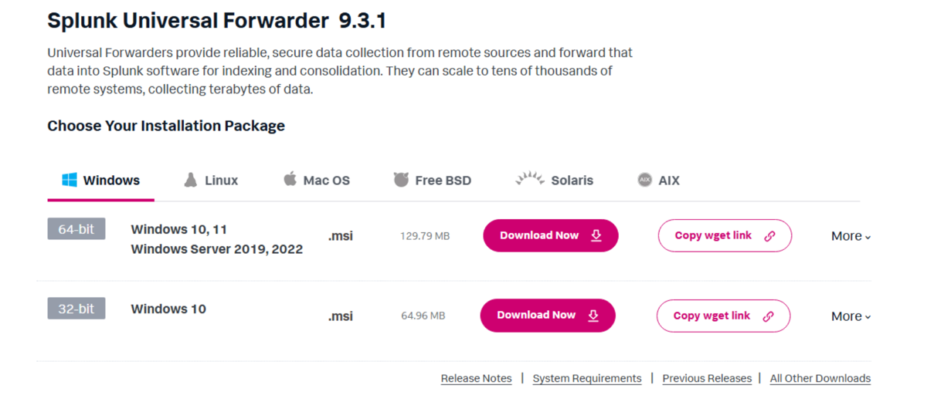
Double-click the .msi to begin the graphical installation
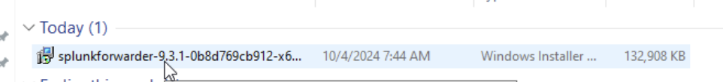

View and check the box to accept the License Agreement.

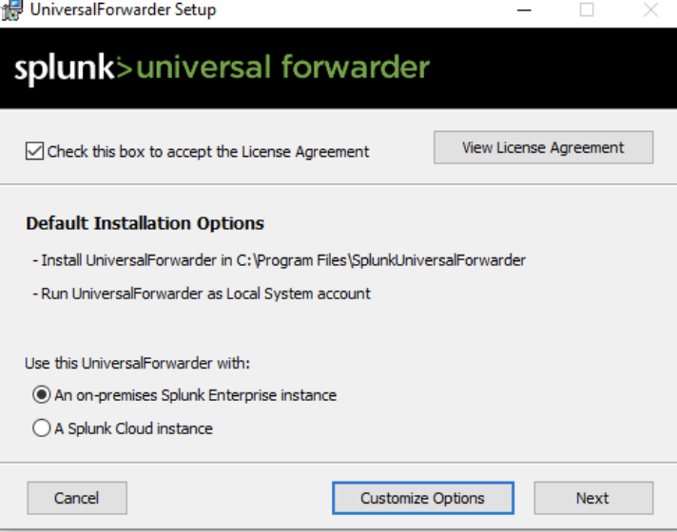

Create a username and password for the universal forwarder. These credentials are separate from your enterprise host but operate similarly to moderate some configuration and modification of the UF. All Splunk nodes require credentials.

More on the deployment server

The Splunk Enterprise we installed is enabled as a deployment server by default with management port 8089. When an app is added to the $SPLUNK_HOME/etc/deployment-apps directory on the deployment server (Ubuntu 22.04 in this lab), it is available to be distributed to your Forwarders that are listening on that port (8089). The UF is set to listen for app and configuration updates through the GUI installation step shown below. Add the IP of your Ubuntu machine with port 8089.

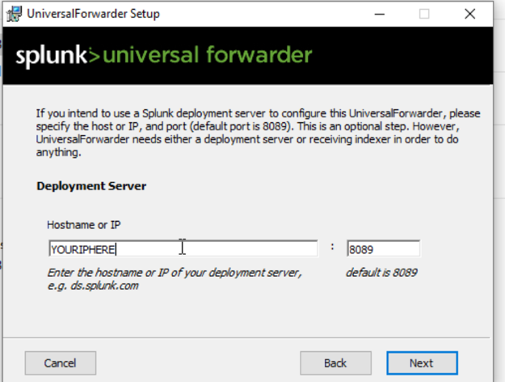
Set up the Receiver Indexer (Search Head) with the same IP as above with the port 9997. We have added the receiving port already.

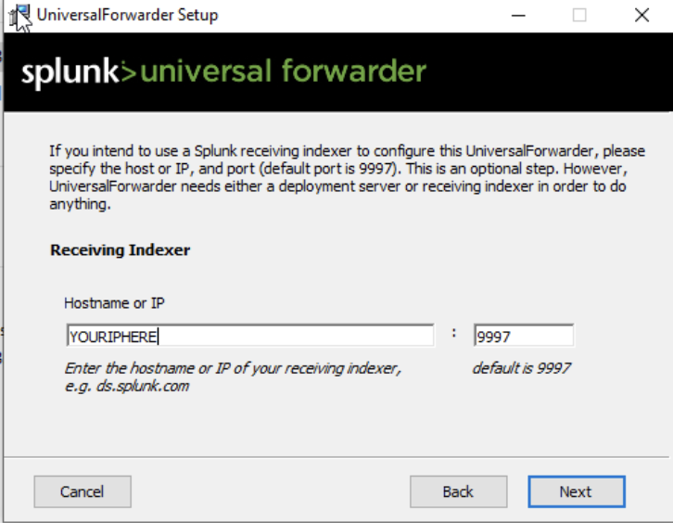

After installation is complete check the status of your forwarder. The default Path for the Splunk executable in Windows is ‘C:\Program Files\SplunkUniversalForwarder\bin’ (NOTE: $UFHOME will refer to C:\Program Files\SplunkUniversalForwarder)

Navigate to $UFHOME\bin and check the status with <.\splunk.exe status>.

Now we are ready to install in Splunk App for Stream

Splunk App for Stream

In the Splunk Server Web UI select the drop down for Apps and select “find more apps.” Using the search bar, search for “Stream.”

This will return a list of option related to the search word. Splunk App for Stream and Splunk Add-on for Stream Forwarders should be at the top of the results. Select install for Splunk App for Stream first and then Splunk Add-on. Splunk Add-on will prompt you to restart the server. Restart and wait, then log back in.

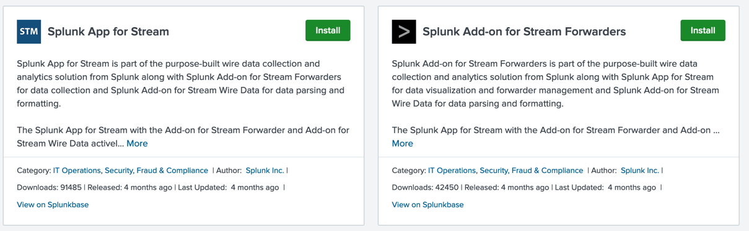

You should see under the same search in Find more Apps.
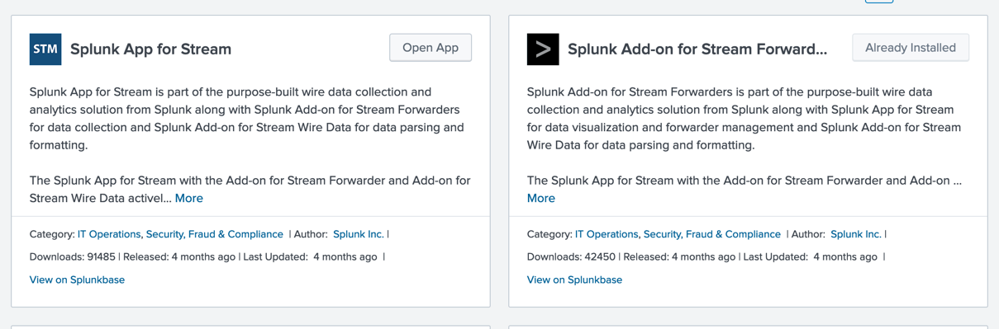

You can also check the server directories for splunk_app_stream and Splunk_TA_stream.

Apps are always installed on the server at $SPLUNK_HOME/etc/apps.

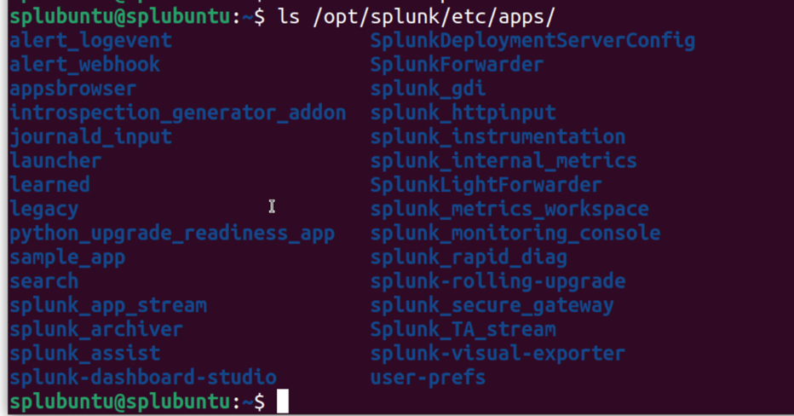

To start receiving data from your windows forwarder you will need to add Splunk_TA_stream to your deployment apps folder.

You can do this by:

sudo cp -r $SPLUNK_HOME/etc/apps/Splunk_TA_stream $SPLUNK_HOME/etc/deployment_apps

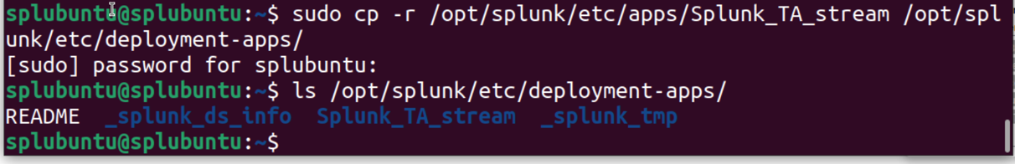

After confirming installation go back in the Splunk Enterprise Web UI.

We will now be setting up a server class to add our Stream App and Client to so that the desired App is delivered to the UF Client. This is how Splunk knows which deployment apps to deliver where.

Go to Setting -> Forwarder management -> Server Classes

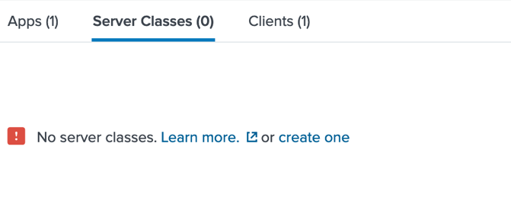
Select create one.

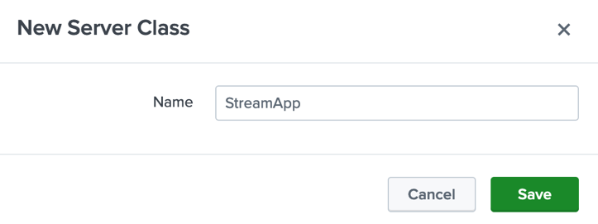

I’ve named mine SteamApp.

Under Add Apps select Splunk_TA_steam and Save

After saving, you will either have to click Cancel or go to settings > Forwarder Manager -> Server Classes and Select Edit on the Server class you’ve just created. There is no back option in the interface, but your App selection will save.

Under Clients

Select Add Clients and add your target client to the Include List and click save

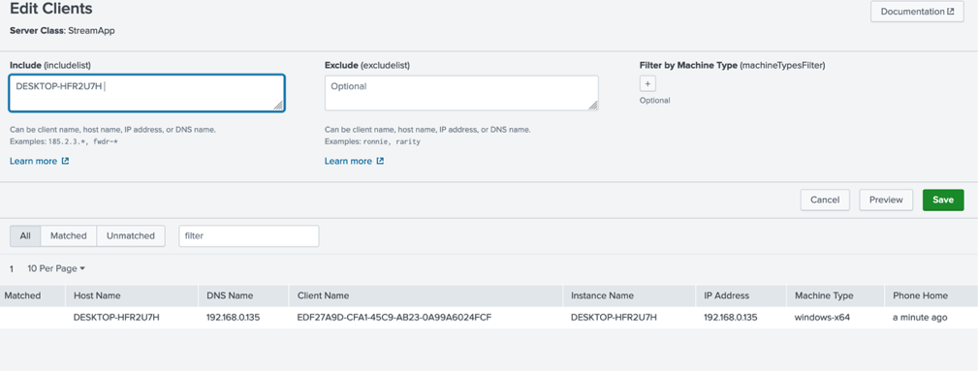

Select Preview and this will return you to your server class preview page.

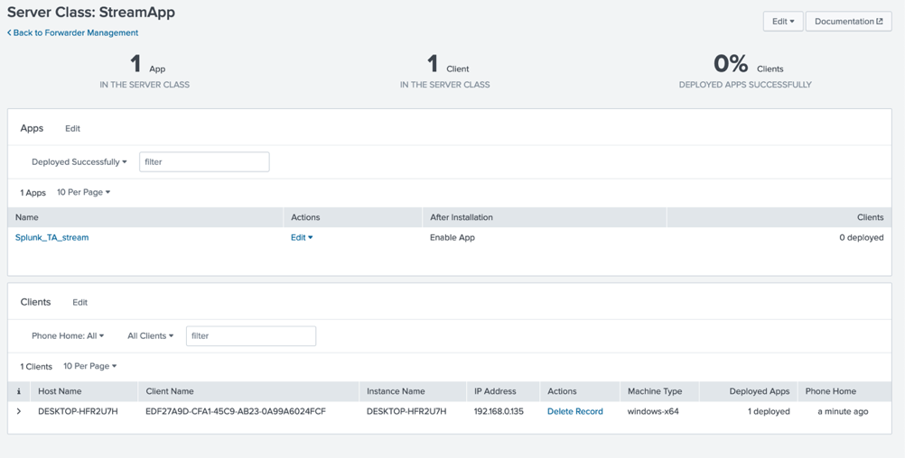

Now, for the Stream app to function you have to create a streamfwd token…

Go to Apps -> Splunk Stream

Skip or take the tour if you would like.

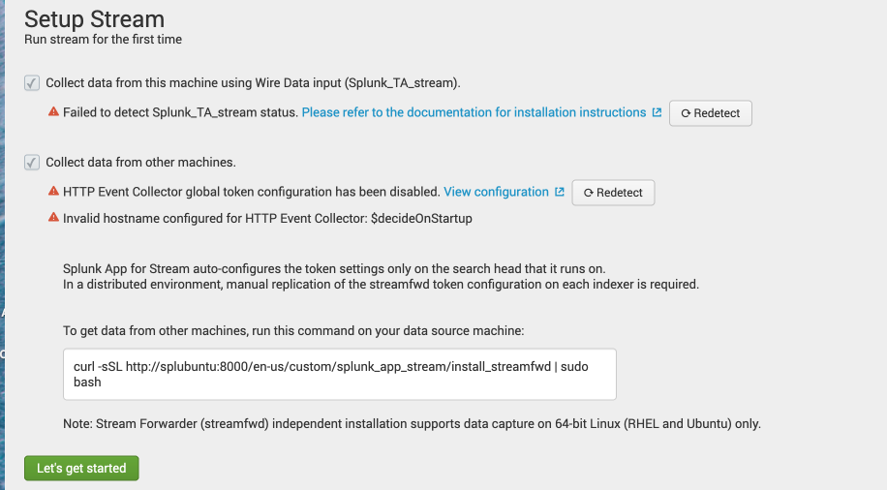

Check both boxes but what we need to configure is the HTTP Event Collector global token. Select View configuration.

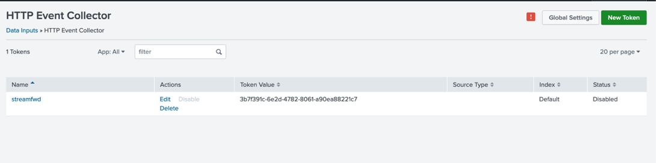

You will see the status is disabled. Select Global Settings and enabled for All Tokens and disable SSL.

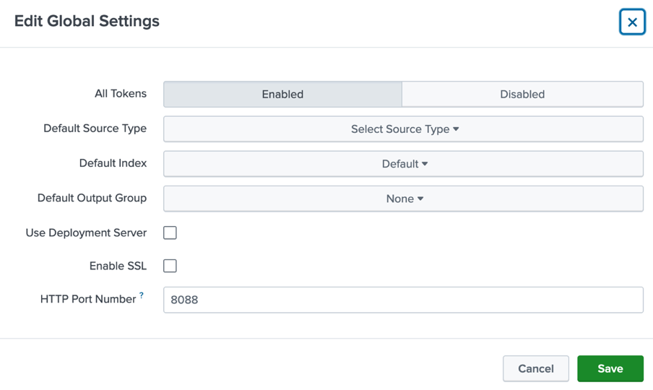

Go back to Splunk Stream and confirm token configuration is enabled.
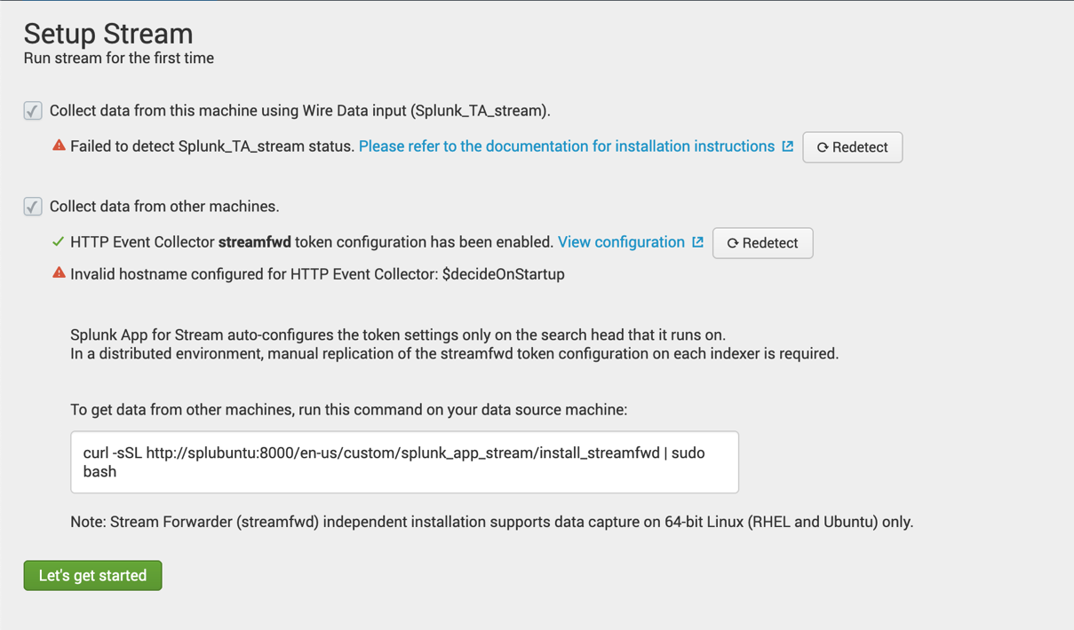

Ignore the other warnings for now and select let’s get started.

You should already be receiving data from the Splunk Enterprise Search Head

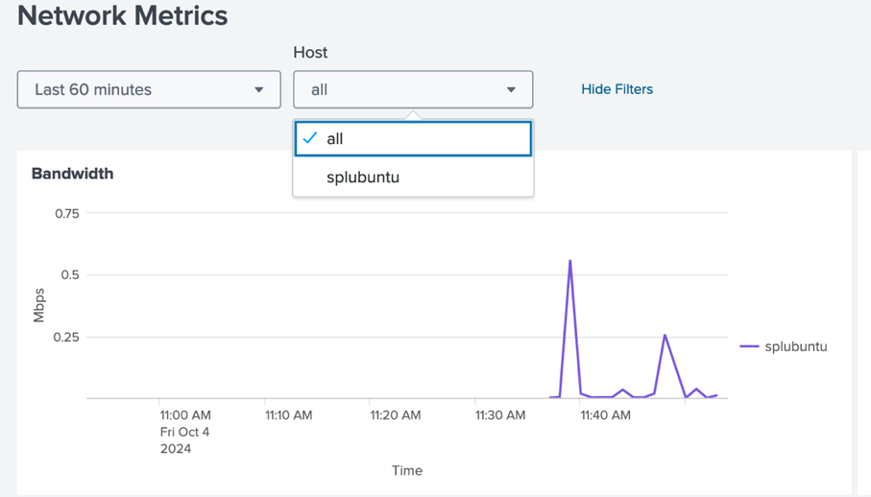

Universal Forwarder configuration for Splunk Stream

Now we will need to install npcap and make a simple configuration change to the UF inputs.conf file on Windows 10. Splunk_TA_Stream app comes prepackaged with both linux and windows installation sub directories. We will be using the windows_x86_64.

Confirm you have Splunk_TA_stream in the $UFHOME\etc\apps directory on your Universal Forwarder. See below for my full path. You should have something similar.

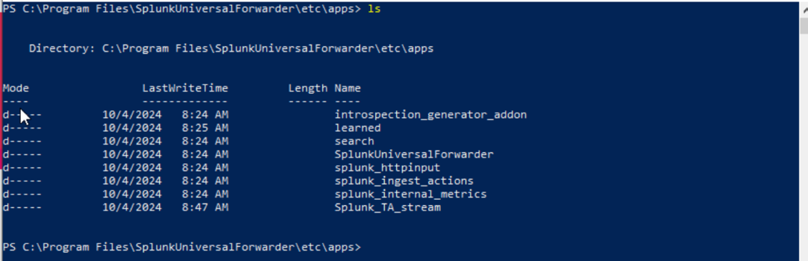

In Splunk_TA_stream there is a npcap installation executable under the windows_x86_64 folder.

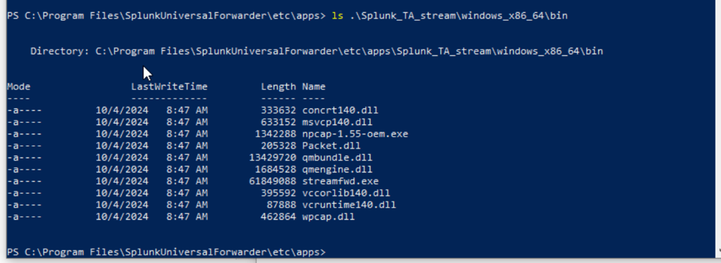

Run the npcap.exe installation with

$UFHOME\etc\apps\Splunk_TA_stream\windows_x86_64\bin\npcap-1.55-oem.exe

Or find it in file explore and double click.
Follow the GUI steps for installation.

Check the boxes to support 802.11 raw traffic as well as the WinPcap API compatible mode do not select run as administrator.

Once the installation is complete open Notepad as administration and select File -> Open.

NAVIATE to $UFHOME/etc/apps/Splunk_TA_Stream/local

Change file type to All Files and open the inputs.conf file to edit. Change “localhost” to your <SEARCH_HEAD_IP>.

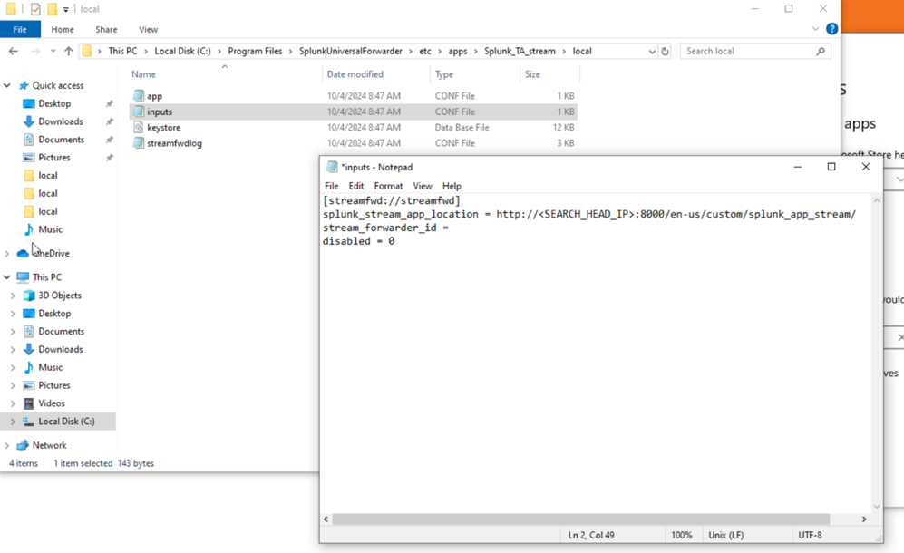
You can remove the stream_forwader_id.

Restart the Splunk UF.

Navigate to $UFHOME\bin and restart with <.\splunk.exe restart>.

You may also need to restart the Splunk Server. You can do this through the Web UI -> Settings -> Sever controls -> Restart.

You should now be receiving data to your Splunk Enterprise Stream App for your Windows host.

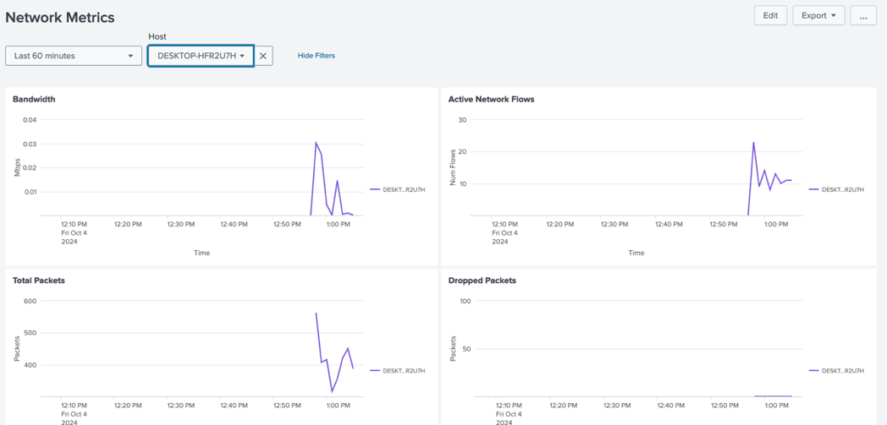

Packet Stream with Stream App

First create a new index under Settings -> Indexes -> New Index

I’ll call mine packet_stream. Ensure Steam App is selected as the application and leave the rest as default.

Under Configuration and Configure Streams you can change the index of where your streams are going. I will leave the Meta Streams on the default index and use the new index packet_stream to test our new UF forwarding stream app data.

Select New Stream -> Packet Stream selecting TCP Protocol naming it tcp_stream select next and define a target. I’ve defined generic targets to capture all TCP data across the host. Any TCP packet where source IP and destination IP are defined. This can be refined later.

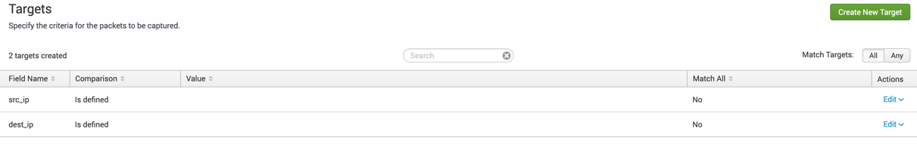

I’ve set the expiration for 1 week. With an index limit of 500gb for one host it is unlikely that this stream will exceed that in one week.

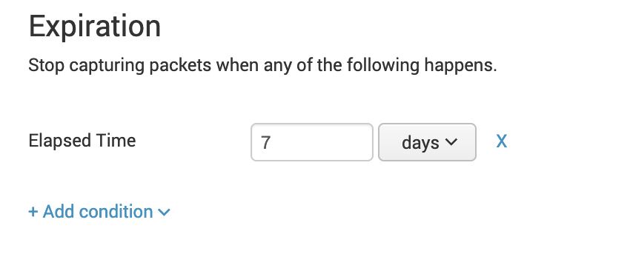
And leave the default fields.

Under index select “packet_stream” and enable the stream. Then added the stream to the default group.

From here we can go to Search and reporting (under apps) and simply search with <index=’packet_stream’>

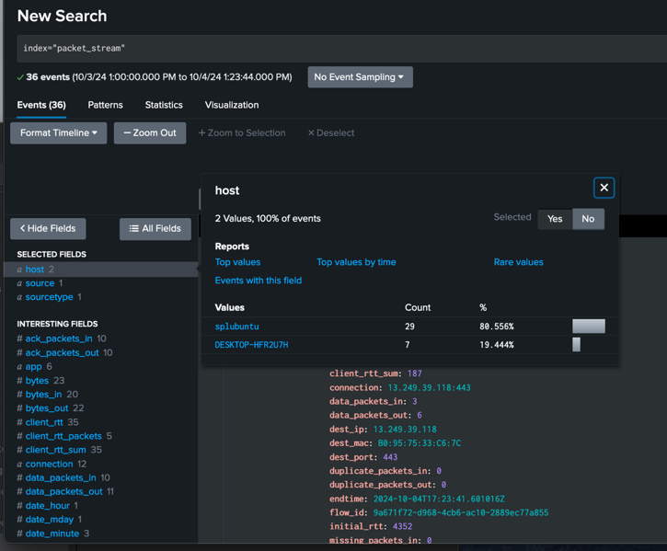

From here we can use Splunk’s search processing language (SPL) to parse and format output the indexed data to explore potential issues identifiable by network traffic events.

