Lab S01
  - Splunk and Sysmon

Prerequisites

Lab S00 For Splunk and a Universal Forwarder

This lab was run using a Ubuntu 22.04 Virtual Machine in VMM and a Windows 10 Virtual Machine. Check links for .iso images.

This should work for nearly any local network environment of the same operating systems, virtual or bare metal, but was tested only on a Synology Network Attached Stored using Synology’s Virtual Machine Manager.

Introduction

What is Sysmon?

Sysmon debut in 2014 and was developed by Mark Russinovich and has contributions by Tomas Garnier, David Magnotti, Mark Cook, Rob Mead, Giulia Biagini, and others at Microsoft. Sysmon is part of the Sysinternals Suite. Sysinternals was originally owned by Russinovich and Bryce Cogswell who created the Sysinternals website, then called NTInternals, to host their system utilities and technical information and was aquired by Microsoft in 2006.

(Google AI)

System Monitor (Sysmon) is a Windows system service and device driver that monitors and logs system activity:

What it does
Sysmon tracks network traffic, code behavior, and file system changes to detect malicious activity. It provides detailed information about system activity, including process creations, network connections, and file creation times.

How it works
Sysmon is installed once and remains resident across system reboots. It adds new Event IDs to Windows systems, which system administrators can use to monitor system processes, network activity, and files.

Why it's useful
Sysmon is a cost-effective way to gain insight into what's happening on a system. It provides a more detailed view of system activity than the Windows security logs.

How it's used
Sysmon is often installed alongside other endpoint defense solutions, such as antivirus or Endpoint Detection and Response (EDR). Sysmon serves as telemetry, while EDR is equipped to detect malicious activities and respond proactively.

Part of what
Sysmon is part of the Sysinternals software package, which is now owned by Microsoft.

Sysmon on Splunk Enterprise on Ubuntu 22.04

In your Splunk Enterprise Web UI go to “Find more Apps”

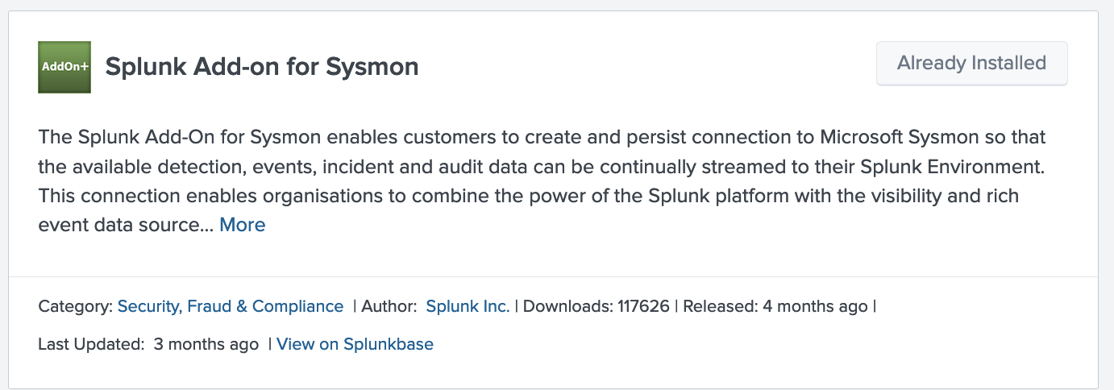

Make Sysmon for Splunk Deployable

After Installation Splunk_TA_microsoft_sysmon was manually copied recursively to the deployment_apps folder. (Note: $SPLUNK_HOME refers to /opt/splunk in the Ubuntu 22.04 environment)

sudo cp -r $SPLUNK_HOME/etc/apps/Splunk_TA_microsoft_sysmon $SPLUNK_HOME/etc/deployment_apps

Create Server Class for Sysmon

In the Web UI -> Go to Settings -> Forwarder Manager -> Server Classes -> New Server Class

Note: Server Class naming convention should follow some best practices. I have mistakenly committed BOTH the index and the server class with the same name. I would encourage you to Rename your server class to something more descriptive, like WinSysmon_Server.

A new server class was made called winsysmon. The app and target client were added to the Server Class. This will distribute the app folder to the Splunk Forwarder Client (or Clients) you have specified in the Server Class.

You can see below the Universal Forwader (UF) Client we added in Lab S00 is found and added to the Server Class with the Sysmon App.

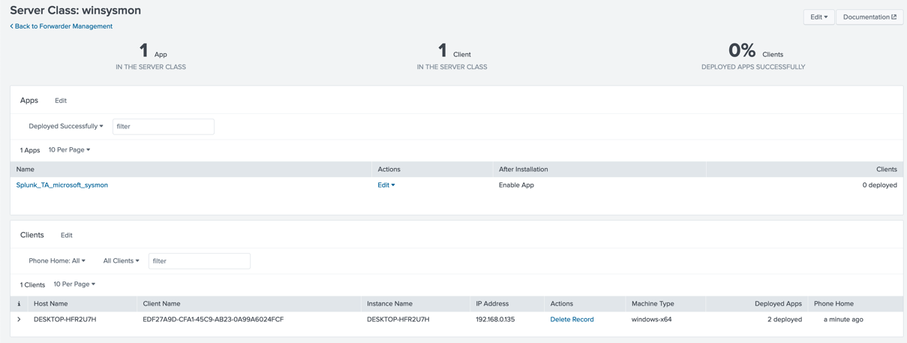

Create Index

In the Web UI -> Go to Setting -> Indexes

New Index

I’ve named mine winsysmon and simply set the app to “search” with the rest as default

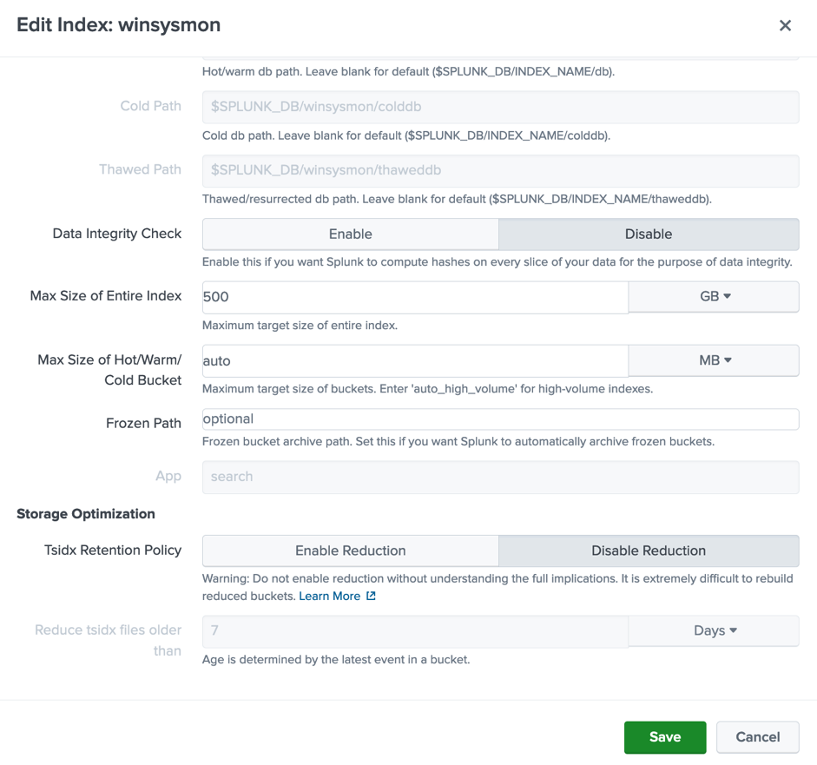

Edit index of Data Input

Through the “Make Sysmon for Splunk Deployable” and “Create Server Class for Sysmon” steps previously new Data Inputs were added to our Forwaded Inputs.

Go to Settings -> Data Inputs and the Forwarded Inputs to see Windows Event Logs now has 2 Inputs.
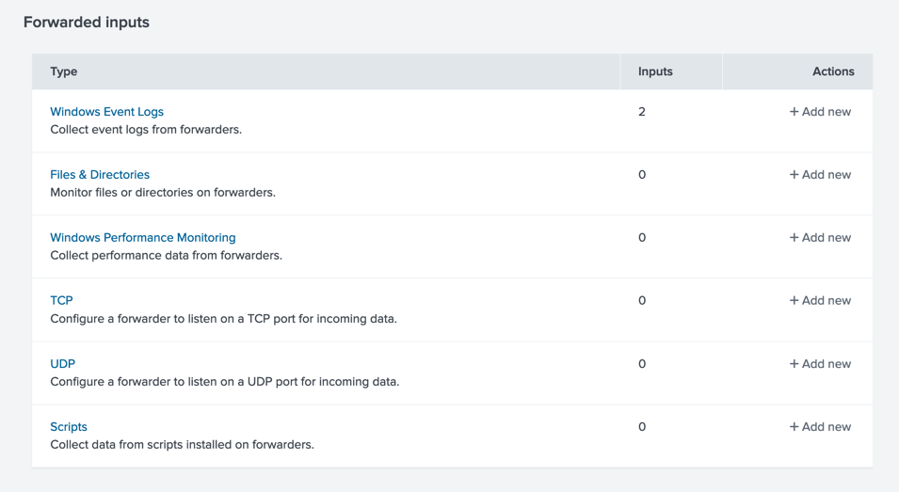

Now we will want to edit these to index to our newly created index “winsysmon”

Under Forwaded Inputs -> Select Windows Event Logs

Select Microsoft-Windows-Sysmon/Operational and change the index to the one you’ve created (“winsysmon”).

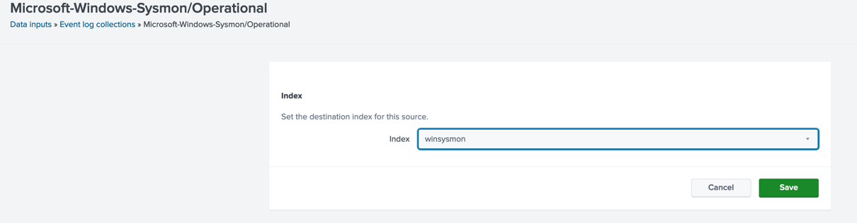

Save and confirm the event log collector is enabled and the index configuration on the previous page by selecting Event log collections in the Path in the top left of the UI panel.

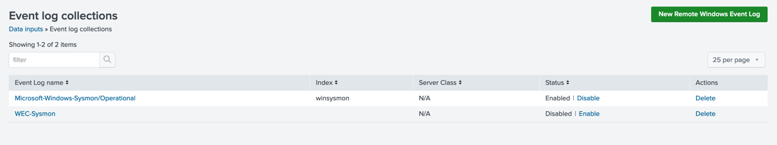
Windows Sysmon Installation on Windows 10 22h2

On the windows client download the Sysmon.zip from Microsoft install using -accepeula -i

Confirm Sysmon Events are begin collected

Open Event Viewer

In the Windows search bar in the bottom left corner input “Run” press enter to open the Run System tool and input “eventvwr.msc” and press OK.

OR Type “Event Viewer” in the Search Bar and press Enter to open Event Viewer

On the left panel, expand the “Applications and Services” folder
Expand “Microsoft”
Expand “Windows”
Head to “Sysmon” and under that and the Operational log

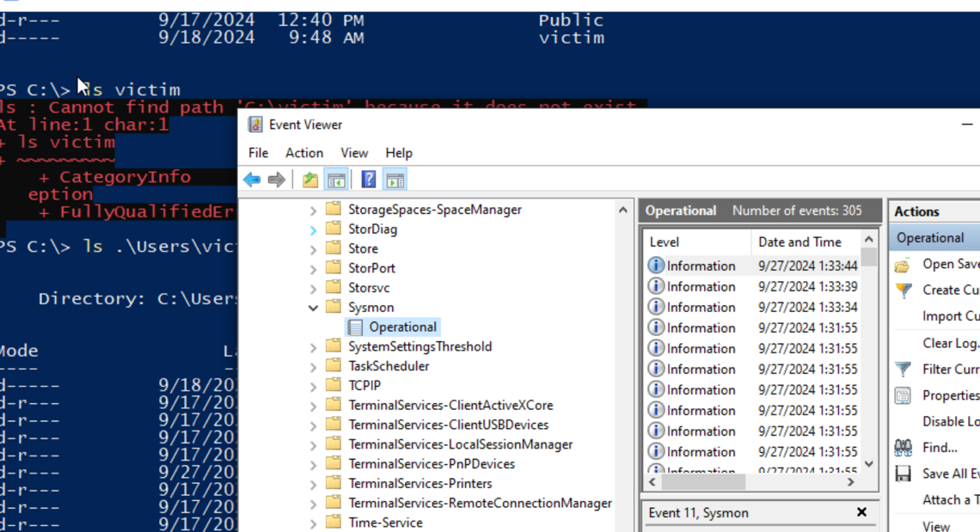

Add Splunk to the Event Log Viewer

Note: The following settings violate the principle of least privilege (NOT FOR PRODUCTION) by adding “Everyone” to the Event Log Viewer group. There should be an NT Serivce/SplunkForwarder User to add to this group. While the user is shown in Task Manager -> Details to be the NT Serivce/SplunkForwarder

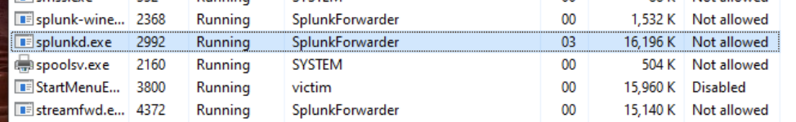

This user isn’t identifiable by lusrmgr.
This is also shown under Windows Services Application:

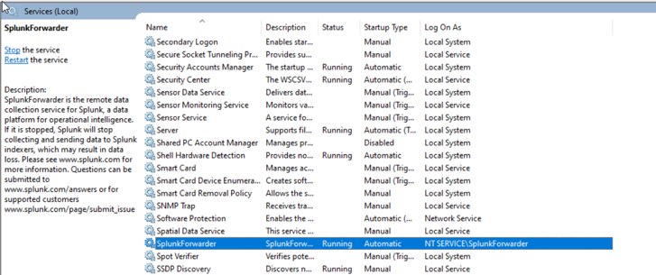

Lets get some Sysmon logs forwarding!

Lusrmgr is suggested for managing groups and is a third party management software found here. Scroll down to download and Download latest version 1.6.3.

From there simply run the executable as administrator.

Add Everyone to Event Log Readers.

For now, I’ve added Everyone to Event Log Readers:

Go to Groups and Event Log Reader and double-click.

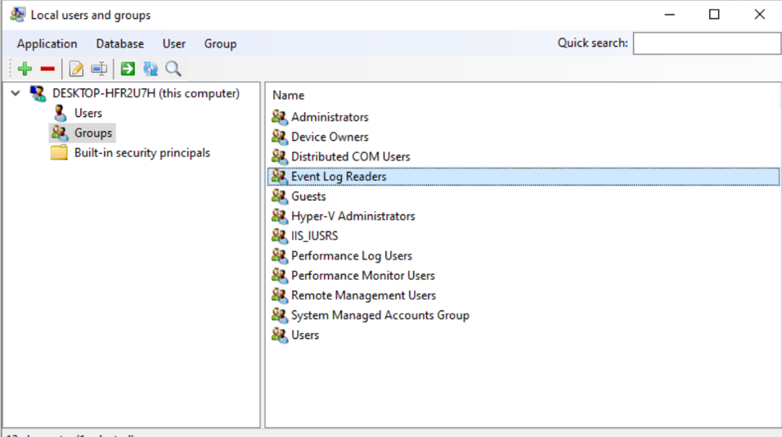

Select the Green Plus (+) and add “everyone” to the group members.

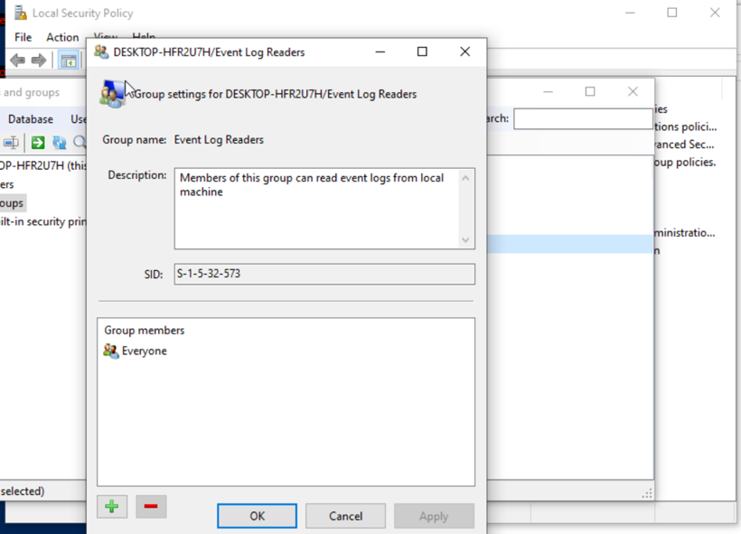
Splunk_TA_windows_sysmon Configuration

Open Notepad and add the following lines:

[WinEventLog://Microsoft-Windows-Sysmon/Operational]
Index=winsysmon
disabled = false
renderXml = true
source = XmlWinEventLog:Microsoft-Windows-Sysmon/Operational

___________________________________________________________

Save this file as inputs.conf to the following path.

$UFHOME/etc/app/Splunk_TA_windows_sysmon/local/input.conf

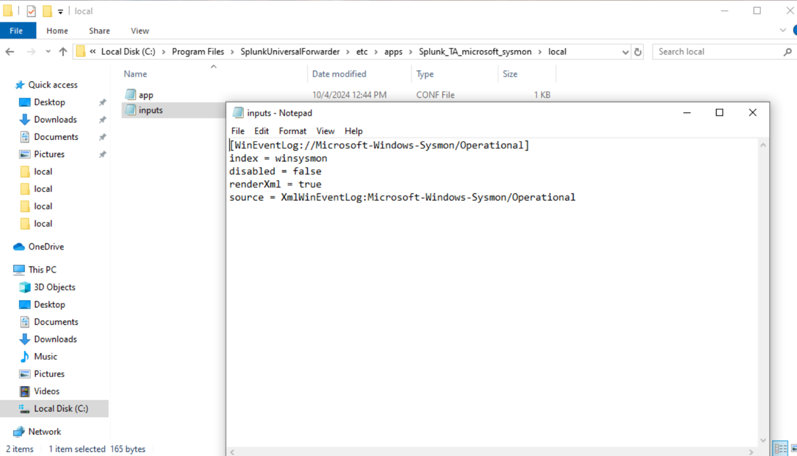
$UFHOME/etc/app/Splunk_TA_windows_sysmon/local/input.conf

Restart your Universal Forwarder.

Confirm Sysmon Logs are populating your winsysmon index back in the Spunk Web UI.

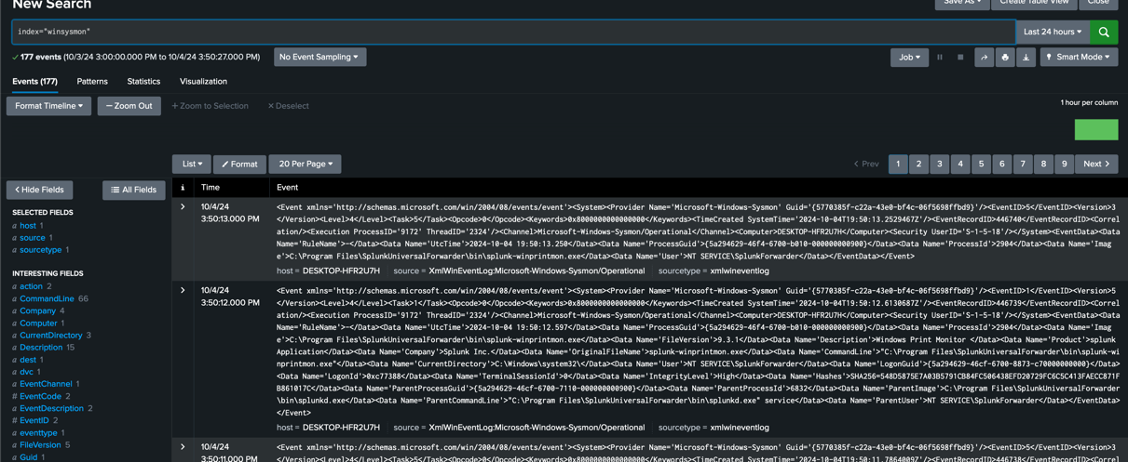

From here we can use Splunk’s search processing language (SPL) to parse and format output the indexed data to explore potential issues identifiable by Sysmon traffic events.

