Lab S02
  - Splunk and Zeek

Prerequisites

Lab S00 for Splunk

This lab was run using a Ubuntu 22.04 Virtual Machine in Virtual Mahine Manager. Check link for .iso image.

Introduction

This walkthrough will only be collecting Zeek Data from the Ubuntu 22.04 Splunk Enterprise. (Future Work Install Zeek/RITA Within WSL2 from here and transport logs via splunk)

What is Zeek? (From Google AI)

Zeek is a free, open-source network security monitoring and analysis tool that can also be used as a network intrusion detection system (NIDS):

Network traffic analysis
Zeek analyzes network traffic to detect anomalies and suspicious signatures. It can also track DNS, HTTP, and FTP activity.

Incident response
Zeek can automatically download suspicious files, send them for analysis, and notify relevant parties. It can also blacklist the source and shut down the device that downloaded the file.

Flexible framework
Zeek provides a flexible framework for in-depth monitoring that allows users to develop custom scripts to identify suspicious activity.

Platform
Zeek can be deployed on-prem, in the cloud, or out-of-band. It can gather metadata and extracted files, and format them for input into any SIEM or XDR.

Zeek was originally called Bro, and was developed by Vern Paxson at Lawrence Berkeley National Lab in 1995. The name was changed to Zeek in 2018 to better reflect the values of the community.

Zeek is considered less beginner-friendly than other tools like Suricata because it requires scripting knowledge for advanced analysis. However, it offers more customization potential.

Zeek App in Splunk Enterprise on Ubuntu 22.04

On the linnux server and natively deployable to *nix platforms. Install TA_for_zeek and Zeek App for Hunting (they can all be installed together before restart) then restart.

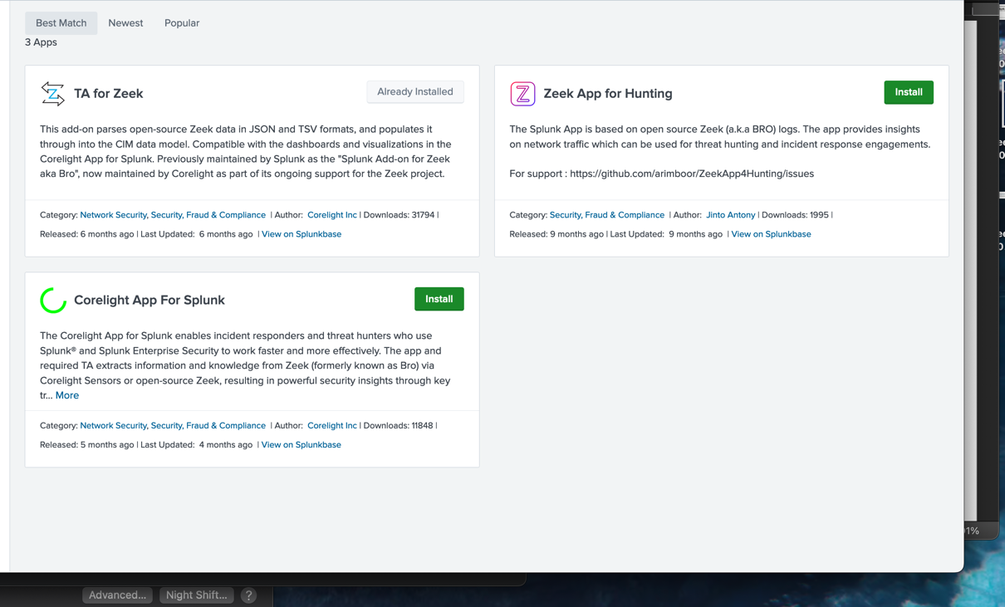

I’ve created a new index for this lab called zeek assigned this index to the Zeek app for Threat Hunting and with default settings.

I’ve installed zeek from here on the Ubuntu 22.04 Splunk Enterprise Server

echo 'deb http://download.opensuse.org/repositories/security:/zeek/xUbuntu_22.04/ /' | sudo tee /etc/apt/sources.list.d/security:zeek.list

curl -fsSL https://download.opensuse.org/repositories/security:zeek/xUbuntu_22.04/Release.key | gpg --dearmor | sudo tee /etc/apt/trusted.gpg.d/security_zeek.gpg > /dev/null

sudo apt update && sudo apt install zeek

Select No Configuration for the Mail server

Add to path

echo "PATH=$PATH:/opt/zeek/bin" >> ~/.bashrc
source ~/.bashrc

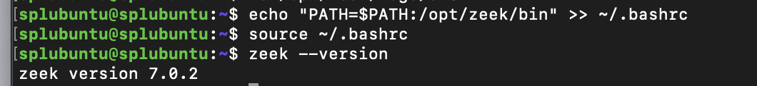

Edit /opt/zeek/etc/node.cfg with the following:

sudo nano /opt/zeek/etc/node.cfg

[zeek]
type=standalone
host=localhost
interface=eno2

Change eno2 to your interface.

If you don’t know your interface you can find it in the command line of Ubuntu with

ip address

Edit /opt/zeek/share/zeek/site/local.zeek to enable the json logging format:
Add this to the bottom of local.zeek with:

sudo nano /opt/zeek/share/zeek/site/local.zeek

# Output to JSON
@load policy/tuning/json-logs.zeek

Then run:

sudo /opt/zeek/bin/zeekctl install

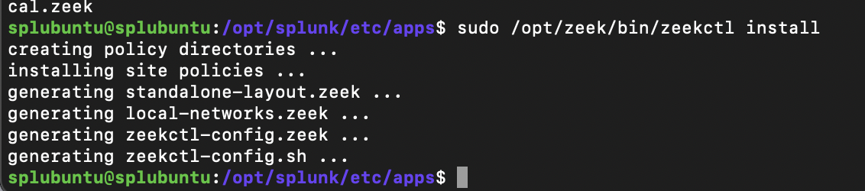

sudo /opt/zeek/bin/zeekctl start

Configure Zeek to start automatically on boot by creating the file /etc/systemd/system/zeek.service with the following contents:

sudo nano /etc/systemd/system/zeek.service

[Unit]
Description=Zeek Collection Server
After=network.target

[Service]
ExecStartPre=/opt/zeek/bin/zeekctl check
ExecStart=/opt/zeek/bin/zeekctl start
ExecReload=/opt/zeek/bin/zeekctl reload
ExecStop=/opt/zeek/bin/zeekctl stop
Restart=on-failure
RestartPreventExitStatus=255
Type=forking

[Install]
WantedBy=multi-user.target
Alias=zeek.service

Before starting as a service be sure to stop the previous run with

sudo /opt/zeek/bin/zeekctl stop

Start the service:
sudo systemctl start zeek

Establish a task every 5 minutes

sudo crontab -e

# Select your editor. I use nano.

Then…

# Add the following line
*/5 * * * * /opt/zeek/bin/zeekctl cron

On Cron (From Wikipedia)

“The cron command-line utility is a job scheduler on Unix-like operating systems. Users who set up and maintain software environments use cron to schedule jobs, also known as cron jobs, to run periodically at fixed times, dates, or intervals”

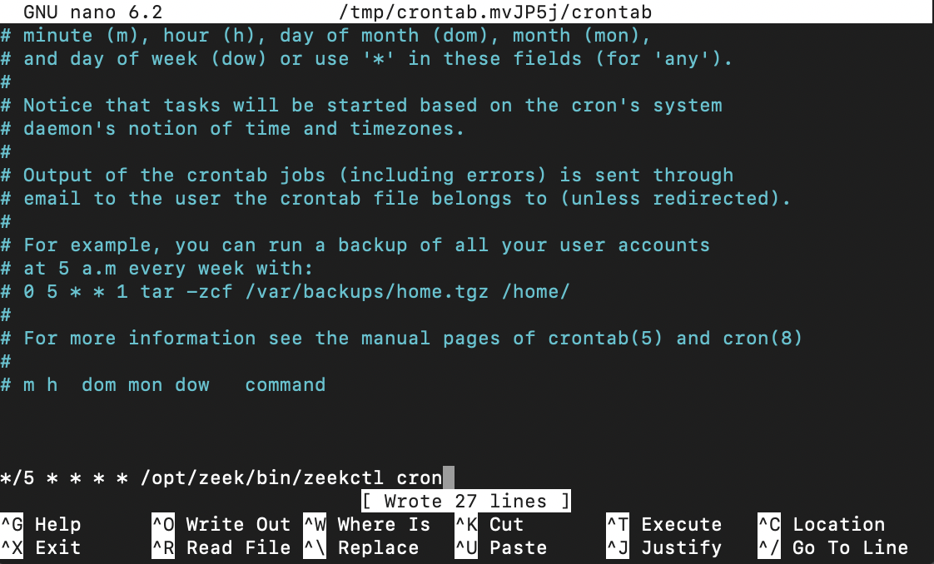

You can confirm what zeek is logging by checking the $ZEEK_HOME/spool/zeek folder

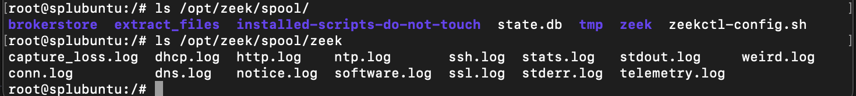

Add the following lines to /opt/splunk/etc/system/local/inputs.conf (you may need to make a inputs.conf file) (sudo nano will do this)

sudo nano /opt/splunk/etc/system/local/inputs.conf

[default]
host = zeek-01

[monitor:///opt/zeek/logs/current/conn.log]
_TCP_ROUTING = *
index = zeek
source = bro.conn.log
sourcetype = bro:json

[monitor:///opt/zeek/logs/current/dns.log]
_TCP_ROUTING = *
index = zeek
source = bro.dns.log
sourcetype = bro:json

[monitor:///opt/zeek/logs/current/software.log]
_TCP_ROUTING = *
index = zeek
source = bro.software.log
sourcetype = bro:json

[monitor:///opt/zeek/logs/current/smtp.log]
_TCP_ROUTING = *
index = zeek
source = bro.smtp.log
sourcetype = bro:json

[monitor:///opt/zeek/logs/current/ssl.log]
_TCP_ROUTING = *
index = zeek
source = bro.ssl.log
sourcetype = bro:json

[monitor:///opt/zeek/logs/current/ssh.log]
_TCP_ROUTING = *
index = zeek
source = bro.ssh.log
sourcetype = bro:json

[monitor:///opt/zeek/logs/current/x509.log]
_TCP_ROUTING = *
index = zeek
source = bro.x509.log
sourcetype = bro:json

[monitor:///opt/zeek/logs/current/ftp.log]
_TCP_ROUTING = *
index = zeek
source = bro.ftp.log
sourcetype = bro:json

[monitor:///opt/zeek/logs/current/http.log]
_TCP_ROUTING = *
index = zeek
source = bro.http.log
sourcetype = bro:json

[monitor:///opt/zeek/logs/current/rdp.log]
_TCP_ROUTING = *
index = zeek
source = bro.rdp.log
sourcetype = bro:json

[monitor:///opt/zeek/logs/current/smb_files.log]
_TCP_ROUTING = *
index = zeek
source = bro.smb_files.log
sourcetype = bro:json

[monitor:///opt/zeek/logs/current/smb_mapping.log]
_TCP_ROUTING = *
index = zeek
source = bro.smb_mapping.log
sourcetype = bro:json

[monitor:///opt/zeek/logs/current/snmp.log]
_TCP_ROUTING = *
index = zeek
source = bro.snmp.log
sourcetype = bro:json

[monitor:///opt/zeek/logs/current/sip.log]
_TCP_ROUTING = *
index = zeek
source = bro.sip.log
sourcetype = bro:json

[monitor:///opt/zeek/logs/current/files.log]
_TCP_ROUTING = *
index = zeek
source = bro.files.log
sourcetype = bro:json

Restart your splunk server.

In Search and Report check the index zeek

index=”zeek”

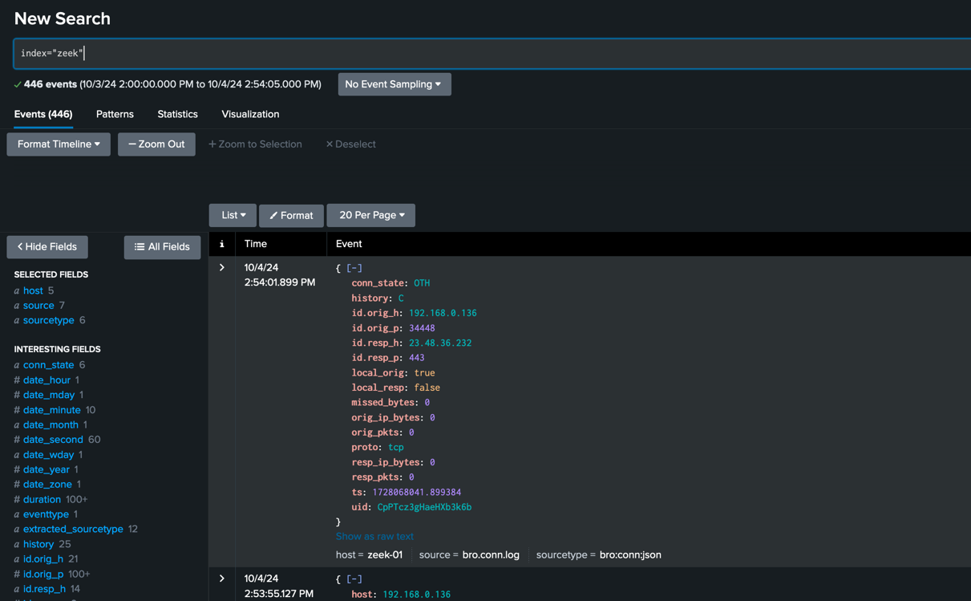

And in the Zeek App for Threat Hunting Under Apps. Confirm data is coming in.
