Lab S03
  - Splunk and OSquery

Prerequisites

Lab S00 For Splunk and a Universal Forwarder

This lab was run using a Ubuntu 22.04 Virtual Machine in VMM and a Windows 10 Virtual Machine. Check links for .iso images.

Objective

The objective of this lab is to install and forward logs from an OSquery service running on Windows 10.

Introduction

What is OSquery? (Google AI)

Osquery is an open-source tool that lets you monitor and analyze devices on your network by using SQL-like queries:

How it works:
Osquery exposes an operating system as a relational database, allowing you to ask questions about it using SQL commands.

What it can do:
Osquery can gather a wide range of data, including running processes, user logins, open network connections, and more. You can use this data to perform IT operations, security monitoring, and compliance activities.

What it supports:
Osquery is cross-platform and supports multiple operating systems, including macOS, Linux, FreeBSD, and Windows. It can also monitor Docker containers.

How it's useful:
Osquery can help you understand your infrastructure and simplify the process of security and admin tasks. It's easy to use and doesn't require custom scripts for each platform.

Who created it:
Mike Arpaia created Osquery in 2014 at Facebook.

For the installation of OSquery we will be using the OSquery docs installation using Chocolatey.

What is Chocolatey? (Google AI)

Chocolatey is a command-line package manager and installer for Windows software that automates the process of downloading and installing software. It's built on top of the NuGet command line and Windows PowerShell.

With Chocolatey, you can: Select what software to install, download and install the software, update software, and uninstall multiple pieces of software at once.

Chocolatey is an open-source project created by Rob Reynolds in 2011. It's similar to apt-get, but for Windows.

Chocolatey for Business (C4B) offers additional tools for package creation, internalization, audit, synchronization, and more. C4B can help reduce downtime, accelerate deployment, and provide organizational-level software visibility.

References:

https://osquery.readthedocs.io/en/stable/installation/install-windows/

https://chocolatey.org/install

https://community.chocolatey.org/packages/osquery/

Chocolatey Install

From https://chocolatey.org/install the Powershell command was run Setting ExecutionPolicy to Bypass as given in the command and shown below..

In an administrative powershell run the command provided by the chocolatey install instructions.

If you are not certain if you’re in an administrative powershell run the following commands:

$currentPrincipal = New-Object Security.Principal.WindowsPrincipal([Security.Principal.WindowsIdentity]::GetCurrent())

Then:

$currentPrincipal.IsInRole([Security.Principal.WindowsBuiltInRole]::Administrator)

Which will return True if the currentPrinciple IsInRole of Administrator.

From the chocolatey installation guide install use the commands provided:

Set-ExecutionPolicy Bypass -Scope Process -Force; [System.Net.ServicePointManager]::SecurityProtocol = [System.Net.ServicePointManager]::SecurityProtocol -bor 3072; iex ((New-Object System.Net.WebClient).DownloadString('https://community.chocolatey.org/install.ps1'))

Type choco –version to check installation was successful.

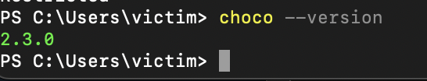

OSquery Install

choco install osquery

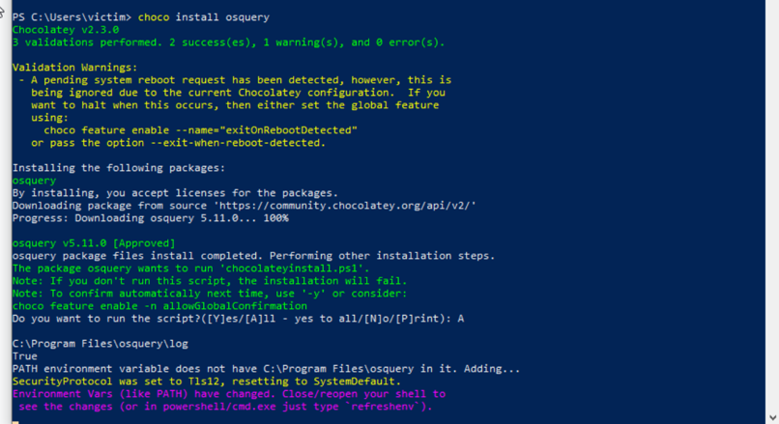

Confirm installation in C:\Program Files

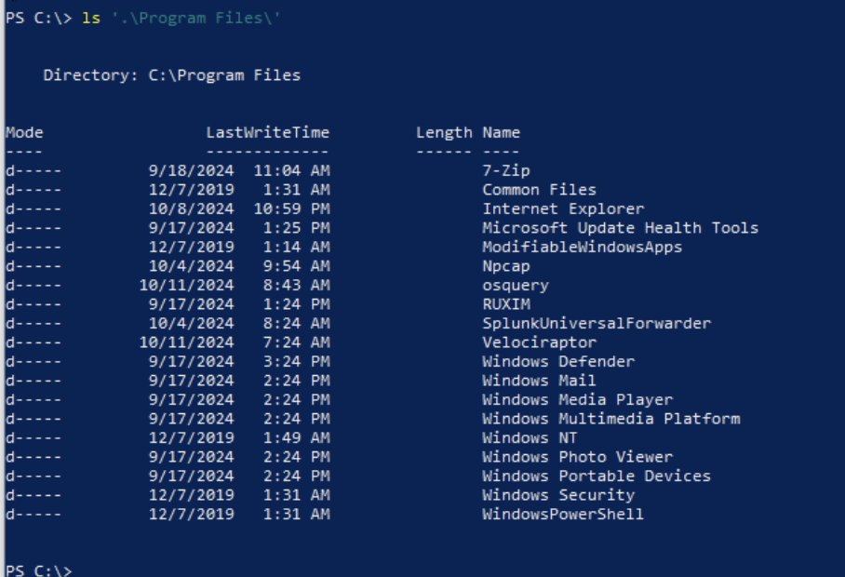

From C:\Program Files\osquery install using the osqueryd.exe –install command.

Then start the service.

This was done without a configuration file telling OSquery what to monitor, so you will not be accumulating results just yet.

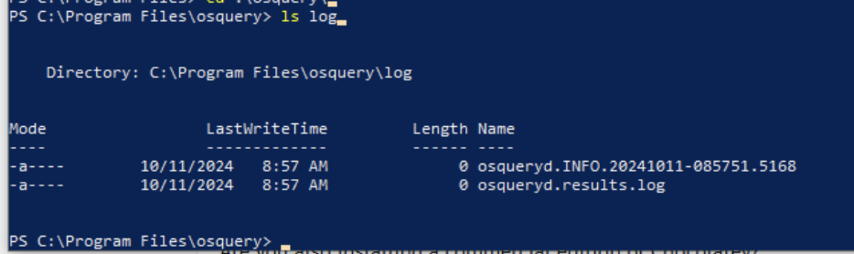

OSquery Configuration Palantir Technologies

You can download the github configuration directory to your localmachine through github or you can maintain a directory on your search head desktop to secure copy like shown in the videos. This step can be a bit confusing but check the final results of where the .conf and .flags files and the packs directory should go.

I have chosen to use the configurations from Palantir Technologies that were detailed in this blog:

https://blog.palantir.com/osquery-across-the-enterprise-3c3c9d13ec55

Please read through this blog to better understand the configuration files used in this lab.

Palantir Technologies is a US-based software company that specializes in big data analytics and data fusion platforms. Palantir's products are used by governments, intelligence agencies, and other organizations to analyze data and make decisions.

The Palantir osquery configuration master repo can be found here:
https://github.com/palantir/osquery-configuration/tree/master

To do this for Windows 10 we will need to get copies of the .conf and .flags files found here as well as the packs folder found here. However, if you look at the bottom of the osquery.conf file you will find that not all packs configurations are present (particularly unwanted-chrome-extensions and windows-attacks) as these are part of the osquery original suite. These can be found in the osquery repo found here.

Now this file structure can be a bit confusing so let me show what I have:
osquery.conf, osquery.flags, and osquery_no_tls.flags found here in the root of the osquery application Directory in Program Files

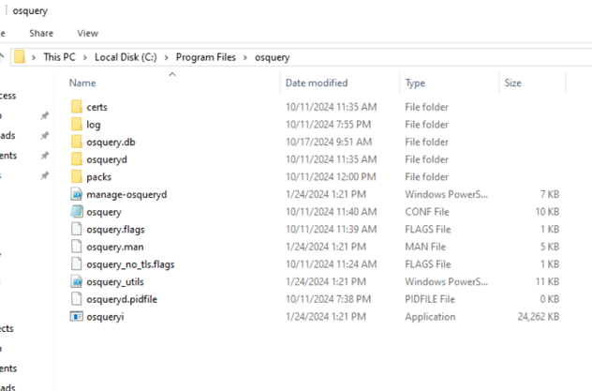
And in a directory called packs I’ve added the seven configuration files (found here and here) needed by the osquery.confs.

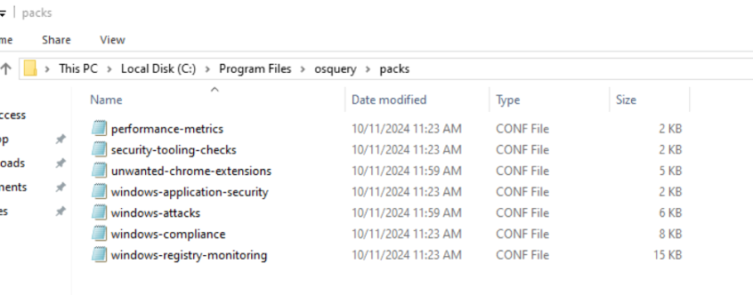

In the blog however they are collecting windows events through another means and have windows events disabled. So let’s enable windows event logging in our configuration.

After downloading the repository from https://github.com/palantir/osquery-configuration/tree/master, in an administrator PowerShell navigate to the downloads folder and the Classic -> Endpoints -> Windows

From here run:

cp -Force ./*.conf ‘C:/Program Files/osquery’
cp -Force ./*.flags ‘C:/Program Files/osquery’

To copy and overwrite and existing example file that may contain.

Navigate back to the parent directory (Classic -> Endpoints) and run

cp -Recurse ./pack ‘C:/Program Files/osquery’

Now that the desired file structure is in place lets make a couple of changes.

Enable Windows Event Logging

In the Palantir configuration suggestions, they are collecting windows event logs through another means and windows events are disabled in the osquery.flags file. Let’s reenable windows events.

Open Notepad as administrator

Navigate to C:/Program Files/osquery/osquery.flags

Open the file osquery.flags and change disable_events to false

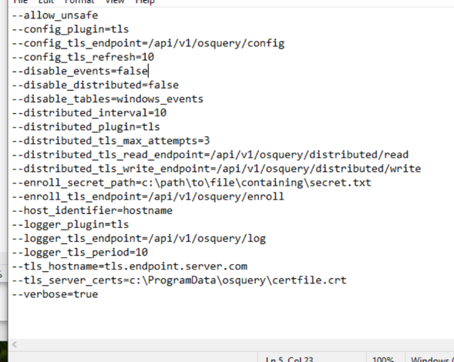

In and administrator powershell run Restart-Service osqueryd and confirm you are accumulating content in the osqeuryd.results.log file.

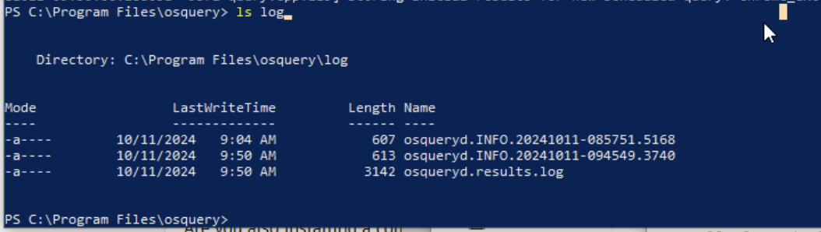

Install OSquery on Linux

wget the latest version from https://osquery.io/downloads/official

Copy the Link for the Debian selecting your underlying architecture (arm/x86_64)

At the time of this lab the latest version was 5.13.1.

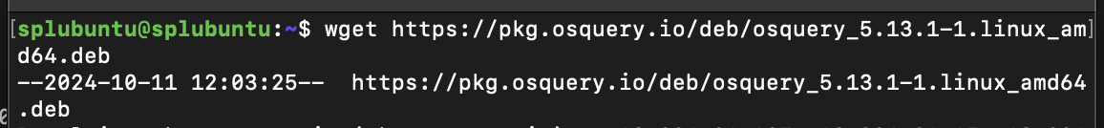

I’ve moved the .deb file for better organization on my server.

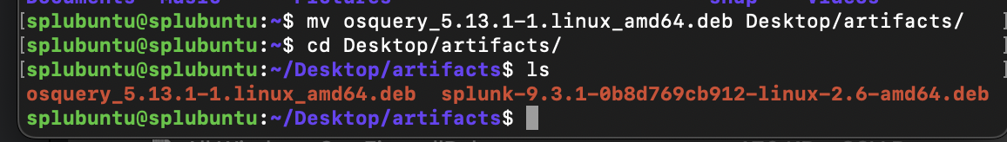

Install with:

sudo dpkg -i osquery_5.13.1-1.linux_amd64.deb

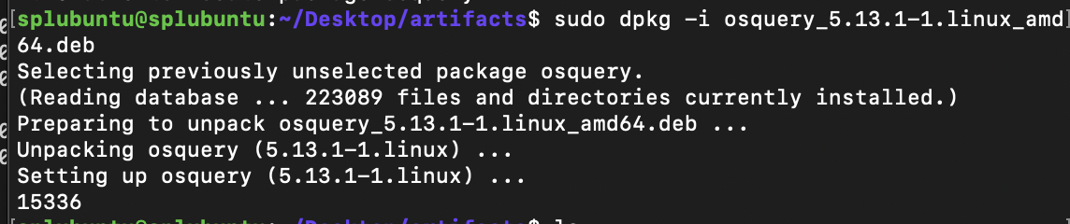’

Test the installation was successful with <osqueryi>

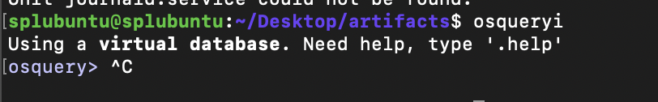

For our server we will just use the default configuration file for now by changing the osquery.example.conf found in the /opt/osquery directory to osquery.conf

sudo cp /opt/osquery/share/osquery/osquery.example.conf /etc/osquery/osquery.conf

Start osquery as a service with:

sudo systemctl start osqueryd

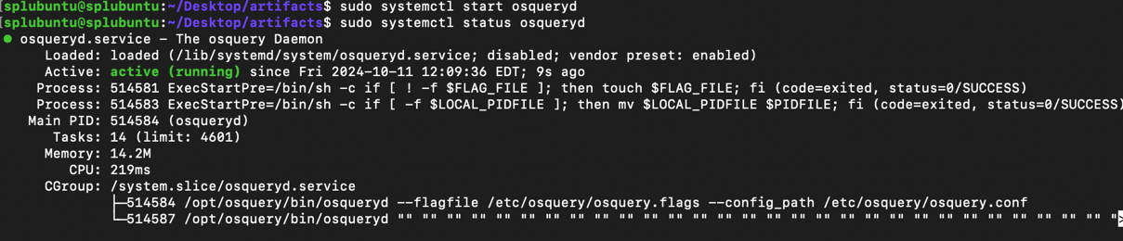

And confirm logs are being generated by checking the /var/log/osquery directory

Update OSquery with Palantir Labs configuration for Linux

You can download the github configuration directory to your local machine through github or you can maintain a directory on your search head desktop to secure copy like shown in the videos. This step can be a bit confusing but check the final results of where the .conf and .flags files and the packs directory should go.

Now that we tested that the service can be started you will want to edit that osquery.conf in /etc/osquery with the configuration from Palantir Labs.

sudo rm /etc/osquery/osquery.conf

You can download the repo and cp the desired file or copy and paste the raw text into the nano command line editor. Having a copy of the configuration can be useful but let’s just copy the raw text for this example.

sudo nano /etc/osquery/osquery.conf

And populated the file with the config file here
https://raw.githubusercontent.com/palantir/osquery-configuration/refs/heads/master/Classic/Servers/Linux/osquery.conf

OR use cp from the Palantir Labs osquery configuration.

From the Classic/Servers/Linux/ of the Palantir Labs osquery configuration copy the contents to /opt/osquery/share/osquery.

Remove packs and the example.conf from current contents

sudo rm /opt/osquery/share/osquery/osquery.example.conf
sudo rm -r /opt/osquery/share/osquery/packs

Copy the .flags and .conf files with the wildcard *

sudo cp osquery-configuration/Classic/Servers/Linux/osquery.* /opt/osquery/share/osquery/

Recursive copy the packs

sudo cp -r osquery-configuration/Classic/Servers/Linux/packs /opt/osquery/share/osquery/

Then run

sudo systemctl restart osqueryd

Confirm status with

sudo systemctl status osqueryd

See the initial results storing in the bottom lines

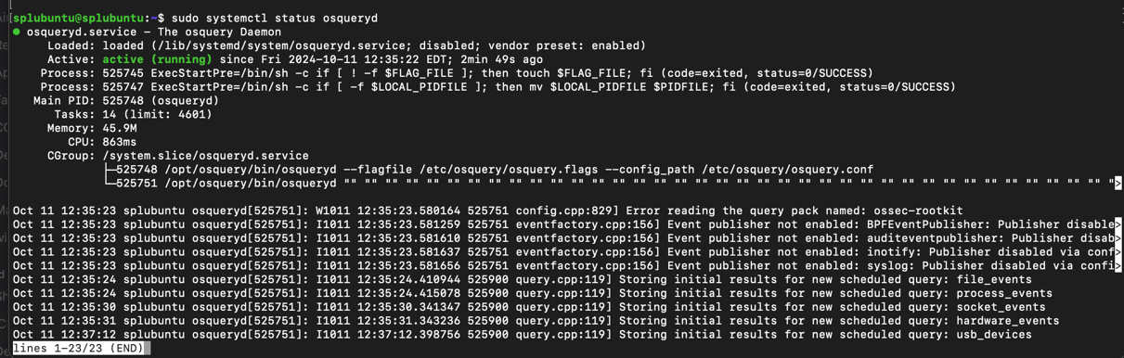

And the logs in /var/log/osquery

Install the Splunk add-on for osquery

This addon is archived but is still accessible for use:

From Splunk:

While archived content is removed from default Splunkbase search results, the content is still available if a search specifically specifies the archived area of Splunkbase. The content is categorized as Unsupported on Splunkbase and you won't have access to leads from archived content.

https://splunkbase.splunk.com/app/4402

Login using your splunk account and download the .tgz

In the Splunk Web UI go to Apps -> Manage Apps -> install from file

Select the .tgz

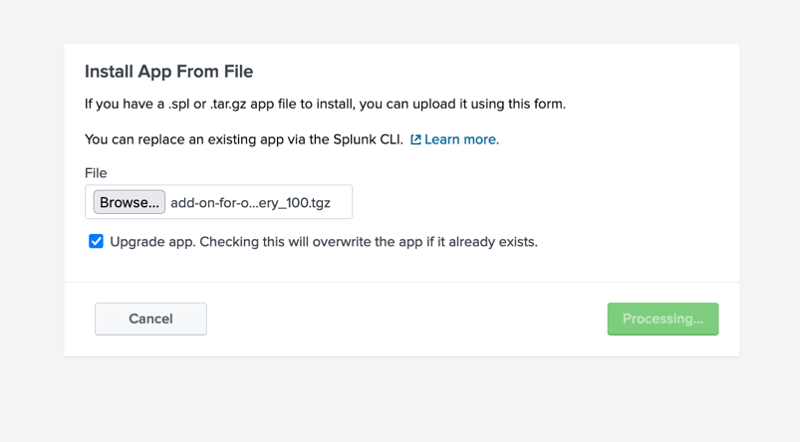

And Restart the server.

Confirm installation by checking the $SPLUNKHOME/etc/apps/ directory.

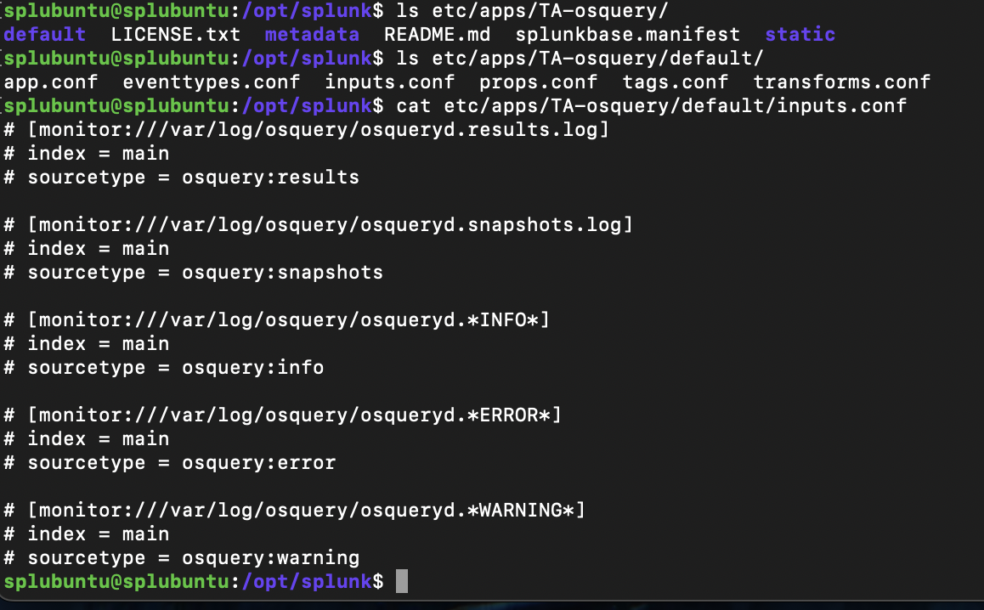

In the Splunk Web UI create new index called osquery

From https://osquery.readthedocs.io/en/stable/deployment/log-aggregation/

Edit the inputs.conf file in the TA-osquery -> defaults folder

[monitor:///var/log/osquery/osqueryd.results.log]
index = main
sourcetype = osquery:results

[monitor:///var/log/osquery/osqueryd.*INFO*]
index = main
sourcetype = osquery:info

[monitor:///var/log/osquery/osqueryd.*ERROR*]
index = main
sourcetype = osquery:error

[monitor:///var/log/osquery/osqueryd.*WARNING*]
index = main
sourcetype = osquery:warning

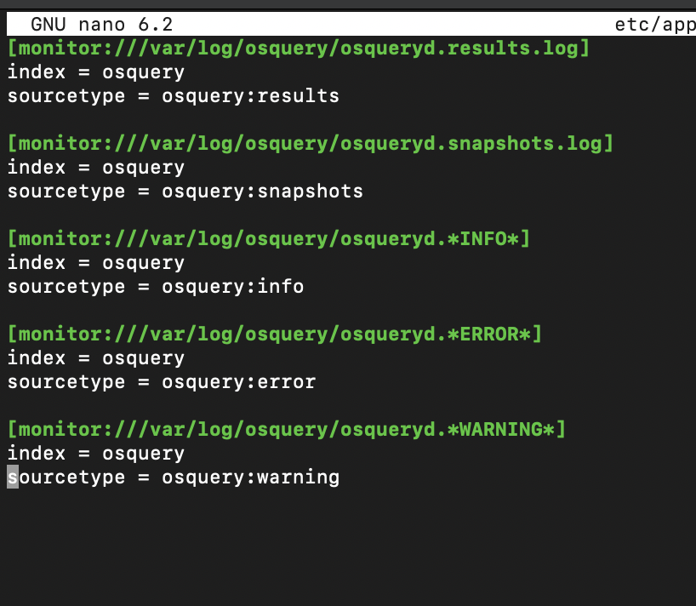

Write out the file

RESTART your server.

Confirm that data is in coming from your server.

NOTE: Ignore the host name. When configuring zeek this host name was changed.

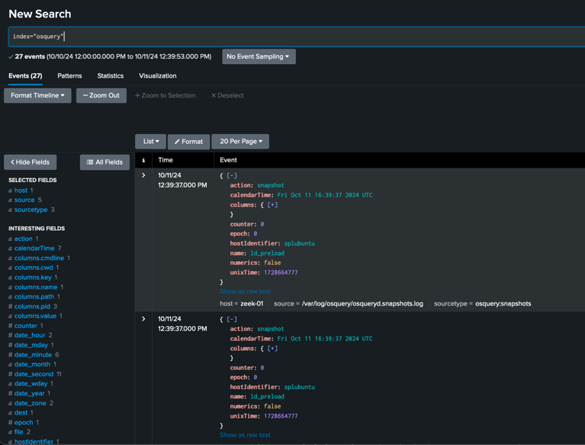

Deploy add-on for osquery to Forwarders

Now that we have data coming in from our Splunk Server Lets do the same for our Windows Forwarder.

Make the app deployable
Manually copy recursively from $SPLUNKHOME/etc/apps to $SPLUNKHOME/etc/deployment-apps

Create a new Server Class
Create a new Server Class under Forwarder Manager and Add the target Client and the TA-OSquery App

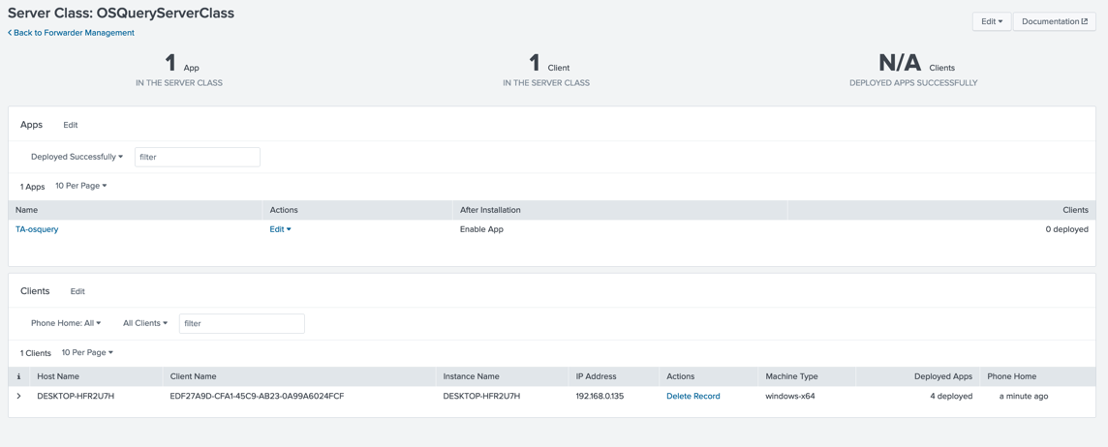

Now that the app is deployed, we will want to change where the app is monitoring for inputs to match the log location on the windows client

Open an administrator Notepad navigate to C:\Program Files\SplunkUniversalForwarder\etc\apps\TA-osquery\default

Open inputs.conf to the Notepad editor

In another Administrative Notepad copy the default\inputs.conf chaning the path to match the windows osquery log locations as shown below using Find and Replace.
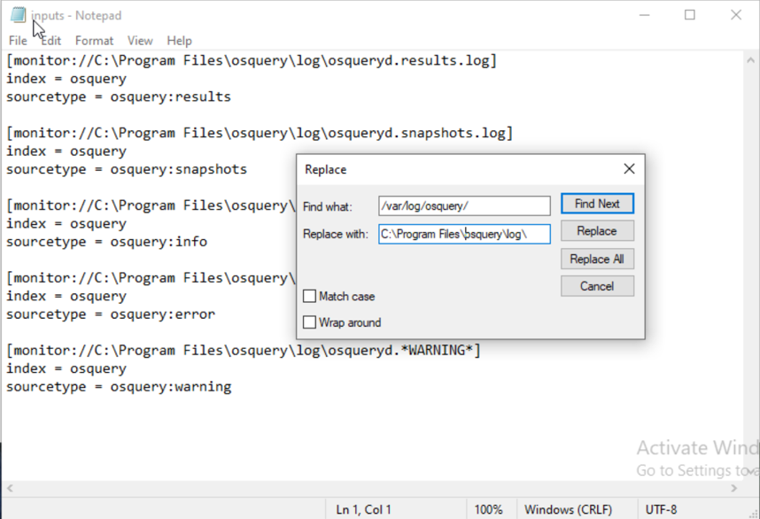
Save to ALL FILES as inputs.conf to TA-osquery-> local ->inputs.conf

The local folder has precedence in Splunk so the changes you make here will be implemented in your UF configuration.

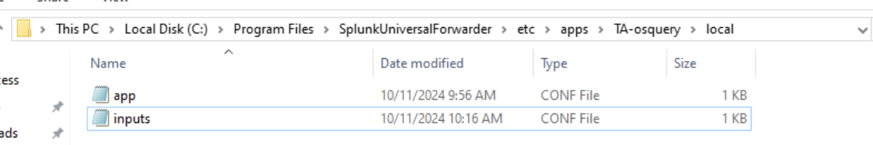

Confirm OSquery data from your Windows UF are populating the osquery index in the Splunk Search Head.

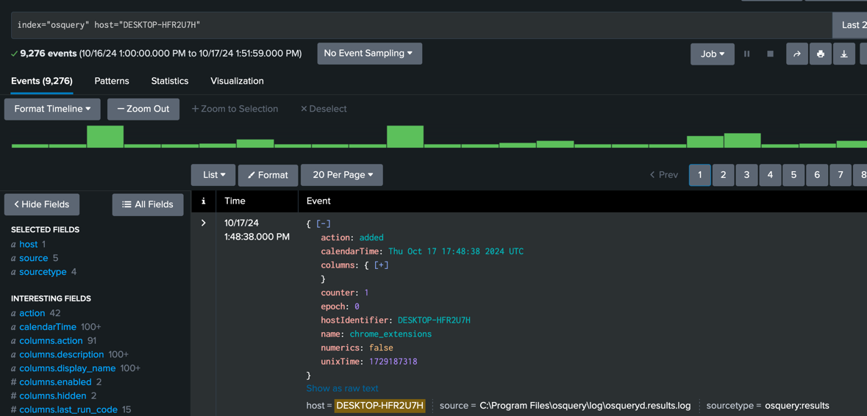

Using the following search you can extract raw OSquery data:

index="osquery" host="DESKTOP-HFR2U7H" sourcetype="osquery:results" | table _time, _raw

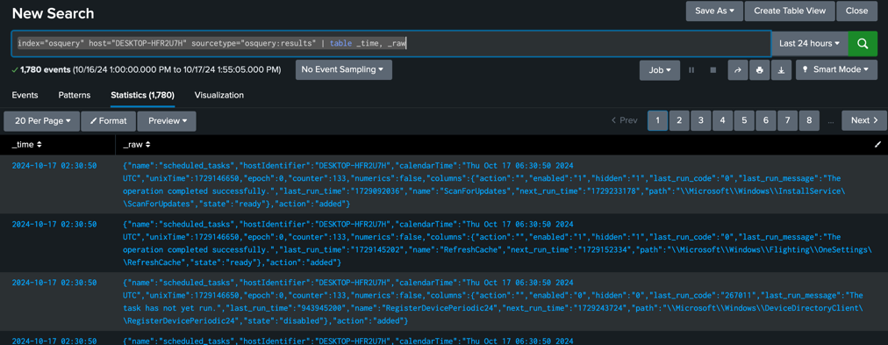

If you would like to find only OSqueries from running services run

index="osquery" host="DESKTOP-HFR2U7H" sourcetype="osquery:results" | table _time, _raw, field | spath | search name="services"

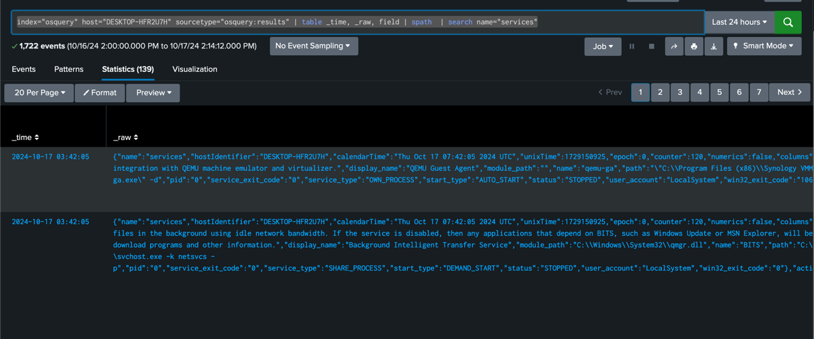

And let’s say you wanted to search the services for a particular service. Let’s check on Synology’s Guest agent that will have the name qemu-ga.

index="osquery" host="DESKTOP-HFR2U7H" sourcetype="osquery:results" | table _time, _raw | spath | search name="services" | search columns.name="qemu-ga"

