Lab S04.B
  - Setting up a Postfix Mail Transfer Agent (MTA) on the localhost

Prerequisites

Lab S00 For Splunk and S04 for data ingest

This lab was run using a Ubuntu 22.04 Virtual Machine in VMM

Introduction

Installation of Postfix

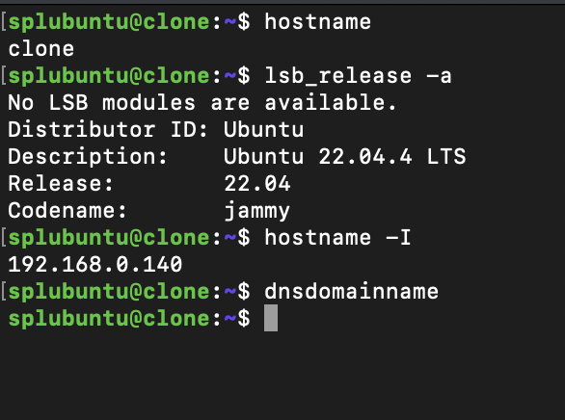

So let’s set up a FQDN for a .lan

Nano /etc/hosts

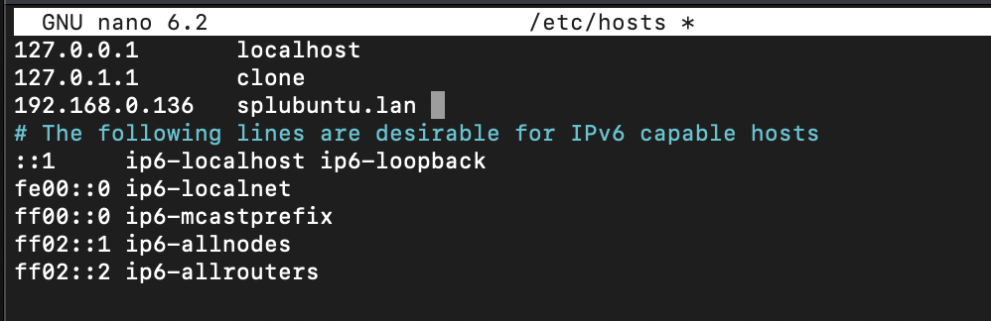

Nano /etc/hostname

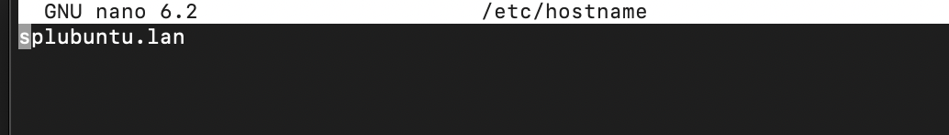

Verify with dnsdomainname

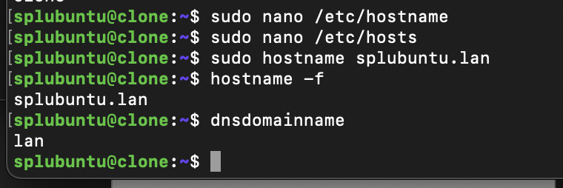

This will change you @<hostname> as well

Lets test the initial out of the box settings of postfix

First open port 25

Ufw allow 25

Sudo apt update

Then sudo apt install postfix and sudo apt install mailutils

(If postfix is already installed or you need to remove and purge postfix at any point use sudo touch /etc/init.d/postfix; sudo apt-get purge postfix then reinstall postfix)

When installing for the first time you will be taken to the command line GUI.
First installation will only have two options to choose from.

I’ve chosen to install as an Internet server with the splubuntu.lan mail server address, We will reconfigure the postfix server later to be able to handle SMTP_AUTH support for Splunk mail agents.

Create a user for incoming email.
sudo useradd -m -s /bin/bash incoming
Set a password for this user.
sudo passwd incoming

chmod ug+rw adds read and write permissions for the user and group

sudo touch /var/mail/splubuntu
sudo chmod ug+rw /var/mail/splubuntu

sudo touch /var/mail/incoming
sudo chmod ug+rw /var/mail/incoming

sudo chown splubuntu /var/mail/ splubuntu
sudo chown incoming /var/mail/incoming

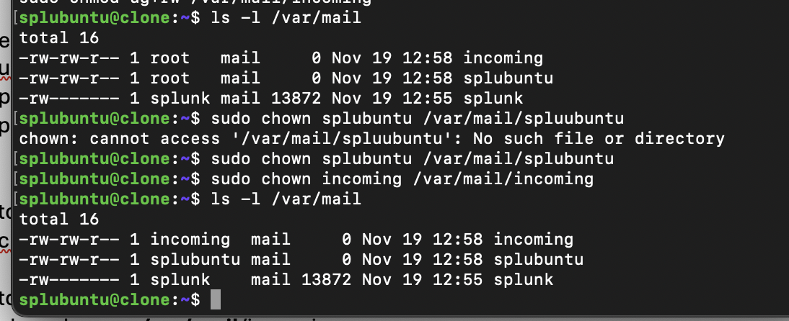

Check the status of postfix

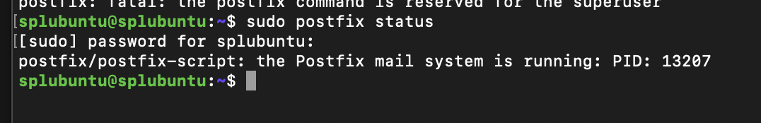

If its not running you can use sudo postfix start

Then connect to the mail server port using telnet localhost 25

Then use ehlo localhost (extended hello) to initiate a connection with the mail server

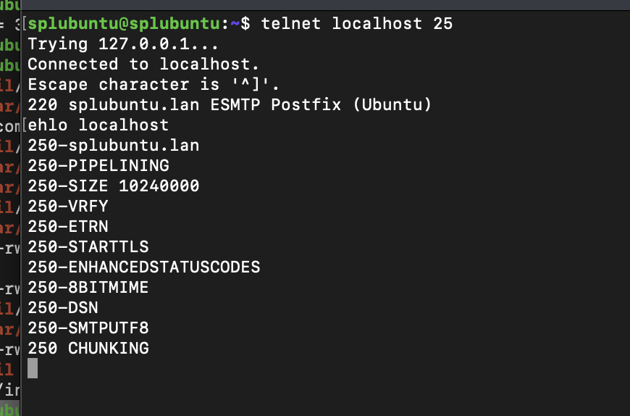

Then lets test our mailing system so far

mail from: splubuntu@splubuntu.lan
rcpt to: incoming@splubuntu.lan
data
Subject: Re: Some issue

Sounds good!

warning: unknown smtpd restriction: "‘permit_sasl_authenticated"

Copy and paste may return some Error as shown below but follow this data input with a literal period (“.”) and confirm that the message is queued

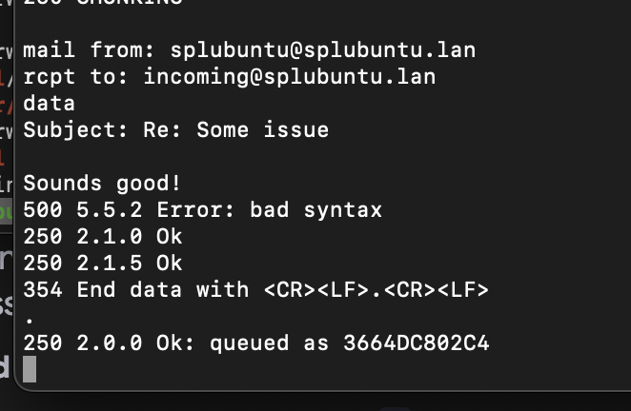

You can quit the postfix telner interaction by typing quit

You can first check the queue to see if the mail may have been held up in the queue.
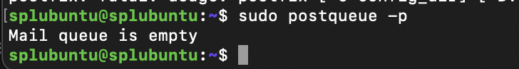

Now lets check the mailbox of our new user incoming (you can do this by using the mailutil command “mail” as shown below.

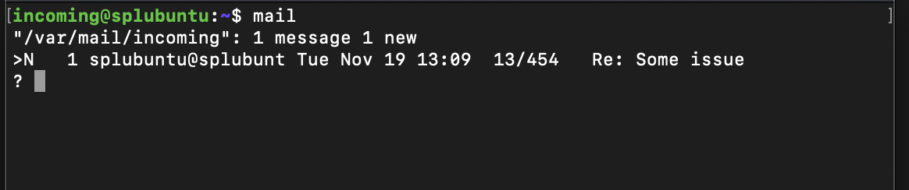

Great! Now to the next step.

We will want to have SMTP AUTH enabled and TLS as a requirement from the Splunk mail agent! The steps I’ve followed are based off of the steps found here https://ubuntu.com/server/docs/install-and-configure-postfix

If you run into any issues check the /var/log/mail.log file! This will be useful when debugging.

You’ll need to know the following
- The <Domain> for which you’ll accept email (we’ll use splubuntu.lan in our example)
- The network and class range of your mail server (we’ll use 192.168.0.0/24)
- The username (we’re using splubuntu)
- Type of mailbox format (mbox is the default, but we’ll use the alternative, /var/mail)

Run:

sudo dpkg-reconfigure postfix

In the command line interface select the following

- Internet Site
- splubuntu.lan
- splubuntu
- splubuntu.lan, localhost.lan, localhost
- No
- 127.0.0.0/8 \[::ffff:127.0.0.0\]/104 \[::1\]/128 192.168.0.0/24
- 0
- +
- all

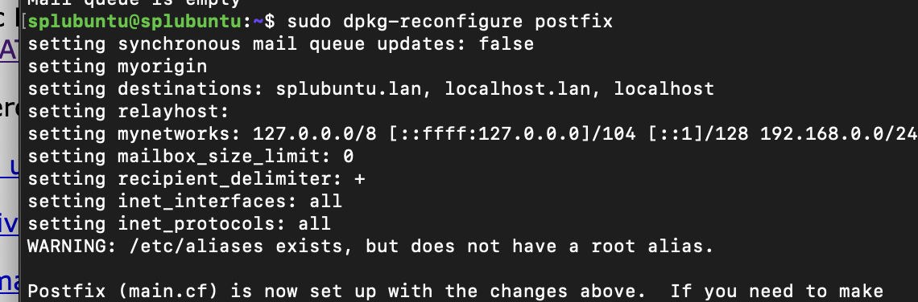

Configure the hom_mailbox with

sudo postconf -e 'home_mailbox = /var/mail/'

SMTP-AUTH Postfix Conf

Run the following to enable SMTP-AUTH using SASL with Dovecot SASL

sudo postconf -e 'smtpd_sasl_type = dovecot'
sudo postconf -e 'smtpd_sasl_path = private/auth'
sudo postconf -e 'smtpd_sasl_local_domain ='
sudo postconf -e 'smtpd_sasl_security_options = noanonymous,noplaintext'
sudo postconf -e 'smtpd_sasl_tls_security_options = noanonymous'
sudo postconf -e 'broken_sasl_auth_clients = yes'
sudo postconf -e 'smtpd_sasl_auth_enable = yes'
sudo postconf -e 'smtpd_recipient_restrictions = permit_sasl_authenticated,permit_mynetworks,reject_unauth_destination'

CERTIFICATES

As stated in (https://ubuntu.com/server/docs/certificates)

This section will cover generating a key both with or without a passphrase. The non-passphrase key will then be used to generate a certificate that can be used with various service daemons.
Warning:
Running your secure service without a passphrase is convenient because you will not need to enter the passphrase every time you start your secure service. But it is insecure – a compromise of the key means a compromise of the server as well.

Make a folder for your certs (“They will be moved later”)

mkdir certs

cd certs

Run:

openssl genrsa -des3 -out server.key 2048

SET A PASSWORD AND DON’T LOSE THIS PASSWORD

Run:
openssl rsa -in server.key -out server.key.insecure
mv server.key server.key.secure
mv server.key.insecure server.key

The insecure key is now named server.key, and you can use this file to generate the CSR without a passphrase.

Run
openssl req -new -key server.key -out server.csr

This will prompt for information to be incorporated into the certificate request.

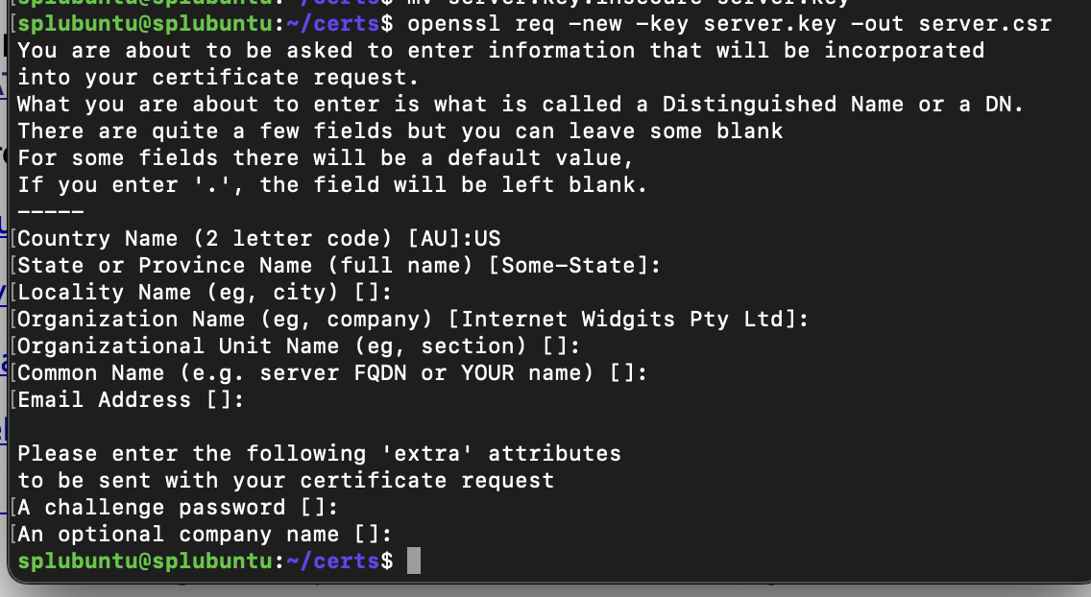

This only option I have added here was Country Name as US. The rest are left black. The CSR contains information about the entity or individual requesting the certificate, such as their organization's name, website domain name, locality, and public key.

Creating a self signed certificate

Run

openssl x509 -req -days 365 -in server.csr -signkey server.key -out server.crt

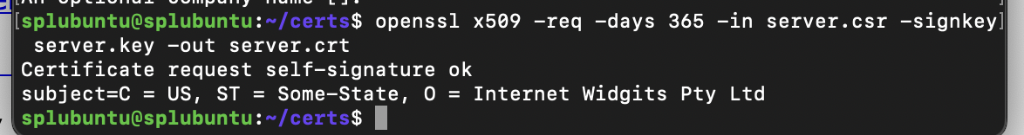

Now we will be situating our keys in the /etc/ssl folder to later reference in out postfix configuration.
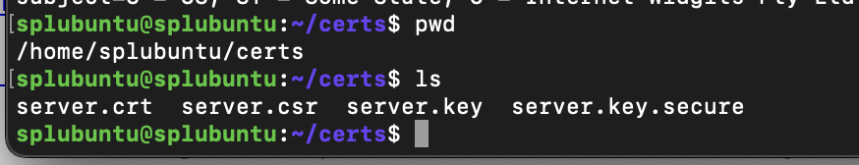

For more information about the certificate process and the CA check out the link provided above for the source of this certificate generation process

sudo cp server.crt /etc/ssl/certs
sudo cp server.key /etc/ssl/private

sudo mkdir /etc/ssl/CA
sudo mkdir /etc/ssl/newcerts

“The CA needs a few additional files to operate; one to keep track of the last serial number used by the CA (each certificate must have a unique serial number), and another file to record which certificates have been issued:”

sudo sh -c "echo '01' > /etc/ssl/CA/serial"
sudo touch /etc/ssl/CA/index.txt

Edit /etc/ssl/openssl.cnf in the [ CA_default ] section

sudo nano /etc/ssl/openssl.cnf

dir = /etc/ssl # Where everything is kept
database = $dir/CA/index.txt # database index file.
certificate = $dir/certs/cacert.pem # The CA certificate
serial = $dir/CA/serial # The current serial number
private_key = $dir/private/cakey.pem# The private key

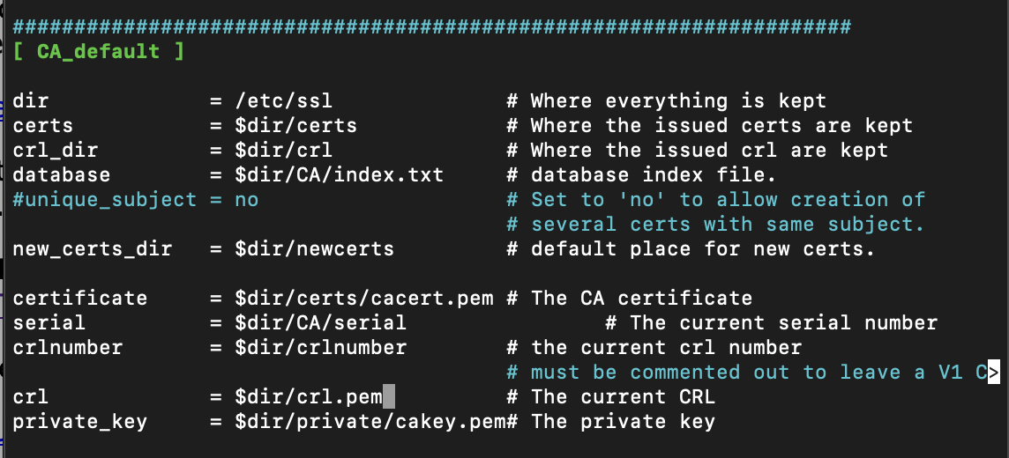

create the self-signed root certificate: (This will need a passphrase)

openssl req -new -x509 -extensions v3_ca -keyout cakey.pem -out cacert.pem -days 3650

install the root certificate and key:

sudo mv cakey.pem /etc/ssl/private/
sudo mv cacert.pem /etc/ssl/certs/

generate a certificate signed by the CA: (Use the passphrase from the self-signed root certificate)

sudo openssl ca -in server.csr -config /etc/ssl/openssl.cnf

You will receive an error for “The commonName field needed to be supplied and was missing”

sudo nano /etc/ssl/openssl.cnf

Find with ctrl + w and search for commonName

Change this attribute to “optional”

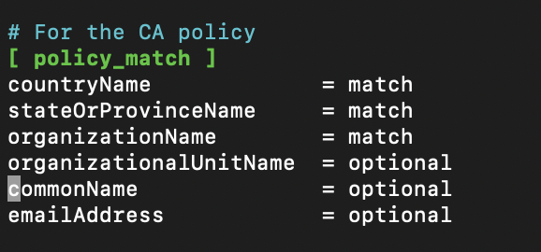

generate a certificate signed by the CA: (Use the passphrase from the self-signed root certificate)

sudo openssl ca -in server.csr -config /etc/ssl/openssl.cnf

enter y to sign and y to commit

There should be a new file
/etc/ssl/newcerts/01.pem

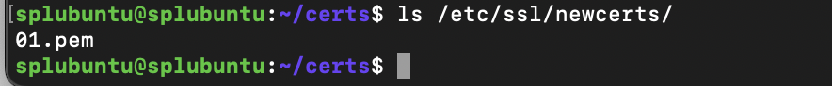

Great! Now lets get back to configuring postfix for TLS

TLS in postfix

This is using the same file paths as before:

sudo postconf -e 'smtp_tls_security_level = may'
sudo postconf -e 'smtpd_tls_security_level = may'
sudo postconf -e 'smtp_tls_note_starttls_offer = yes'
sudo postconf -e 'smtpd_tls_key_file = /etc/ssl/private/server.key'
sudo postconf -e 'smtpd_tls_cert_file = /etc/ssl/certs/server.crt'
sudo postconf -e 'smtpd_tls_loglevel = 1'
sudo postconf -e 'smtpd_tls_received_header = yes'

Be sure this matches your hostname:

sudo postconf -e 'myhostname = splubuntu.lan'

Since we are using our own CA enter:

sudo postconf -e 'smtpd_tls_CAfile = /etc/ssl/certs/cacert.pem'

These changes will be applied to /etc/postfix/main.cf

Set up SASL Authentication

sudo apt install dovecot-core

edit /etc/dovecot/conf.d/10-master.conf

sudo nano /etc/dovecot/conf.d/10-master.conf

service auth {
# auth_socket_path points to this userdb socket by default. It's typically
# used by dovecot-lda, doveadm, possibly imap process, etc. Its default
# permissions make it readable only by root, but you may need to relax these
# permissions. Users that have access to this socket are able to get a list
# of all usernames and get results of everyone's userdb lookups.
unix_listener auth-userdb {
#mode = 0600
#user =
#group =
}

# Postfix smtp-auth
unix_listener /var/spool/postfix/private/auth {
mode = 0660
user = postfix
group = postfix
}
}

Edit /etc/dovecot/conf.d/10-auth.conf

auth_mechanisms = plain login

There is one last change that is not mentioned in the references for this walk through.

Edit /etc/postfix/main.cf

Change smtpd_sasl_security_options = noanonymous,noplaintext

To smtpd_sasl_security_options = noanonymous

This is from the dovecot configuration using “plain login”. This configuration is not as secure as it could be, but it will work for our purposes sending mail from splunk to our local mail server.

Be sure to restart both services!

sudo systemctl restart postfix.service
sudo systemctl restart dovecot.service

Any errors can be checked with /var/log/mail.log or journalctl -xeu <service>.service

TEST

If you can telenet into your mail server as before and send another test email you should be good to go!

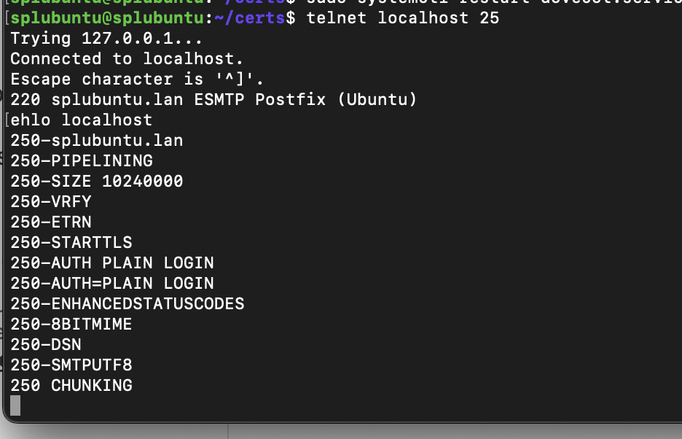

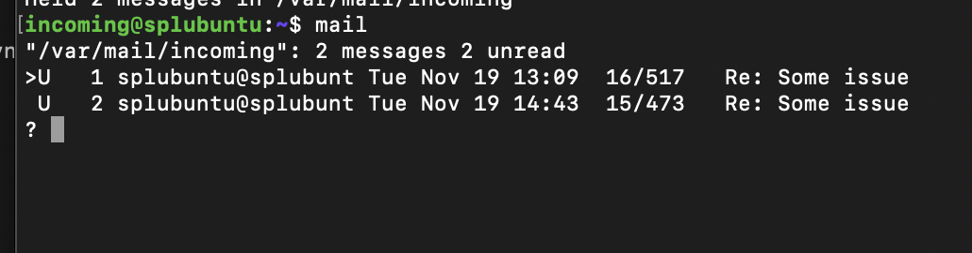

Alerts emailed

Lets set up an alert on one of the suspicious events that we’d uncovered in S-04!

In email settings change to your mail host name you’ve created with the username and password of your linux user:

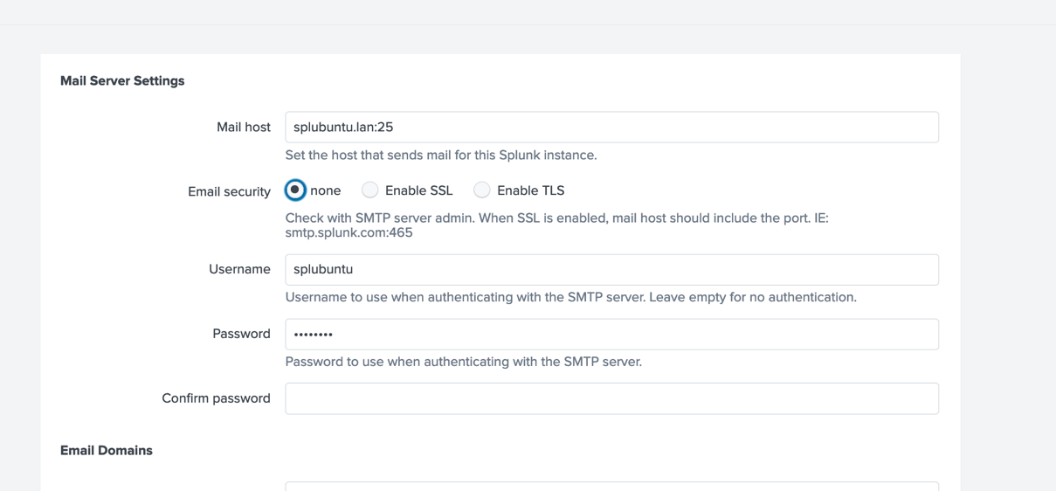

There are certain commands that we’ve identified that we can construct into a simple

This will check for the use of esentutl to create …
index = test2 CommandLine="*esentutl.exe /y /vss*"

This will check for in installation of pypykatz….
index = test2 CommandLine="*install pypykatz*"

This will check for the saving of register info

index = test2 CommandLine="*reg save*"

Among other interesting points, like where the AtmoicRed Team was run, we could create a number of rule surrounding this one Tactic T1003.02.

Lets create an alert for the volume shadow copy but lets be a bit more specific and include only the commands that might include the use of SAM. From this we can begin to realize that we can monitor for a list of potential targets that may be packaged for extraction using esenutl.

In your splunk Search& Reporting

index = test2 CommandLine="*esentutl.exe /y /vss*" *SAM*

Save As Alert

Since this is historical data well want to run this alert on all time.

Alert Type schedules. Run on Cro schedules. ON all time, And cron time to run every minute( to speed up the test) use https://www.uptimia.com/cron-expression-generator to make a cron expression to run every minute. Trigger when the number of results is equal to one and for each result add the actions to add to triggered alerts and send an email. To the recipiecnt add the incoming user from earlier incoming@splubuntu.lan select save.
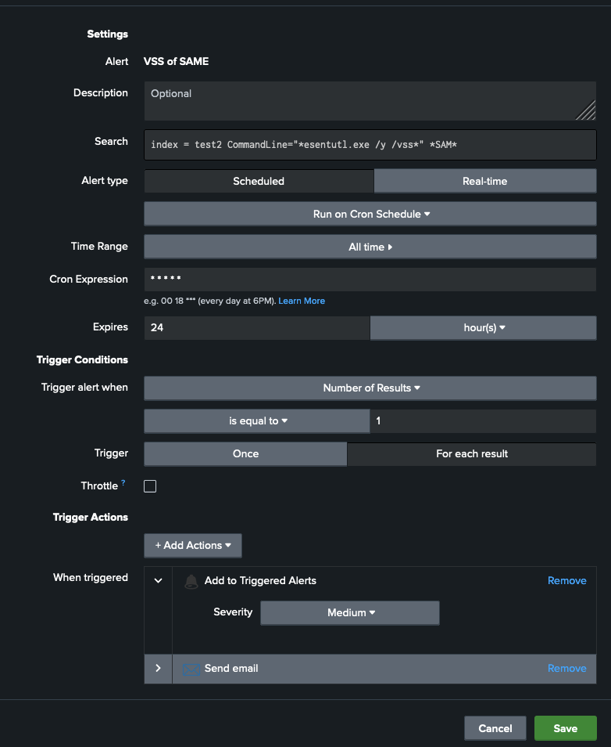

Under settings search alerts and go to search, reports, and alerts which will give you a better view of alerts you’ve created

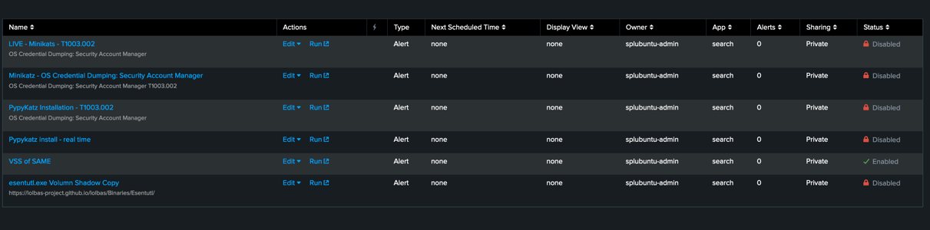

Once your alert has triggered:

Check the email of incoming:

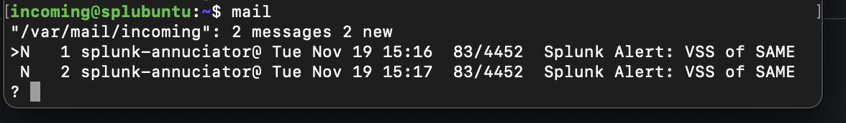

You can use enter to scroll.
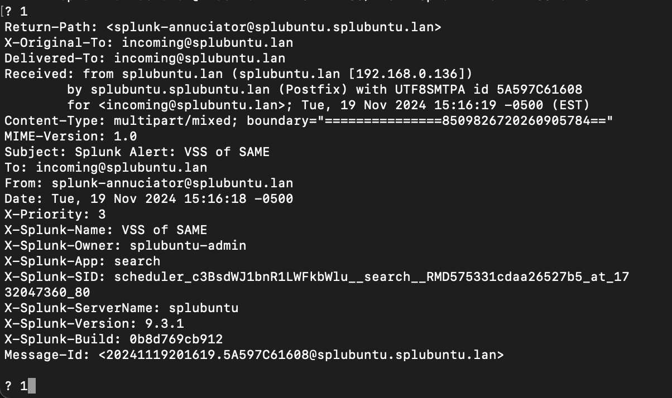

This could be a way for an organization to manage triggered alerts separately and bring in their own automation mechanisms for IR&R.

Thanks for joining! See you next time!

