Lab S06
PX4, MAVLink, and Airsim Software-In-The-Loop data to Splunk
Prerequisites

LabS05

- Introduction

Lab Description

For this lab we will be setting up, testing, and collecting telemetry and status data from a Software-In-The-Loop quadcopter in AirSim. This drone will be receiving control commands through an information flow that simulates MAVLink commands send to a PX4 controller that sends motor outputs to AirSim such as is found in real-world scenarios.

The objective of this lab is to introduce participants to the open-source PX4 firmware for flight control

MAVLink is a hybrid publish-subscribe and point-to-point model that commonly used in UAV communications. In a publish-subscribe model, the data sources (sensors or autopilot systems) broadcast messages to all connected resources, such as ground stations or onboard computers, enabling simultaneous processing by all subscribed clients (i.e. position monitoring/analysis and automated navigation). The point-to-point model in MAVLink sends commands (COMMAND_LONG) or requests(PARAM_REQUEST_LIST) directly to a target system, and replies (COMMAND_ACK or PARAM_VALUE) are returned directly to the sender. This model design enables lightweight and efficient data dissemination and targeted control simultaneously.

MAVSDK will be our server and our python API interface to communicate with the simulated PX4 flight controller. This process will bridge MAVSDK python and PX4 using MAVLink by handling the translation of python command input to low-level MAVLink communication with the simulated PX4.

The PX4 firmware is a complete open-source flight control system that runs on drones and other systems. While it is primarily an autopilot firmware its features are still utilized during manual flight, which we will be working through today. In our simulation, motor outputs are received by PX4 via MAVVLink command from a python navigation program and the firmware calculates the necessary motor outputs and sends these values to the actuators. Actuators are devices that function by “acting” on their environment for a designed purpose, in this case, the simulated actuators are servomotors (or servos). These servomotors are comprised of multiple actuators/sensors, the motor, gearbox to amplify torque, and a position sensor. The PX4 firmware will fuse data from multiple sensors to perform state estimation on position, velocity, attitude (attitude is aircraft orientation). PX4 uses control loops to maintain desired pitch, roll, and yaw angles of attitude and fuses sensor data like accelerometers and gyroscopes to monitor and prevent instability or drift. PX4 includes middleware components for managing communication between the flight stack, sensors, and actuators as well as features for safety and redundancy that can be configured that we will not go into here.

Tasks

3.1 Download PX4 Firmware to a Linux machine, or WSL in windows

3.1.1 Walkthrough WSL installation

Windows Subsystem for Linux (WSL) is a compatibility layer provided by Microsoft that enables the functionality of a linux environment in Windows without the need a for a virtual machine or to dual-boot. Particularly WSL 2 introduces a real Linux kernel in sight of a light weight Hyper-V virtual machine. This is going to be useful when running the PX4 firmware simulation as it only runs in Linux. Additionally, PX4 firmware is currently supported up to Ubuntu 22.04 so we will need to install that distribution.

To install WSL2 Ubuntu 22.04 open a PowerShell terminal and enter:

wsl --list --online
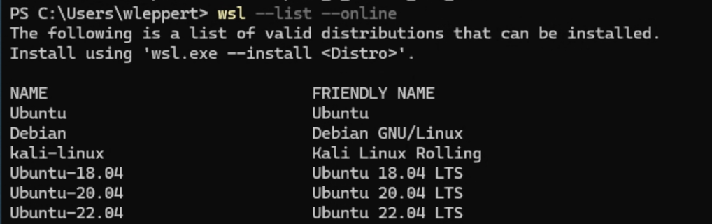

This is to collect the correct name for you desired distribution.

You can install with:

wsl --install Ubuntu-22.04

3.1.2 Ensure WSL is enabled in optional features

Before rebooting let’s make sure WSL is enabled in “Optional features and settings”. If not please do so and select OK and then “Restart Now”

After restarting you may need to install the distro itself again. Running wsl –install installs the latest version but this is not compatible for the current PX4 SITL. To install 22.04 we needed to install wsl with the command below.

You can check your available distributions with:

wsl -l –v

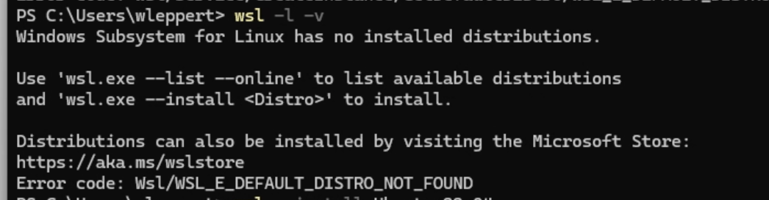

Run:

wsl --install Ubuntu-22.04
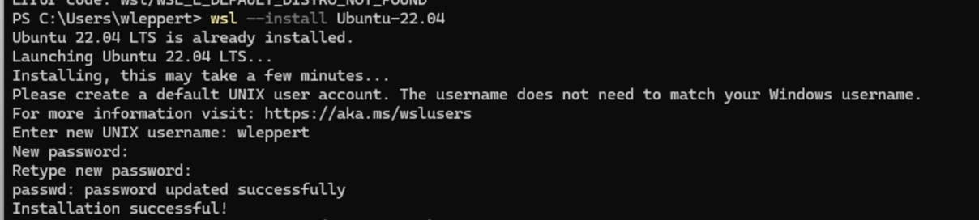
This will prompt you to enter a user name and password.

You can check your current IP address in WSL2 Ubuntu 22.04 with:

ip a
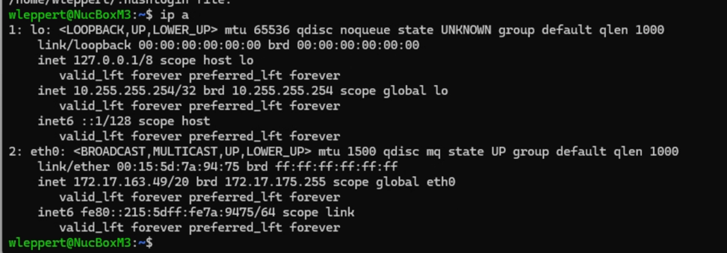
You can see that you are currently on a different network because WSL uses Network Address Translation by default, sharing the host IP address for external networking and translating to the private IP within the virtual network.

3.1.2 Set up VirtualEthernet for WSL to exist on the same network as bridged

To start up wsl in bridged mode first we need to create an external virtual switch in Hypber-V Manager.

In the search type Hyper-V and open the Hyber-V Manager application

Select you computer and on the right hand side select Virtual Switch Manager

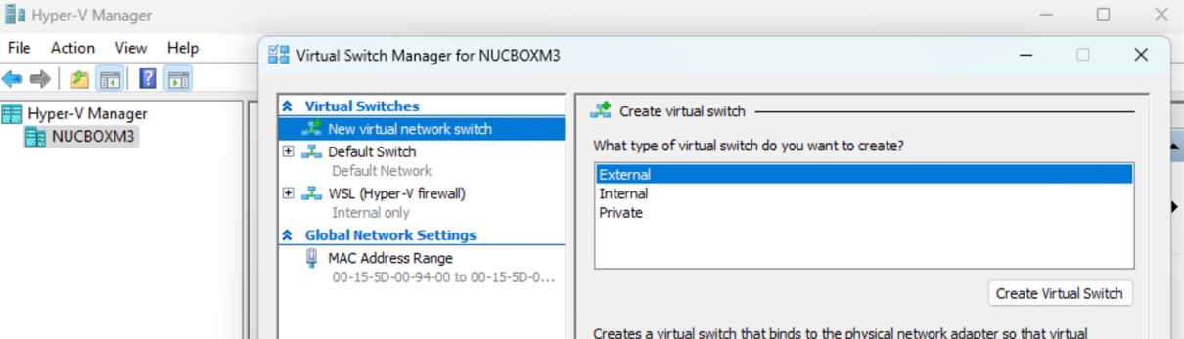

Create a new Virtual Switch with External Type name it something recognizable like WSLBridge.

Connect the virtual switch to your currently connected Network Interface. I am currently on Ethernet so I have that selected.

Leave “Allow management operating system to share the network adapter” checked so that WSL and the host machine can share the same adapter. There is the option of connect hot to one and VM to another if you have multiple network adapters.

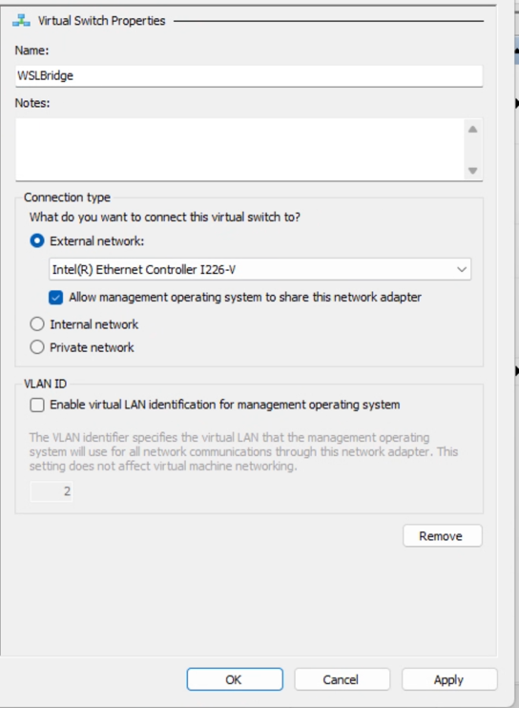

Select “Apply” and accept the warning by selecting “Yes”

3.1.4 WSL config

Open Notepad to create a config file to change the default settings of WSL.

In the file Add the following:

[wsl2]
networkingMode = bridged
vmSwitch = WSL_Bridge

Then save the document to your User Profile that you are logged in as. Name the document .wslconfig so that the WSL initialization will use this document as part of its configuration. Be sure to save the file as “All files”

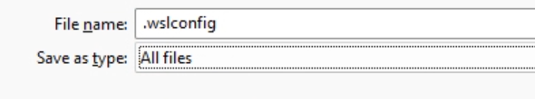

Restart WSL with:

wsl --shutdown

and

wsl

Back in your wsl terminal you should see the IP address updated to you network.

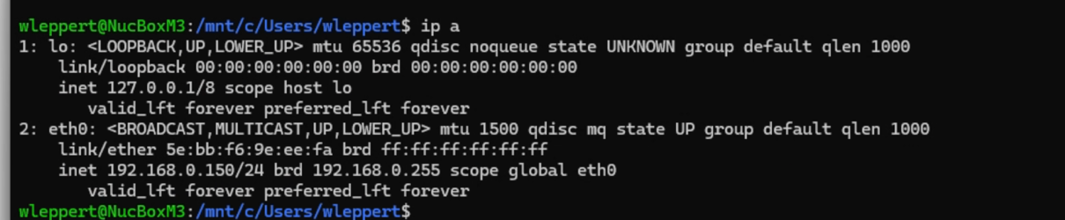

    - PX4 Clone, setup, and make
Check if git is installed with

git --version

You should have git installed already but if you do not run:

sudo apt install git-all

Change directories to the home directory of the WSL user

cd ~

Clone the repo with:
git clone https://github.com/PX4/PX4-Autopilot.git --recursive

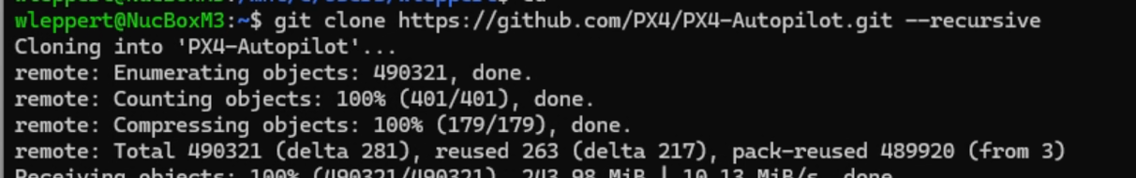

Then run the setup for ubuntu:

bash ./PX4-Autopilot/Tools/setup/ubuntu.sh --no-nuttx --no-sim-tools

--no-nuttx: Skipping Nuttx for the real time operating system in PX4 that is used to run on physical devices means we are focusing only on the simulation (e.g., SITL). This reduces setup time and avoids downloading or building Nuttx-related dependencies.

And --no-sim-tools because our simulation is going to be the AirSim CityEnvironment.

After the setup is complete run:

cd PX4-Autopilot/

make px4_sitl_default none_iris

To start the firmware simulation without starting up a simulator.

If you receive an warning about missing dependencies type “u” then enter to update the repo.
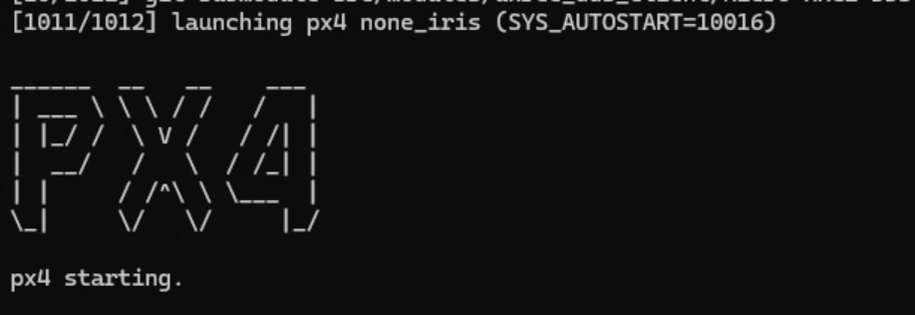

Once the simulator has started you should see this screen.

You can stop the simulation for now

3.2 Start Airsim City environment

The AirSim environment will need to be configured to accept control information from the mavlink server. To do this navigate to the settings.json found in <User Profile> -> Documents -> AirSim -> settings.json. Where “Start backup” is replaced with your user profile name through C: -> Users -> <User Profile>

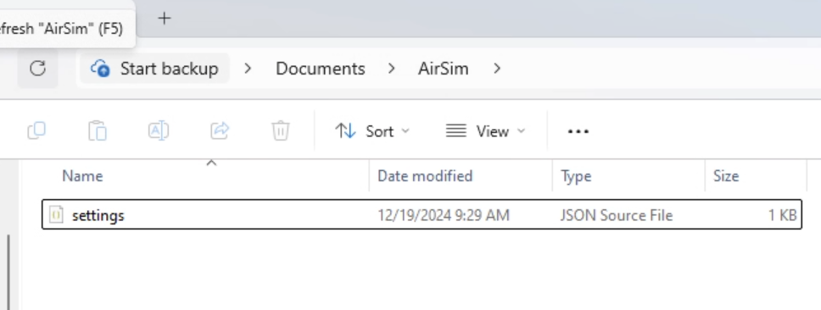
This will need to be updated with the following configuration:

Please Change the LocalHostIP to your host machines IP. This will connect to the MAVSDK server we are about to run.

{
"SettingsVersion": 1.2,
"SimMode": "Multirotor",
"ClockType": "SteppableClock",
"Vehicles": {
"PX4": {
"VehicleType": "PX4Multirotor",
"UseSerial": false,
"LockStep": true,
"UseTcp": true,
"TcpPort": 4560,
"ControlIp": "remote",
"ControlPortLocal": 14540,
"ControlPortRemote": 14580,
"LocalHostIp": "CHANGEME",
"LogMessages": true,
"Sensors":{
"Barometer":{
"SensorType": 1,
"Enabled": true,
"PressureFactorSigma": 0.0001825
}

}
}
}
}

Save the configuration and open the AirSim City Environment.

Once the City Environment is open navigate back to WSL and your WSL users home directory. To set an environment variable to tell PX4 where to listen to connect.

AirSim is running in our windows environment so we will need that address.

echo "export PX4_SIM_HOST_ADDR=<YOURWINDOWSIP>" >> ~/.bashrc
source ~/.bashrc

Restart the px4 simulation with the command above with airsim open

You should see the following

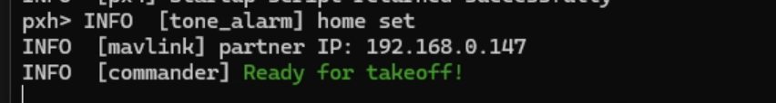

Before shutting down confirm the port number of the mavlink channel

Check this by entering the px4 terminal and typing mavlink status

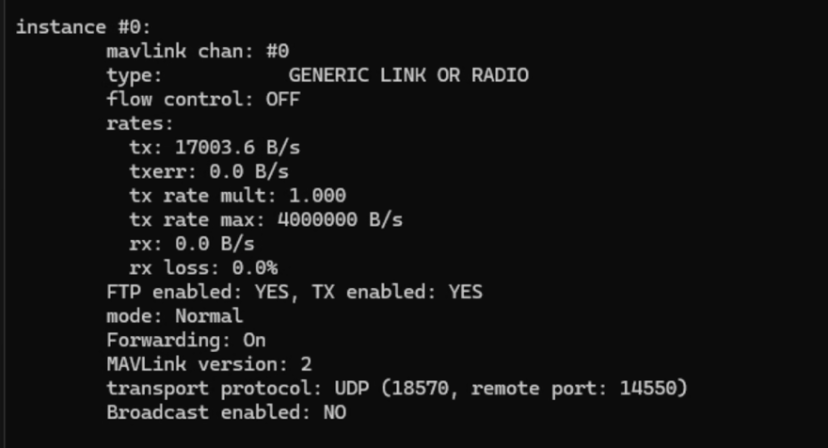

You can see in the channel configuration output above that the channel is set to only communicate with devices explicitly configured to listen on port 14550, send data on port 18570, and that broadcast is disabled for point-to-point communication.

Your PX4 simulation should be running in WSL2 Ubuntu 22.04 at the IP 172.X.X.X.

The next step will start the MAVSDK Server to run on port 50051, which will be used to communicate with the MAVSDK python client via gRPC (Google Remote Procedure Call). Specify the upd port of the sending PX4 firmware shown in the previous step, mine was 18570, and the IP address of your PX4 simulation.

3.3 Download MAVSDK Server executable for windows and connect

From https://github.com/mavlink/MAVSDK/releases download the mavsdk-windows-x64-release.zip

Extract the contents somewhere you can hold on to them. I have done so on my D: Drive.

To connect to PX4 you will need the channel port # that is assigned in PX4 that we got earlier.

In the mavlink folder execute the server binary with the following:

.\bin\mavsdk_server_bin.exe start -p 50051 -d udp://<YOUR-WSL-IP>:18570

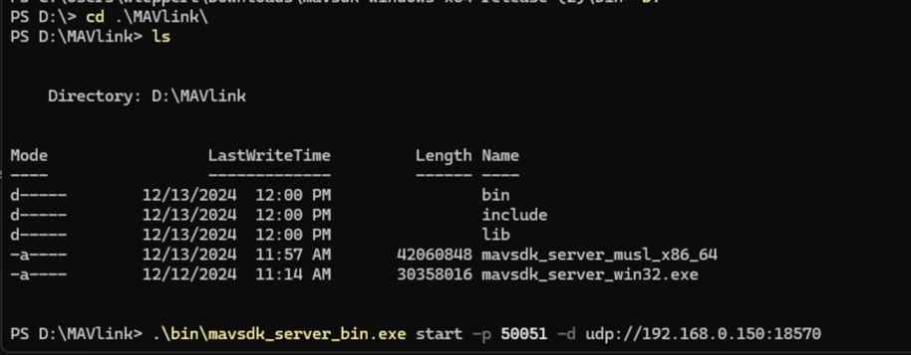

If successful you should see this output:

And this in px4:

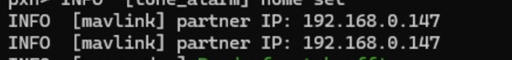

If not try restarting the px4 simulator.

Typically the order of initialization does matter and in this case you will want to run AirSIm, following by px4, followed by MAVSDK_server, and then the python scripts.

If resetting it is best to just close out and restart each component from the beginning.

  - Start PX4 simulation and the MAVSDK Server

This is repeat information but
Start PX4 simulation with:

make px4_sitl_default none_iris

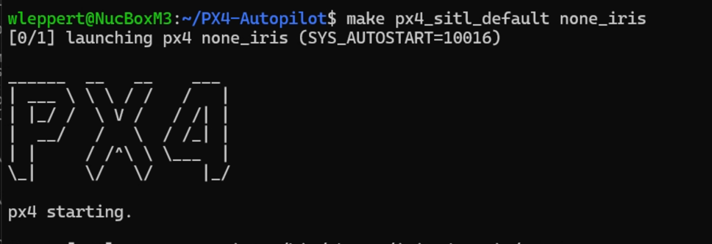

Collect the mavlink channel port number in the px4 terminal with (click into the running simulation terminal and press <Enter>):

mavlink status

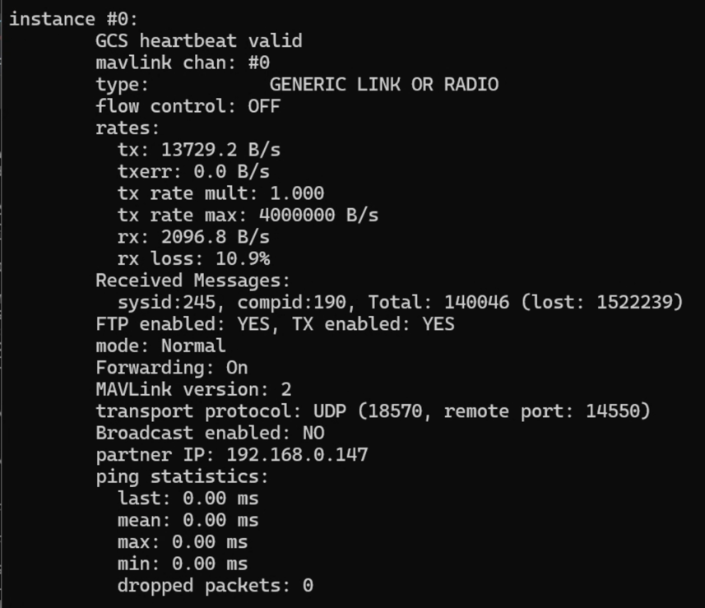

You can see in the channel configuration output above that the channel is set to only communicate with devices explicitly configured to listen on port 14550, send data on port 18570, and that broadcast is disabled for point-to-point communication.

My PX4 simulation is running in WSL2 Ubuntu 22.04 at the IP 192.168.0.150.

Start the MAVSDK Server to run on port 50051, which will be used to communicate with the MAVSDK python client via gRPC (Google Remote Procedure Call). Specify the upd port of the sending PX4 firmware shown in the previous step, mine was 18570, and the IP address of your PX4 simulation.

.\bin\mavsdk_server_bin.exe start -p 50051 -d udp://192.168.0.150:18570

    - Confirm connectivity.

All three service must be running at the same time to be working. Do check your port numbers and IP assignments if you have any issues.

In PX4 you should see:

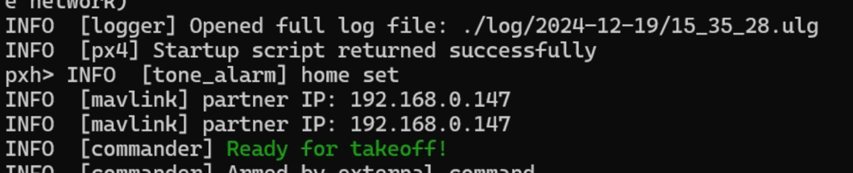

In MAVLink:

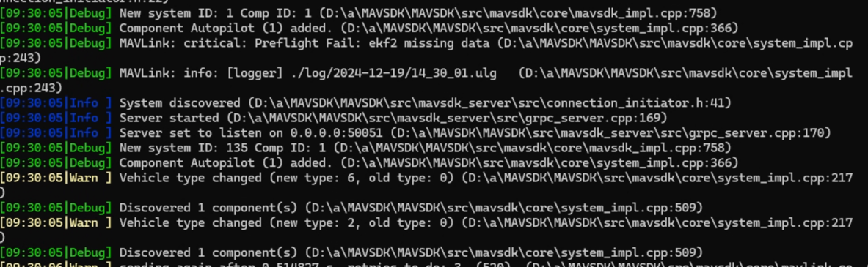

And in AirSim:

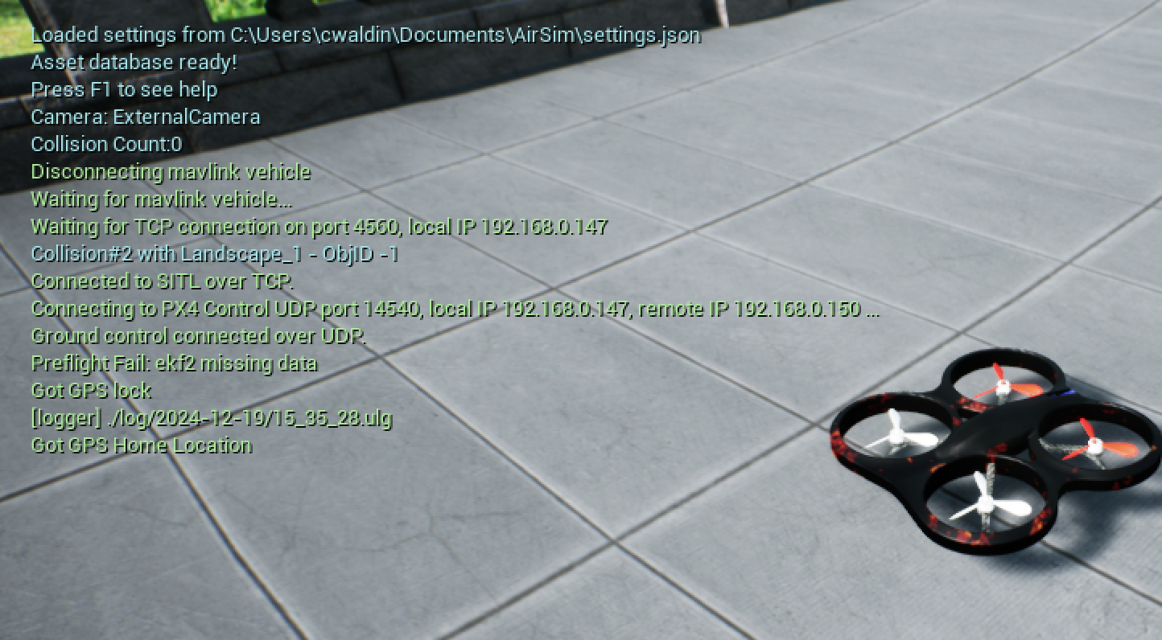

Now that connection is confirmed we can shut these down for now to go over the navigation and data collection code for the setup up. We will want to collect data points that contribute to the contextualization of nominal drone behavior. As well as collect sufficient information. This can be done on a single field like forward velocity or through correlation of various fields like GPS and position estimation.

For the code we will be using the same virtual environment from the previous Lab S05, if you would like to create a subdirectory in the same project directory of this lab or copy the .venv over to a new directory. I’ve created a new directory called mav_sitl on the D: drive and copied the .venv from the S05 folder (py_dronamaly) to this directory.

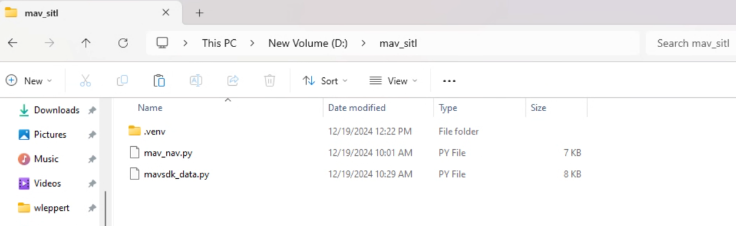

Open VS Code and open the folder we’ve just created. Then press Ctrl+Shift+P to open the command pallet go to Python: Select Interpreter and select the .venv in this folder as the interpreter.

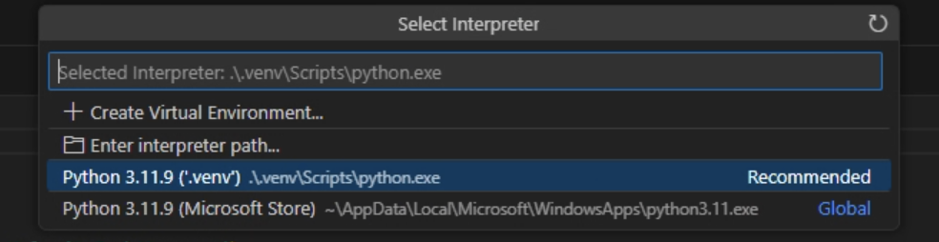

Open a new terminal in VS Code and activate the .venv isolated environment to install the needed dependency mavsdk. Developer reasoning for the use of the virtual environment is that, as a self-contained directory, management of dependencies independently prevents conflicts between package versions, prevents system cluttering python installations particular to projects, and that the virtual environment is portable and reproducable.

Activate the virtual environment with:

.venv/Scripts/Activate.ps1

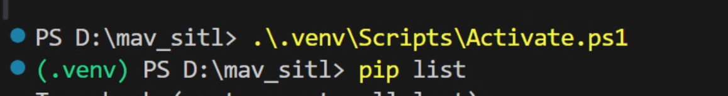

You can list the pip installed packages with pip list to see what all is available outside of pythons native libraries but we will need the mavsdk modules.

Install the mavsdk module with:

pip install mavsdk

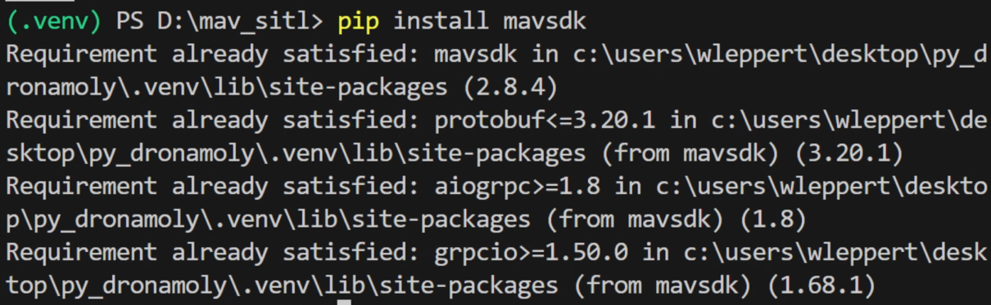

There are two files central to the navigation and data collection.

Navigation: mav_nav.py

Data Collection: mavsdk_data.py

Create blank files with these names (or something recognizable) and copy and the following code.

#mav_nav.py
import asyncio
import keyboard
from mavsdk import System
from mavsdk.offboard import (OffboardError, VelocityBodyYawspeed)
import airsim

# Default body-frame velocity
default_velocity = 8.0

async def setup_drone():
drone = System(mavsdk_server_address="localhost", port=50051)
# Connect MAVSDK to PX4 SITL's MAVLink endpoint. Adjust if necessary:
await drone.connect(system_address="udp://<IP_OF_WINDOWS>:14540")

print("Waiting for drone to connect...")
async for state in drone.core.connection_state():
if state.is_connected:
print("Drone connected via MAVSDK!")
break

print("Waiting for global position estimate...")
async for health in drone.telemetry.health():
if health.is_global_position_ok and health.is_home_position_ok:
print("Global position estimate OK")
break

print("Arming...")
await arm_drone(drone)

print("Taking off...")
await drone.action.takeoff()
await asyncio.sleep(5)

return drone

async def arm_drone(drone):
"""
Attempt to arm the drone after ensuring it is ready.
"""
print("Waiting for drone health checks...")
async for health in drone.telemetry.health():
if health.is_gyrometer_calibration_ok and health.is_accelerometer_calibration_ok and \
health.is_magnetometer_calibration_ok and health.is_global_position_ok:
print("Drone is healthy!")
break

print("Waiting for global position lock...")
async for gps_info in drone.telemetry.gps_info():
if gps_info.num_satellites > 5:
print("GPS lock acquired!")
break

print("Arming the drone...")
try:
await drone.action.arm()
print("Drone armed successfully!")
except Exception as e:
print(f"Failed to arm the drone: {e}")

async def enter_offboard_mode(drone):
# Send a neutral setpoint before starting offboard
await drone.offboard.set_velocity_body(VelocityBodyYawspeed(0.0, 0.0, 0.0, 0.0))
print("Starting Offboard mode...")
try:
await drone.offboard.start()
except OffboardError as e:
print(f"Failed to start Offboard: {e._result.result}")
print("Disarming...")
await drone.action.disarm()
return False
return True

async def user_control(drone, client):
"""
Control the drone with keyboard inputs via MAVSDK Offboard mode while AirSim runs in the background.
"""
global default_velocity
print("User control active (MAVSDK for flight control, AirSim for simulation).")
print("W/A/S/D: Move horizontally in direction of heading")
print("Space: Up | Shift: Down")
print("Left/Right Arrow: Yaw control")
print("[/]: Decrease/Increase velocity")
print("\\: Land and disarm")
print("Ctrl: Hover in place")

try:
while True:
forward_vel = 0.0
right_vel = 0.0
down_vel = 0.0
yawspeed = 0.0

# Adjust speed
if keyboard.is_pressed(']'):
default_velocity = min(default_velocity + 0.5, 25.0)
print(f"Velocity increased to {default_velocity} m/s")
await asyncio.sleep(0.2)
if keyboard.is_pressed('['):
default_velocity = max(default_velocity - 0.5, 0.5)
print(f"Velocity decreased to {default_velocity} m/s")
await asyncio.sleep(0.2)

# Movement keys
if keyboard.is_pressed('w'):
forward_vel += default_velocity
if keyboard.is_pressed('s'):
forward_vel -= default_velocity
if keyboard.is_pressed('a'):
right_vel -= default_velocity
if keyboard.is_pressed('d'):
right_vel += default_velocity
if keyboard.is_pressed('space'):
down_vel -= default_velocity # negative for up
if keyboard.is_pressed('shift'):
down_vel += default_velocity # positive for down

# Yaw control
if keyboard.is_pressed('left arrow'):
yawspeed -= 30.0
if keyboard.is_pressed('right arrow'):
yawspeed += 30.0

# Hover if ctrl pressed
if keyboard.is_pressed('ctrl'):
forward_vel = 0.0
right_vel = 0.0
down_vel = 0.0
yawspeed = 0.0

# Land if '\' pressed
if keyboard.is_pressed('\\'):
print("Landing...")
await drone.action.land()
await asyncio.sleep(5)
print("Disarming...")
await drone.action.disarm()
break

# Send velocity setpoint in body frame
await drone.offboard.set_velocity_body(VelocityBodyYawspeed(forward_vel, right_vel, down_vel, yawspeed))

# Optionally read data from AirSim (e.g., position)
# This gives you direct access to AirSim's ground truth.
state = client.getMultirotorState()
position = state.kinematics_estimated.position

await asyncio.sleep(0.05) # ~20Hz

except KeyboardInterrupt:
print("Keyboard interrupt. Landing and disarming...")
await drone.action.land()
await asyncio.sleep(5)
await drone.action.disarm()

async def main():
# Connect to AirSim
client = airsim.MultirotorClient()
client.confirmConnection()
print("Connected to AirSim!")
# Don't arm/disarm via AirSim, let PX4 & MAVSDK handle that.
# Just use AirSim for environment data if needed.

drone = await setup_drone()
if await enter_offboard_mode(drone):
await user_control(drone, client)

# Stop Offboard mode gracefully if still active
try:
await drone.offboard.stop()
except:
pass

print("Exiting program.")

if __name__ == "__main__":
asyncio.run(main())

if __name__ == "__main__":
asyncio.run(main())

The code above integrates drone control using MAVSDK and AirSim to simulate control of the drone via mavlink. The AirSim modules is used only as a place holder for data retrieval but no data is output line 144 and 145.

The function definition setup_drone initialized and connects to the airsim drone via mav sdk, checks drone health, arms, the takes off. The drone object is held in the variable drone for subsequent navigation by keyboard input tasks. The controls are printed to the stdout terminal and are the same as the previous lab.

w/a/s/d: Forward, backward, left, and right movements in the body frame.
space and shift: Ascend and descend vertically.
left and right arrows: Control yaw (rotational movement).
[ and ]: Adjust the default velocity.
\: Lands the drone and disarms it.
ctrl: Stops all movement to hover in place.

The Offboard Mode is set to permit commands from an external source (python script) which will act as our ground station. Asynchronous programming is implemented to ensure smooth application of keyboard inputs to drone commands. Tasks are interleaved concurrently to process multiple tasks at the same time allowing for more efficient use of resources. Sensor input is available from this drone object accessor modules are not called, that is done in the next script.

The mavsdk_data.py script collects data points through both airsim and mavsdk. While this decreases the overall “realness” or fidelity of the simulation, to maintain simplicity the following were collected from airsim.

#mavsdk_data.py
import airsim
import asyncio
import json
import requests
from datetime import datetime
import pytz
import os
from mavsdk import System

latest_health = None

# Splunk HEC Configuration
splunk_url = "http://<Splunk_SERVER_IP>:8088" # Replace with your Splunk HEC endpoint
splunk_token = '<SPLUNK_TOKEN>'
headers = {"Authorization": f"Splunk {splunk_token}"}

# Connect to the AirSim simulator
client = airsim.MultirotorClient()
client.confirmConnection()

def get_system_time_iso():
"""
Get the current system time in ISO 8601 format (UTC).
"""
est_timezone = pytz.timezone("America/New_York")
now = datetime.now(est_timezone)
return now.isoformat()

async def poll_health(drone):
"""
Poll the health stream asynchronously and update the shared global variable.
"""
global latest_health
try:
async for health in drone.telemetry.health():
latest_health = {
"gyrometer_calibration": health.is_gyrometer_calibration_ok,
"accelerometer_calibration": health.is_accelerometer_calibration_ok,
"magnetometer_calibration": health.is_magnetometer_calibration_ok,
"local_position_ok": health.is_local_position_ok,
"global_position_ok": health.is_global_position_ok,
"home_position_ok": health.is_home_position_ok,
}
print(f"Updated Health: {latest_health}")
except asyncio.CancelledError:
print("Stopping health polling.")

async def get_flight_data(drone):
"""
Collect flight data from the MAVSDK telemetry streams.
"""

state = client.getMultirotorState()
kinematics = state.kinematics_estimated

position, velocity, attitude, battery, heading, gps_info = await asyncio.gather(
drone.telemetry.position().__anext__(),
drone.telemetry.velocity_ned().__anext__(),
drone.telemetry.attitude_euler().__anext__(),
drone.telemetry.battery().__anext__(),
drone.telemetry.heading().__anext__(),
drone.telemetry.gps_info().__anext__()

)

imu_data = {
"acceleration": {
"x": kinematics.linear_acceleration.x_val,
"y": kinematics.linear_acceleration.y_val,
"z": kinematics.linear_acceleration.z_val,
},
"angular_velocity": {
"x": kinematics.angular_velocity.x_val,
"y": kinematics.angular_velocity.y_val,
"z": kinematics.angular_velocity.z_val,
}
}

rotor_data = {"rotor_states": []}
rotor_states = client.getRotorStates()
for j, rotor in enumerate(rotor_states.rotors):
rotor_data["rotor_states"].append({
"rotor_index": j,
"speed": rotor["speed"],
"thrust": rotor["thrust"],
"torque_scaler": rotor["torque_scaler"]

})

# Combine into a single dictionary
data_entry = {
"timestamp": get_system_time_iso(),
"gps_position": {
"lat_deg": position.latitude_deg,
"lon_deg": position.longitude_deg
},
"abs_alt_m": position.absolute_altitude_m,
"vel_north_m_s": velocity.north_m_s,
"vel_east_m_s": velocity.east_m_s,
"vel_down_m_s": velocity.down_m_s,
"roll_deg": attitude.roll_deg,
"pitch_deg": attitude.pitch_deg,
"yaw_deg": attitude.yaw_deg,
"battery":{
"battery_percentage": battery.remaining_percent,
"battery_voltage_v": battery.voltage_v,
},
"health": latest_health,
"imu": imu_data,
"gps_num_satellites": gps_info.num_satellites,
"gps_fix_type": str(gps_info.fix_type),
"heading": heading.heading_deg,

"rotor":{
"rotor_fl": rotor_data["rotor_states"][0],
"rotor_fr": rotor_data["rotor_states"][1],
"rotor_br": rotor_data["rotor_states"][2],
"rotor_bl":rotor_data["rotor_states"][3]
}
}
return data_entry

def send_to_splunk(event):
payload = {"event": event, "index": "<SPLUNK_INDEX>", "sourcetype": "_json"}
try:
response = requests.post(f"{splunk_url}/services/collector/event", headers=headers, json=payload, timeout=1)
if response.status_code != 200:
print(f"Failed to send data to Splunk: {response.text}")
except requests.exceptions.RequestException as e:
print(f"Splunk error: {e}")

def append_to_json_file(filepath, data):
"""
Append data to a JSON file. Create the file if it doesn't exist.
"""
if not os.path.exists(filepath):
with open(filepath, 'w') as f:
json.dump([], f) # Initialize with an empty list

with open(filepath, 'r+') as f:
existing_data = json.load(f)
existing_data.append(data) # Append new data
f.seek(0) # Reset file pointer to the beginning
json.dump(existing_data, f, indent=4)

def send_to_splunk(event):
"""
Send data to Splunk.
"""
payload = {"event": event, "index": "TEST", "sourcetype": "_json"}
response = requests.post(f"{splunk_url}/services/collector/event", headers=headers, json=payload)
if response.status_code != 200:
print(f"Failed to send data to Splunk: {response.text}")

async def main():
"""
Main async loop for data recording.
"""
drone = System(mavsdk_server_address="localhost", port=50051)
await drone.connect(system_address="udp://<WINDOWS_IP>:14540")

print("Waiting for drone connection...")
async for state in drone.core.connection_state():
if state.is_connected:
print("Drone connected!")
break

# Set telemetry rates to 5 Hz
await drone.telemetry.set_rate_position(5.0) # Global position
await drone.telemetry.set_rate_velocity_ned(5.0) # Velocity in NED frame
await drone.telemetry.set_rate_attitude_euler(5.0) # Attitude as Euler angles
await drone.telemetry.set_rate_battery(5.0) # Battery status
await drone.telemetry.set_rate_gps_info(5.0) # GPS information

health_task = asyncio.create_task(poll_health(drone))

# queue = asyncio.Queue()
# asyncio.create_task(splunk_sender(queue))

print("Waiting for drone connection...")
async for state in drone.core.connection_state():
if state.is_connected:
print("Drone connected!")
break

print("Press Ctrl+C to stop recording.")
flight_data_log = []

try:
while True:

flight_data = await get_flight_data(drone)
if flight_data:
print(f"Collected data: {flight_data}")
#send_to_splunk(flight_data) # Uncomment to send data to Splunk

# await asyncio.sleep(max(0.2 - loop_duration, 0))

except asyncio.exceptions.CancelledError:
print("Stopping recording...")

finally:
# Clean up actions, if any
health_task.cancel() # Stop the health polling task
await health_task
print("Exiting program.")

if __name__ == "__main__":
asyncio.run(main())

send_to_splunk is commented out so that you can test the output to the terminal before forwarding to your index.

You will need:
- A new index
- A new HEC token (Please see Lab S05 for creation of an HEC token)
- Change in the code above SPLUNK_IP, SPLUNK_TOKEN, SPLUNK_INDEX, WINDOWS_IP to their respective indexes.

Linear Acceleration (acceleration): Represents the rate of change of velocity along the X, Y, and Z axes in m/s².

Angular Velocity (angular_velocity):
Represents the rate of rotational change (yaw, pitch, roll) around the X, Y, and Z axes. (This is also represented by mavsdk’s attitude).

Rotor Data: Rotor Speed, Thrust, and Torque.

To see the available streams of the PX4 simulator you can enter the following in
the PX4 simulation terminal:

mavlink status streams

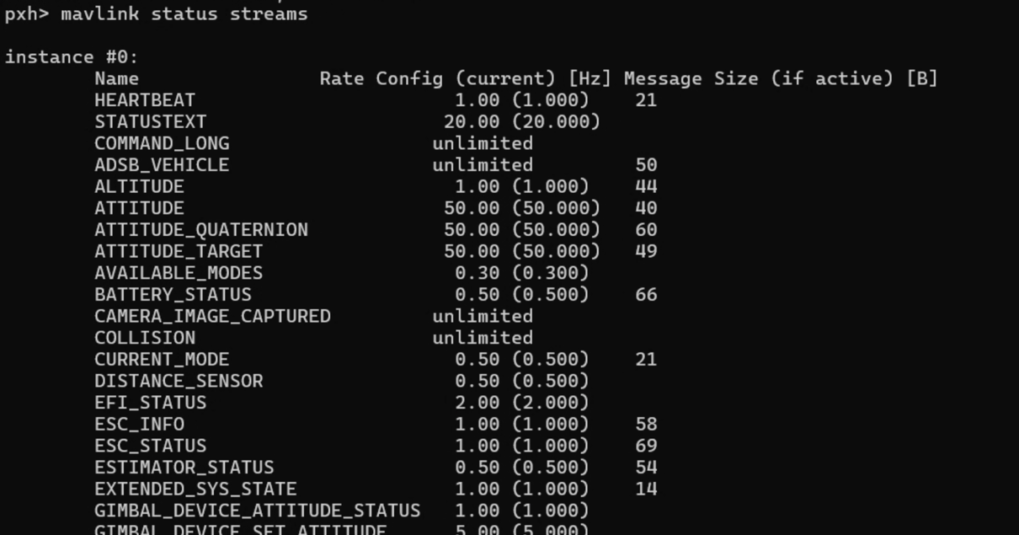

The simulation itself could use some tweaking but there are a number of possible improvements to be made. We can also test the state estimation of PX4 with the data from airsim for comparison and adjust px4 configuration.

Just as an explaination of some of the interesting parts of the code. Health only updates when the status of a health parameter changes, so health is stored in a global variable latest_health and poll_health is run as a asynchronous task to receive and assign the values of updates to this global variable.

The variable position, velocity, attitude, battery, heading, gps_info are retrieved with async.gather. The function await asyncio.gather schedules multiple coroutines (concurrent asynchronous processes run as a single thread), waits for all to complete, the gather collects and returns their results.

  - Test navigation and flight data json print to console

To test the navigation and data, launch airsim, the px4 simulator, and the MAVSDK server. From VS code run the python file for mav_nav.py the run the mavsdk_data.py.
If you are able to control the flight of the drone and the data terminal output looks like this then you are ready to go!
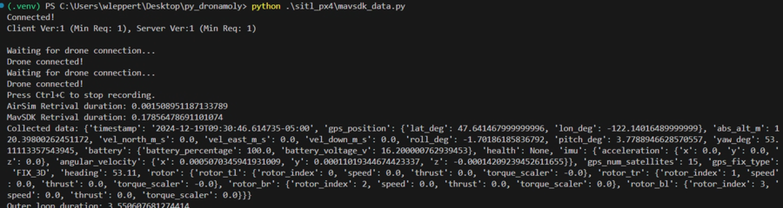

  - Create a Splunk Index and Create an Index Token then forward data to splunk.

The steps for creating a splunk index and an index token are not mentioned here but follow the same steps as in S05. I have named my index drone_mavlink_index, you may choose something recognizable.

Test for just a few packets. Check index in search and reporting. If successful you are ready to begin data collection.

Use error output, and splunk logs to debug <grep “HEC” $SPLUNK_HOME/var/log/splunk/splunkd.log>

To collect data for 20k events to the index to build up a source for a nominal flight baseline fly with specific rules like in the previous lab. They are listed here:

- we flew around at 8 m/s
- at around lamppost height
- stayed in the street
- turn carefully
- for about 1 hours with 5hz log frequency for 20,000 event

  - Select Anomaly detection for data fields

  - Create baseline

